






Clean and prepare rooms for incoming guests
D1.HHK.CL3.03
Trainer Guide

Clean and prepare rooms for incoming guests

D1.HHK.CL3.03

Trainer Guide





Project Base
William Angliss Institute of TAFE
555 La Trobe Street
Melbourne 3000 Victoria
Telephone: | (03) 9606 2111
Facsimile: | (03) 9670 1330
Acknowledgements
Project Director: | Wayne Crosbie
Chief Writer: | Alan Hickman
Subject Writer: | Nick Hyland
Project Manager: | Alan Maguire
Editor | Jim Irwin
DTP/Production | Daniel Chee, Mai Vu, Jirayu Thangcharoensamut, Kaly Quach

The Association of Southeast Asian Nations (ASEAN) was established on 8 August 1967. The Member States of the Association are Brunei Darussalam, Cambodia, Indonesia, Lao PDR, Malaysia, Myanmar, Philippines, Singapore, Thailand and Viet Nam.
The ASEAN Secretariat is based in Jakarta, Indonesia.
General Information on ASEAN appears online at the ASEAN Website: www.asean.org.
All text is produced by William Angliss Institute of TAFE for the ASEAN Project on “Toolbox Development for Priority Tourism Labour Division”.
This publication is supported by the Australian Government’s aid program through the ASEAN-Australia Development Cooperation Program Phase II (AADCP II).
Copyright: Association of Southeast Asian Nations (ASEAN) 2012.
All rights reserved.
Disclaimer
Every effort has been made to ensure that this publication is free from errors or omissions. However, you should conduct your own enquiries and seek professional advice before relying on any fact, statement or matter contained in this book. The ASEAN Secretariat and William Angliss Institute of TAFE are not responsible for any injury, loss or damage as a result of material included or omitted from this course. Information in this module is current at the time of publication. Time of publication is indicated in the date stamp at the bottom of each page.
Some images appearing in this resource have been purchased from stock photography suppliers Shutterstock and iStockphoto and other third party copyright owners and as such are non-transferable and non-exclusive. Clip arts, font images and illustrations used are from the Microsoft Office Clip Art and Media Library. Some images have been provided by and are the property of William Angliss Institute.
Additional images have been sourced from Flickr and SXC and are used under Creative Commons licence: http://creativecommons.org/licenses/by/2.0/deed.en

File name: TG_Clean_&_prepare_rooms_for_incoming_guests_refined





Table of Contents
Competency Based Training (CBT) and assessment an introduction for trainers 1
Competency standard 11
Notes and PowerPoint slides 25
Recommended training equipment 217
Instructions for Trainers for using PowerPoint – Presenter View 219
Appendix – ASEAN acronyms 221

Competency Based Training (CBT) and assessment an introduction for trainers

Competency
Competency refers to the ability to perform particular tasks and duties to the standard of performance expected in the workplace.
Competency requires the application of specified knowledge, skills and attitudes relevant to effective participation, consistently over time and in the workplace environment.
The essential skills and knowledge are either identified separately or combined.
Knowledge identifies what a person needs to know to perform the work in an informed and effective manner.
Skills describe the application of knowledge to situations where understanding is converted into a workplace outcome.
Attitude describes the founding reasons behind the need for certain knowledge or why skills are performed in a specified manner.
Competency covers all aspects of workplace performance and involves:
- Performing individual tasks
- Managing a range of different tasks
- Responding to contingencies or breakdowns
- Dealing with the responsibilities of the workplace
- Working with others.

Unit of Competency
Like with any training qualification or program, a range of subject topics are identified that focus on the ability in a certain work area, responsibility or function.
Each manual focuses on a specific unit of competency that applies in the hospitality workplace.
In this manual a unit of competency is identified as a ‘unit’.
Each unit of competency identifies a discrete workplace requirement and includes:
- Knowledge and skills that underpin competency
- Language, literacy and numeracy
- Occupational safety and health requirements.
Each unit of competency must be adhered to in training and assessment to ensure consistency of outcomes.

Element of Competency
An element of competency describes the essential outcomes within a unit of competency.
The elements of competency are the basic building blocks of the unit of competency. They describe in terms of outcomes the significant functions and tasks that make up the competency.
In this manual elements of competency are identified as an ‘element’.

Performance criteria
Performance criteria indicate the standard of performance that is required to demonstrate achievement within an element of competency. The standards reflect identified industry skill needs.
Performance criteria will be made up of certain specified skills, knowledge and attitudes.

Learning
For the purpose of this manual learning incorporates two key activities:
- Training
- Assessment.
Both of these activities will be discussed in detail in this introduction.
Today training and assessment can be delivered in a variety of ways. It may be provided to participants:
- On-the-job – in the workplace
- Off-the-job – at an educational institution or dedicated training environment
- As a combination of these two options.
No longer is it necessary for learners to be absent from the workplace for long periods of time in order to obtain recognised and accredited qualifications.

Learning Approaches
This manual will identify two avenues to facilitate learning:
Competency Based Training (CBT)
This is the strategy of developing a participant’s competency.
Educational institutions utilise a range of training strategies to ensure that participants are able to gain the knowledge and skills required for successful:
- Completion of the training program or qualification
- Implementation in the workplace.
The strategies selected should be chosen based on suitability and the learning styles of participants.

Competency Based Assessment (CBA)
This is the strategy of assessing competency of a participant.
Educational institutions utilise a range of assessment strategies to ensure that participants are assessed in a manner that demonstrates validity, fairness, reliability, flexibility and fairness of assessment processes.

Flexibility in Learning
It is important to note that flexibility in training and assessment strategies is required to meet the needs of participants who may have learning difficulties. The strategies used will vary, taking into account the needs of individual participants with learning difficulties. However they will be applied in a manner which does not discriminate against the participant or the participant body as a whole.
Catering for Participant Diversity
Participants have diverse backgrounds, needs and interests. When planning training and assessment activities to cater for individual differences, trainers and assessors should:
- Consider individuals’ experiences, learning styles and interests
- Develop questions and activities that are aimed at different levels of ability
- Modify the expectations for some participants
- Provide opportunities for a variety of forms of participation, such as individual, pair and small group activities
- Assess participants based on individual progress and outcomes.
The diversity among participants also provides a good reason for building up a learning community in which participants support each other’s learning.
Participant Centred Learning
This involves taking into account structuring training and assessment that:
- Builds on strengths – Training environments need to demonstrate the many positive features of local participants (such as the attribution of academic success to effort, and the social nature of achievement motivation) and of their trainers (such as a strong emphasis on subject disciplines and moral responsibility). These strengths and uniqueness of local participants and trainers should be acknowledged and treasured
- Acknowledges prior knowledge and experience – The learning activities should be planned with participants’ prior knowledge and experience in mind
- Understands learning objectives – Each learning activity should have clear learning objectives and participants should be informed of them at the outset. Trainers should also be clear about the purpose of assignments and explain their significance to participants
- Teaches for understanding – The pedagogies chosen should aim at enabling participants to act and think flexibly with what they know
- Teaches for independent learning – Generic skills and reflection should be nurtured through learning activities in appropriate contexts of the curriculum. Participants should be encouraged to take responsibility for their own learning
- Enhances motivation – Learning is most effective when participants are motivated. Various strategies should be used to arouse the interest of participants
- Makes effective use of resources – A variety of teaching resources can be employed as tools for learning
- Maximises engagement – In conducting learning activities, it is important for the minds of participants to be actively engaged
- Aligns assessment with learning and teaching – Feedback and assessment should be an integral part of learning and teaching
- Caters for learner diversity – Trainers should be aware that participants have different characteristics and strengths and try to nurture these rather than impose a standard set of expectations.
Active Learning
The goal of nurturing independent learning in participants does not imply that they always have to work in isolation or solely in a classroom. On the contrary, the construction of knowledge in tourism and hospitality studies can often best be carried out in collaboration with others in the field. Sharing experiences, insights and views on issues of common concern, and working together to collect information through conducting investigative studies in the field (active learning) can contribute a lot to their eventual success.
Active learning has an important part to play in fostering a sense of community in the class. First, to operate successfully, a learning community requires an ethos of acceptance and a sense of trust among participants, and between them and their trainers. Trainers can help to foster acceptance and trust through encouragement and personal example, and by allowing participants to take risks as they explore and articulate their views, however immature these may appear to be. Participants also come to realise that their classmates (and their trainers) are partners in learning and solving.
Trainers can also encourage cooperative learning by designing appropriate group learning tasks, which include, for example, collecting background information, conducting small-scale surveys, or producing media presentations on certain issues and themes. Participants need to be reminded that, while they should work towards successful completion of the field tasks, developing positive peer relationships in the process is an important objective of all group work.

Competency Based Training (CBT)
Principle of Competency Based Training
Competency based training is aimed at developing the knowledge, skills and attitudes of participants, through a variety of training tools.
Training Strategies
The aims of this curriculum are to enable participants to:
- Undertake a variety of subject courses that are relevant to industry in the current environment
- Learn current industry skills, information and trends relevant to industry
- Learn through a range of practical and theoretical approaches
- Be able to identify, explore and solve issues in a productive manner
- Be able to become confident, equipped and flexible managers of the future
- Be ‘job ready’ and a valuable employee in the industry upon graduation of any qualification level.
To ensure participants are able to gain the knowledge and skills required to meet competency in each unit of competency in the qualification, a range of training delivery modes are used.
Types of Training
In choosing learning and teaching strategies, trainers should take into account the practical, complex and multi-disciplinary nature of the subject area, as well as their participant’s prior knowledge, learning styles and abilities.
Training outcomes can be attained by utilising one or more delivery methods:
Lecture/Tutorial
This is a common method of training involving transfer of information from the trainer to the participants. It is an effective approach to introduce new concepts or information to the learners and also to build upon the existing knowledge. The listener is expected to reflect on the subject and seek clarifications on the doubts.
Demonstration
Demonstration is a very effective training method that involves a trainer showing a participant how to perform a task or activity. Through a visual demonstration, trainers may also explain reasoning behind certain actions or provide supplementary information to help facilitate understanding.
Group Discussions
Brainstorming in which all the members in a group express their ideas, views and opinions on a given topic, is a free flow and exchange of knowledge among the participants and the trainer. The discussion is carried out by the group on the basis of their own experience, perceptions and values. This will facilitate acquiring new knowledge. When everybody is expected to participate in the group discussion, even the introverted persons will also get stimulated and try to articulate their feelings.
The ideas that emerge in the discussions should be noted down and presentations are to be made by the groups. Sometimes consensus needs to be arrived at on a given topic. Group discussions are to be held under the moderation of a leader guided by the trainer. Group discussion technique triggers thinking process, encourages interactions and enhances communication skills.
Role Play
This is a common and very effective method of bringing into the classroom real life situations, which may not otherwise be possible. Participants are made to enact a particular role so as to give a real feel of the roles they may be called upon to play. This enables participants to understand the behaviour of others as well as their own emotions and feelings. The instructor must brief the role players on what is expected of them. The role player may either be given a ready-made script, which they can memorise and enact, or they may be required to develop their own scripts around a given situation. This technique is extremely useful in understanding creative selling techniques and human relations. It can be entertaining and energising and it helps the reserved and less literate to express their feelings.

Simulation Games
When trainees need to become aware of something that they have not been conscious of, simulations can be a useful mechanism. Simulation games are a method based on "here and now" experience shared by all the participants. The games focus on the participation of the trainees and their willingness to share their ideas with others. A "near real life" situation is created providing an opportunity to which they apply themselves by adopting certain behaviour. They then experience the impact of their behaviour on the situation. It is carried out to generate responses and reactions based on the real feelings of the participants, which are subsequently analysed by the trainer.
While use of simulation games can result in very effective learning, it needs considerable trainer competence to analyse the situations.
Individual /Group Exercises
Exercises are often introduced to find out how much the participant has assimilated. This method involves imparting instructions to participants on a particular subject through use of written exercises. In the group exercises, the entire class is divided into small groups, and members are asked to collaborate to arrive at a consensus or solution to a problem.
Case Study
This is a training method that enables the trainer and the participant to experience a real life situation. It may be on account of events in the past or situations in the present, in which there may be one or more problems to be solved and decisions to be taken. The basic objective of a case study is to help participants diagnose, analyse and/or solve a particular problem and to make them internalise the critical inputs delivered in the training. Questions are generally given at the end of the case study to direct the participants and to stimulate their thinking towards possible solutions. Studies may be presented in written or verbal form.
Field Visit
This involves a carefully planned visit or tour to a place of learning or interest. The idea is to give first-hand knowledge by personal observation of field situations, and to relate theory with practice. The emphasis is on observing, exploring, asking questions and understanding. The trainer should remember to brief the participants about what they should observe and about the customs and norms that need to be respected.
Group Presentation
The participants are asked to work in groups and produce the results and findings of their group work to the members of another sub-group. By this method participants get a good picture of each other's views and perceptions on the topic and they are able to compare them with their own point of view. The pooling and sharing of findings enriches the discussion and learning process.
Practice Sessions
This method is of paramount importance for skills training. Participants are provided with an opportunity to practice in a controlled situation what they have learnt. It could be real life or through a make-believe situation.

Games
This is a group process and includes those methods that involve usually fun-based activity, aimed at conveying feelings and experiences, which are everyday in nature, and applying them within the game being played. A game has set rules and regulations, and may or may not include a competitive element. After the game is played, it is essential that the participants be debriefed and their lessons and experiences consolidated by the trainer.
Research
Trainers may require learners to undertake research activities, including online research, to gather information or further understanding about a specific subject area.

Competency Based Assessment (CBA)
Principle of Competency Based Assessment
Competency based assessment is aimed at compiling a list of evidence that shows that a person is competent in a particular unit of competency.
Competencies are gained through a multitude of ways including:
- Training and development programs
- Formal education
- Life experience
- Apprenticeships
- On-the-job experience
- Self-help programs.
All of these together contribute to job competence in a person. Ultimately, assessors and participants work together, through the ‘collection of evidence’ in determining overall competence.
This evidence can be collected:
- Using different formats
- Using different people
- Collected over a period of time.
The assessor, who is ideally someone with considerable experience in the area being assessed, reviews the evidence and verifies the person as being competent or not.
Flexibility in Assessment
Whilst allocated assessment tools have been identified for this subject, all attempts are made to determine competency and suitable alternate assessment tools may be used, according to the requirements of the participant.
The assessment needs to be equitable for all participants, taking into account their cultural and linguistic needs.
Competency must be proven regardless of:
- Language
- Delivery Method
- Assessment Method.
Assessment Objectives
The assessment tools used for subjects are designed to determine competency against the ‘elements of competency’ and their associated ‘performance criteria’.
The assessment tools are used to identify sufficient:
- Knowledge, including underpinning knowledge
- Skills
- Attitudes
Assessment tools are activities that trainees are required to undertake to prove participant competency in this subject.
All assessments must be completed satisfactorily for participants to obtain competence in this subject. There are no exceptions to this requirement, however, it is possible that in some cases several assessment items may be combined and assessed together.
Types of Assessment
Allocated Assessment Tools
There are a number of assessment tools that are used to determine competency in this subject:
- Work projects
- Written questions
- Oral questions
- Third Party Report
- Observation Checklist.
Instructions on how assessors should conduct these assessment methods are explained in the Assessment Manuals.
Alternative Assessment Tools
Whilst this subject has identified assessment tools, as indicated above, this does not restrict the assessor from using different assessment methods to measure the competency of a participant.
Evidence is simply proof that the assessor gathers to show participants can actually do what they are required to do.
Whilst there is a distinct requirement for participants to demonstrate competency, there are many and diverse sources of evidence available to the assessor.
Ongoing performance at work, as verified by a supervisor or physical evidence, can count towards assessment. Additionally, the assessor can talk to customers or work colleagues to gather evidence about performance.
A range of assessment methods to assess competency include:
- Practical demonstrations
- Practical demonstrations in simulated work conditions
- Problem solving
- Portfolios of evidence
- Critical incident reports
- Journals
- Oral presentations
- Interviews
- Videos
- Visuals: slides, audio tapes
- Case studies
- Log books
- Projects
- Role plays
- Group projects
- Group discussions
- Examinations.
Recognition of Prior Learning
Recognition of Prior Learning is the process that gives current industry professionals who do not have a formal qualification, the opportunity to benchmark their extensive skills and experience against the standards set out in each unit of competency/subject.
Also known as a Skills Recognition Audit (SRA), this process is a learning and assessment pathway which encompasses:
- Recognition of Current Competencies (RCC)
- Skills auditing
- Gap analysis and training
- Credit transfer.
Assessing competency
As mentioned, assessment is the process of identifying a participant’s current knowledge, skills and attitudes sets against all elements of competency within a unit of competency. Traditionally in education, grades or marks were given to participants, dependent on how many questions the participant successfully answered in an assessment tool.
Competency based assessment does not award grades, but simply identifies if the participant has the knowledge, skills and attitudes to undertake the required task to the specified standard.
Therefore, when assessing competency, an assessor has two possible results that can be awarded:
- Pass Competent (PC)
- Not Yet Competent (NYC).
Pass Competent (PC)
If the participant is able to successfully answer or demonstrate what is required, to the expected standards of the performance criteria, they will be deemed as ‘Pass Competent’ (PC).
The assessor will award a ‘Pass Competent’ (PC) if they feel the participant has the necessary knowledge, skills and attitudes in all assessment tasks for a unit.
Not Yet Competent’ (NYC)
If the participant is unable to answer or demonstrate competency to the desired standard, they will be deemed to be ‘Not Yet Competent’ (NYC).
This does not mean the participant will need to complete all the assessment tasks again. The focus will be on the specific assessment tasks that were not performed to the expected standards.
The participant may be required to:
a) Undertake further training or instruction
b) Undertake the assessment task again until they are deemed to be ‘Pass Competent’.

Competency standard
UNIT TITLE: CLEAN AND PREPARE ROOMS FOR INCOMING GUESTS |  |  |  | NOMINAL HOURS: | 30
UNIT NUMBER: D1.HHK.CL3.03
UNIT DESCRIPTOR: This unit deals with skills and knowledge required to clean and prepare rooms for in-coming guests by room attendants to deliver housekeeping services in an accommodation facility.
ELEMENTS AND PERFORMANCE CRITERIA | UNIT VARIABLE AND ASSESSMENT GUIDE
Element 1: Identify the role of room attendants  - Describe the services delivered by a room attendant  - Locate the position of room attendants within the enterprise  - Identify the personal characteristics required of a room attendant  - Describe grooming and personal presentation standards for a room attendant  - Interpret enterprise policies and procedures for the provision of housekeeping services  - Identify and explain the role of communication in the provision of housekeeping services | Unit Variables  The Unit Variables provide advice to interpret the scope and context of this unit of competence, allowing for differences between enterprises and workplaces. It relates to the unit as a whole and facilitates holistic assessment.  This unit applies to the delivery of housekeeping services in an industry sector that provides accommodation facility to guests within the labour divisions of the hotel and travel industries and may include:  1. Housekeeping  Services delivered by a room attendant may be related to:  Routine housekeeping and room servicing/cleaning duties  Rotational cleaning duties  Special area cleaning, such as sauna, steam room, nominated outside areas and nominated inside areas/rooms which may include private offices and public areas  Turn down services  Cooperation with other staff and departments, as required.
Element 2: Prepare for cleaning duties  - Replenish linen room supplies  - Load housekeeping trolley with supplies for service  - Check housekeeping trolley prior to use  - Identify rooms to be cleaned for the shift  - Access and enter guest room appropriately  Element 3: Make beds  - Strip and re-make bed with fresh bed linen  - Re-make bed using existing bed linen  Element 4: Clean bathroom  - Clean bath and shower area  - Clean toilets  - Clean vanity area  - Clean floors  - Replenish guest supplies  Element 5: Clean room  - Follow in-house requirements and policies in relation to room cleaning  - Clean fixtures and fittings  - Vacuum floors and other areas  - Clean kitchenette area, where applicable  - Replenish guest supplies | Personal characteristics may be related to:  Tact, diplomacy and discretion  Etiquette and good manners  Politeness and civility  Honesty and dedication  Willingness to be of genuine service  Attention to detail.  Grooming and personal presentation standards will include:  Wearing of uniform  Personal hygiene  Personal appearance.  Enterprise policies and procedures may be related to:  Service standards and protocols  Honesty  Treatment of VIPs  Use of enterprise equipment and facilities  Complementary goods and services, such as use of room supplies for guest rooms  Security and safety.  The role of communication should include:  Use of appropriate verbal and non-verbal communication techniques with guests  Building rapport and goodwill  Honesty  Tact and diplomacy  Privacy and confidentiality issues
- Check operational readiness of all items and equipment  - Report and remedy room defects and damaged items  - Report suspicious items or situations  - Handle guest property left in room from which guest departed  Element 6: Provide additional housekeeping services  - Provide turn-down service  - Carry out rotational cleaning duties  - Lend equipment to guests, as requested in accordance with house policies  Element 7: Prepare for next shift  - Complete required records and notifications  - Dispose of rubbish  - Clean and store trolleys  - Replenish stock items as necessary  - Clean housekeeping equipment prior to storage | Notifying management of suspicious items or situations  Notifying housekeeping supervisor where room occupancy appears not to coincide with room status sheets.  Linen room supplies could include:  Sheets of all sizes  Pillowcases  Bed skirts  Towels, bat mats, face washers  Blankets, duvets and duvet covers  Linen bags  Mattress and pillow protectors.  Load housekeeping trolley with supplies may include:  Cleaning agents and chemicals including spray bottles  Vacuum cleaners  Mops, buckets, brushes, pans  Cleaning cloths and polishing cloths  Protective equipment, such as gloves  Consumables, including guest room supplies such as shampoo, conditioner, sewing kits, soap, pens, stationery, shower caps, tea, coffee, sugar, milk, biscuits  Promotional materials, local tourist information, refills for in-room compendiums.  Check housekeeping trolley may relate to:  Safety  Appearance  Operational effectiveness  Completeness and readiness for work.
Identify rooms to be cleaned may include:
Head Housekeeper’s briefing
Allocation according to room status, or similar sheets, or housekeeping report
Verbal notification from head of housekeeping or floor supervisor.
Access and enter guest room may include:
Positioning and leaving the trolley and the vacuum cleaner safely in the corridor outside the guest room
Conforming to establishment rules, such as specific requirements in relation to how to knock on door, observance of ‘do not disturb’ signs
Announcing housekeeping
Knocking on guest door
Observing appropriate waiting times before re-knocking and announcing entry to clean the room
Procedures for accessing rooms where there is no response to knocking and announcement
Using appropriate inter-personal and communication skills with guests who are in-room
Dealing with situations where guests are in bed, or in the bathroom.
Re-make bed with fresh bed linen may include:
Observing house requirements for safety, which may include wearing protective gloves, working in pairs
Complying with house requirements for making the bed, such as placement of blankets, etc., on chairs; specific bed making techniques to meet enterprise standards
Removing used bed linen, such as pillow cases and sheets and placing in linen bags
Checking mattress and pillow case protectors for stains and replacing, where necessary
Checking and replacing bed skirts, where necessary.
Re-make bed using existing bed linen may include:
Observing house requirements for safety, which may include wearing protective gloves, working in pairs
Complying with required establishment frequency of changing bed linen
Complying with required establishment procedures for where ‘stay’ changes are required, such as top sheet to bottom and bottom sheet to linen bag
Complying with house requirements for making the bed, such as placement of blankets, etc., on chairs; specific bed making techniques to meet enterprise standards
Removing used bed linen, such as pillow cases and sheets and placing in linen bags
Checking mattress and pillow case protectors for stains and replacing, where necessary
Checking and replacing bed skirts, where necessary.
Bath and shower may include:
Wearing protective gloves
Removing dirty/used towels, bath mats and face washers, in accordance with house policy
Clearing plug holes of foreign material
Washing, disinfecting and drying shower curtain/screen
Cleaning, wiping, washing, drying and polishing tiles, tub, walls, etc., including taps, soap holders, fixtures and fittings
Adjusting shower head, taps, etc., in accordance with house requirements to achieve standardization throughout the property
Ensuring taps and shower are working as required.
Toilets may include:
Wearing protective gloves
Flushing toilet, pouring in cleanser and leaving to soak
Washing lid and seat with detergent, disinfectant and drying
Washing and drying outsides of the bowl
Washing and drying the cistern and polishing the button
Scouring bowl thoroughly using toilet brush
Flushing toilet to wash away dirt and residue
Placing a hygiene strip over the closed toilet lid
Conducting a final visual inspection.
Vanity area may include:
Clearing plug holes of foreign material
Cleaning and drying shelves and replacing guest’s toiletries, if applicable
Scrubbing hand basin, rinsing, then drying and polishing
Polishing fittings
Cleaning and drying wall tiles
Cleaning, drying and polishing bench top
Cleaning and polishing mirror
Checking under bench for cleanliness
Replenishing towels, including bath, face and hand and floor mats
Conducting a final visual inspection.
Floors may include:
Scrubbing floor tiles using detergent and working towards exit door
Cleaning behind doors, in corners, under benches and fittings
Rinsing and drying.
Guest supplies may include:
Emptying and disinfecting rubbish bins
Replenishing supplies, such as shampoo, conditioner, soaps, hand cream, toilet paper, shower cap, shoe polisher, tooth brush and paste, comb, etc., in accordance with enterprise limits for each item
Arranging items in approved and standard position in each room
Meeting guest requests for additional supplies, as appropriate.
In-house requirements and policies in relation to room cleaning may relate to:
Using room lights
Positioning of curtains
Setting of items, such as air conditioning, radio, TV channels, clocks
Checking operation of all equipment, including remote control units
Direction of cleaning, including cleaning sequences as designated by the property and conforming to cleaning activities for single room attendant or room attendants working in pairs
Guest and workers’ safety and security.
Fixtures and fittings may include spot cleaning, full cleaning, dusting, wiping, or other appropriate techniques:
Emptying and disinfecting rubbish bins
Cleaning of mirrors and glassware
Cleaning of wardrobes, desks, cupboards, shelving and drawers
Cleaning of soft furnishings
Cleaning of light fittings, windows, smoke detector
Cleaning of doors
Cleaning of telephones
Cleaning of electrical appliances, such as television, DVD player, clock, toaster, refrigerator
Replacing items that were loaned to guests back in their designated position
Cleaning outside patios and balconies.
Floors and other areas may include:
Picking up loose rubbish
Wet and dry vacuuming as required
Vacuuming exposed floor surfaces of different types/coverings, including under furniture
Vacuuming baseboards, upholstered furniture, ceilings, light fittings, corners, and window sills.
Kitchenette area may include:
Emptying and disinfecting rubbish bins
Washing dirty dishes and cutlery
Checking inventory for kitchenette and replacing items where necessary
Cleaning cooking equipment and items
Cleaning refrigerator
Wiping cupboards and drawers
Organizing and placing items to achieve standardization throughout the property
Replenishing tea towels, clothes and consumable kitchenette items, such as garbage bags, detergent
Cleaning, mopping, vacuuming and polishing floor.
Guest supplies could include:
Shampoo
Conditioner
Sewing kits
Soap
Pens
Stationery
Shower caps
Tea
Coffee
Sugar
Milk
Biscuits.
Report and remedy room defects may include:
Replacing batteries and light globes
Checking all items for damage and correct operation
Checking for missing furniture, items and kitchenette inventory and reporting same for follow-up/billing, as necessary
Returning excess furniture, items, etc., to where they are stored
Completing internal maintenance requests
Verbally notifying head housekeeper
Obtaining substitute item from store, or a ‘vacant’ room
Reporting areas/items requiring major cleaning, replacement, or other action
Pest control.
Suspicious items or situations may include:
Bloodstained items
Unattended packages in public areas/corridors
Drugs and drug paraphernalia
Weapons
Person in a restricted area
Use of excessive force against another person.
Handle guest property left may include:
Checking for guest property left behind under bed, in drawers, cupboards and on shelving, in all vacated rooms
Transporting, or arranging for the transportation of, all found luggage
Reporting left luggage and completing relevant ‘lost and found’ documentation.
Turn-down service may include:
Turning down or removing bed covers
Freshening the room
Replenishing supplies
Turning on lights
Closing curtains
Turning on radio
Placing breakfast menu in designated position
Placing chocolates on pillows.
Rotational cleaning duties may include:
Implementing house cleaning schedule for items, as listed
Turning mattresses
Checking operation of smoke and heat detectors.
Records and notifications may include:
Reporting rooms that have not been serviced due to ‘Do Not Disturb’ signs
Notifying suspicious circumstances or items
Completing requisition forms for stock items.
Replenish stock items may include:
Cleaning agents and chemicals
Guest supplies
Cleaning items and equipment
Promotional material
General-purpose requirements, such as batteries, light globes, cutlery, and glasses.
Clean housekeeping equipment may include:
Vacuum cleaners
Mops, buckets, brushes, pans.
Assessment Guide
The following skills and knowledge must be assessed as part of this unit:
The enterprise’s policies and procedures in regard to delivery of housekeeping services
Principles of cleaning and chemical use
Principles of safe manual handling, including bending and lifting
Ability to use a variety of cleaning items and techniques
Appropriate verbal and non-verbal communication, interpersonal and guest contact skills.
Linkages To Other Units
Develop and update local knowledge
Maintain hospitality industry knowledge
Receive and resolve customer complaints
Provide housekeeping services to guests
Implement occupational safety and health procedures.
Critical Aspects of Assessment
Evidence of the following is essential:
Demonstrated ability to ready housekeeping stores and trolleys for service
Demonstrated ability to make a range of beds according to various house requirements
Demonstrated ability to clean bathroom area including a nominated variety of bathroom fittings and facilities
Demonstrated ability to service a nominated range of guest rooms featuring a variety of in-room facilities, fixtures and fittings
Demonstrated ability to provide nominated additional housekeeping services
Demonstrated ability to clean housekeeping equipment and re-stock supplies.
Context of Assessment
This unit may be assessed on or off the job
Assessment should include practical demonstration either in the workplace or through a simulation activity, supported by a range of methods to assess underpinning knowledge
Assessment must relate to the individual’s work area or area of responsibility.
Resource Implications
Training and assessment to include access to a real or simulated workplace
Access to workplace standards, procedures, policies, guidelines, tools and equipment.
Assessment Methods
The following methods may be used to assess competency for this unit:
Observation of practical candidate performance
Inspection of finished work
Oral and written questions
Third party reports completed by a supervisor
Project and assignment work.
Key Competencies in this Unit
Level 1 = competence to undertake tasks effectively
Level 2 = competence to manage tasks
Level 3 = competence to use concepts for evaluating
 | Key Competencies | Level | Examples
 | Collecting, organising and analysing information | 1 | Determining rooms to be cleaned/serviced; obtaining information on cleaning agents
 | Communicating ideas and information | 1 | Interacting with other staff and with guests; communicating with other departments regarding maintenance and support needs
 | Planning and organising activities | 1 | Following required schedules and adhering to timelines
 | Working with others and in teams | 1 | Working with other housekeeping staff to service a room
 | Using mathematical ideas and techniques | 1 | Calculating dilution for cleaning chemicals and agents
 | Solving problems | 1 | Fixing stain and equipment fault problems
 | Using technology | 1 | Using cleaning equipment to service rooms

Notes and PowerPoint slides
Slide
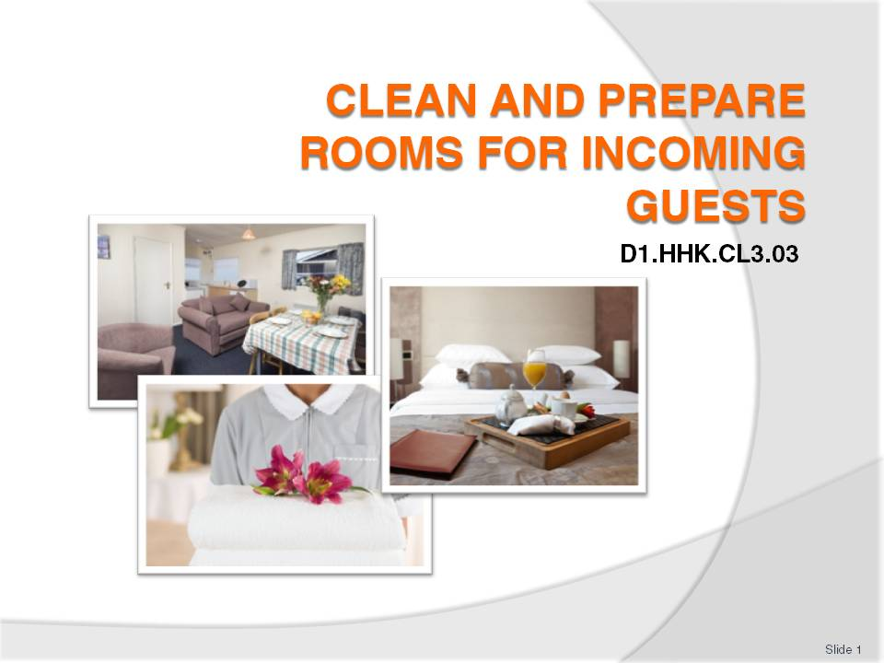
Slide No | Trainer Notes
 | Trainer welcomes trainees to class.

Slide
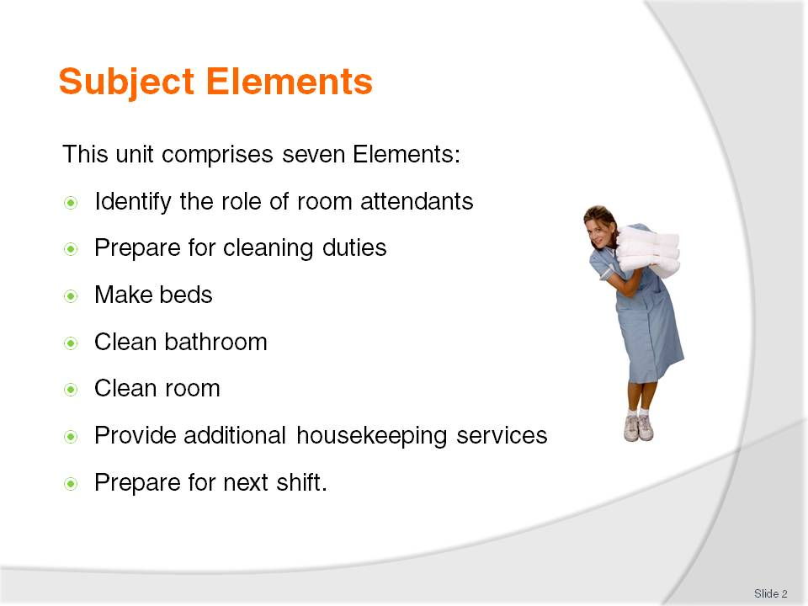
Slide No | Trainer Notes
Trainer advises this Unit comprises seven Elements, as listed on this slide explaining:
Each Element comprises a number of Performance Criteria which will be identified throughout the class and explained in detail
Trainees can obtain more detail from their Trainee Manual
At times the course presents advice and information about various protocols but where their workplace requirements differ to what is presented, the workplace practices and standards, as well as policies and procedures must be observed.

Slide
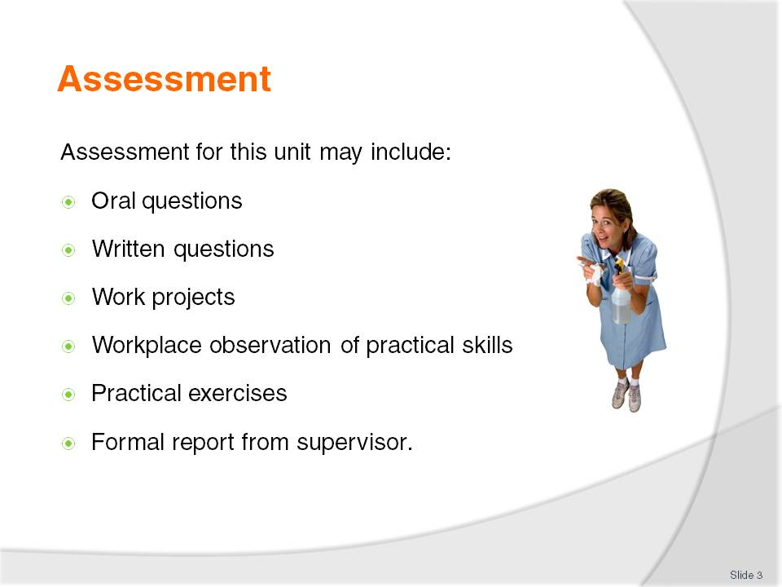
Slide No | Trainer Notes
Trainer advises that assessment for this Unit may take several forms all of which are aimed at verifying they have achieved competency for the Unit as required.
Trainer indicates the methods of assessment that will be applied to them for this Unit.

Slide
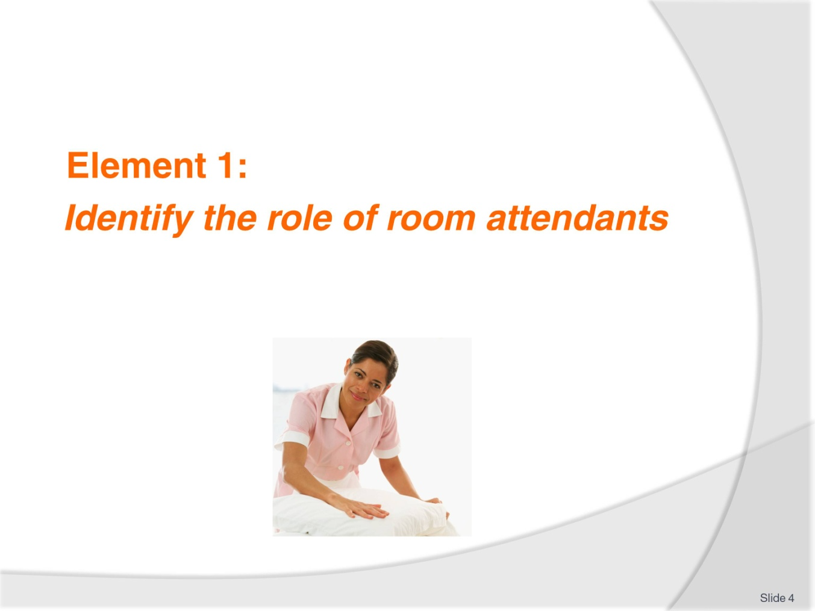
Slide No | Trainer Notes
Introduce topic.
Class Activity – General Discussion
Ask general questions:
What does a room attendant do?
Why is the role of a room attendant important in a hotel?

Slide
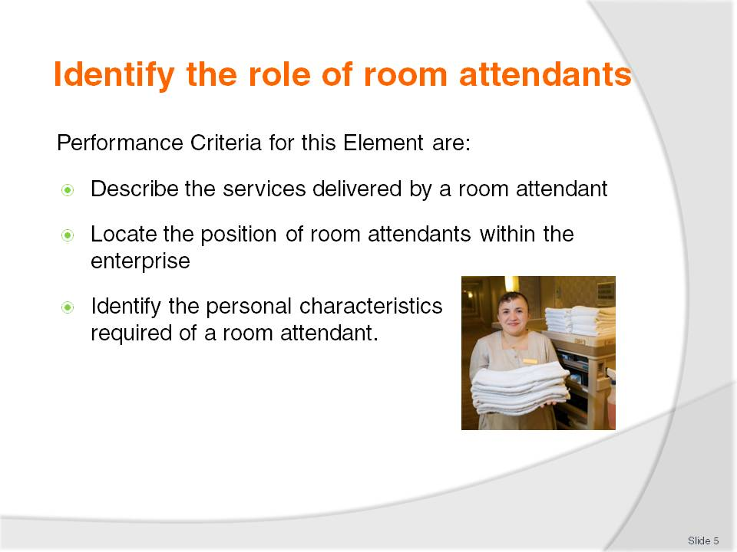
Slide No | Trainer Notes
 | Trainer identifies the Performance Criteria for this Element, as listed on the slide.

Slide
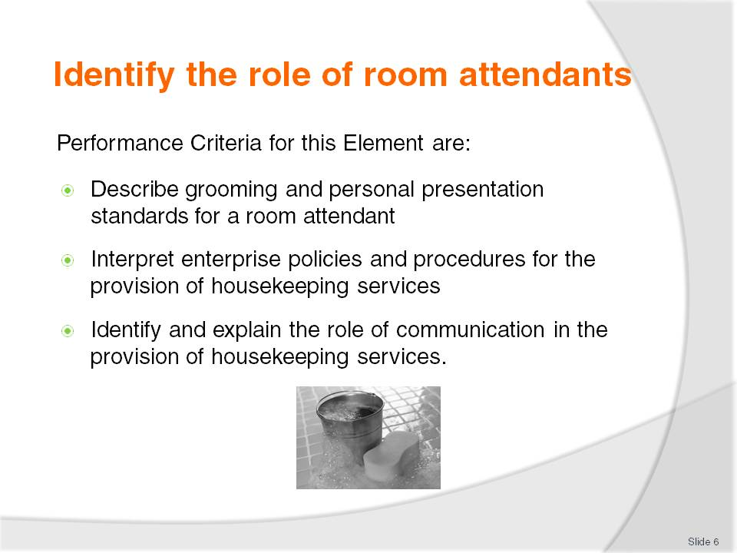
Slide No | Trainer Notes
 | Trainer identifies the Performance Criteria for this Element, as listed on the slide.

Slide
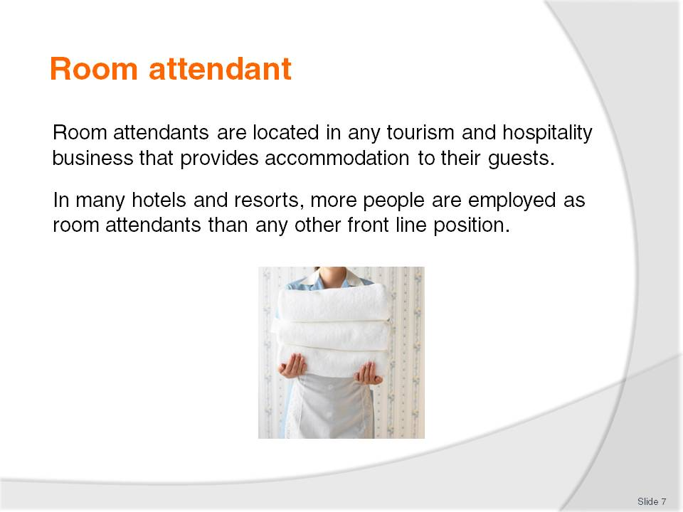
Slide No | Trainer Notes
Class Activity – General Discussion
Why are there more room attendants employed than in other positions within a hotel?

Slide
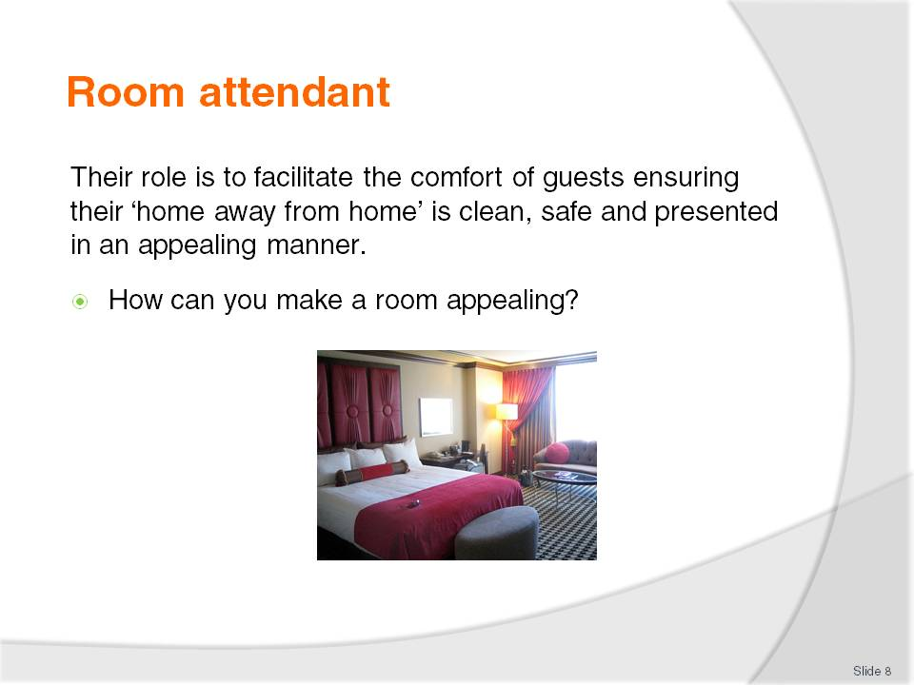
Slide No | Trainer Notes
Class Activity – General Discussion
How can you make a room appealing?

Slide
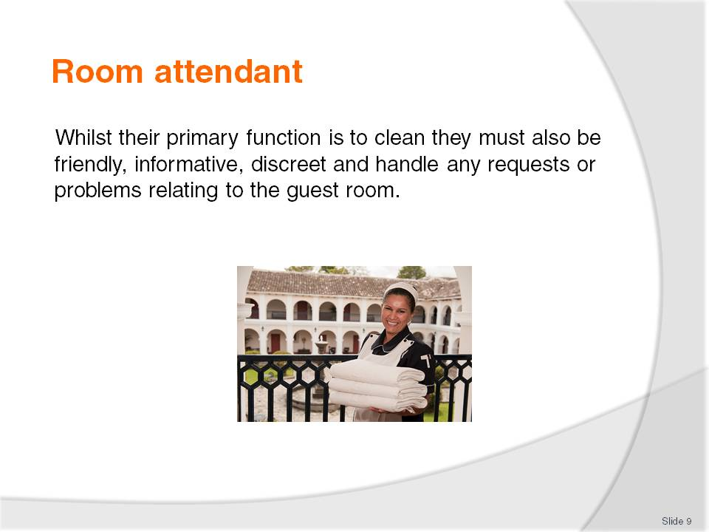
Slide No | Trainer Notes
Class Activity – General Discussion
How can a room attendant:
Be friendly?
Be informative – what information do they need to give the guest about the room?
Be discreet – what does this mean and how do they do it?
What are common requests?
What are common problems?

Slide
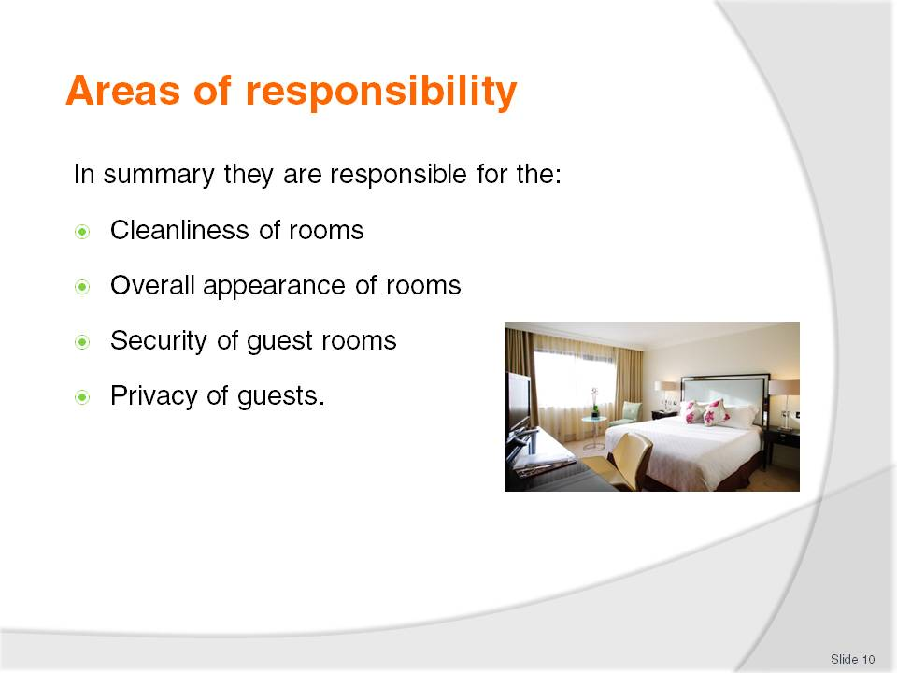
Slide No | Trainer Notes
Class Activity – General Discussion
How can a room attendant:
Make a room clean?
Improve the appearance of a room?
Improve the security of guests and their property in a room?
Ensure the privacy of guests and their actions?

Slide
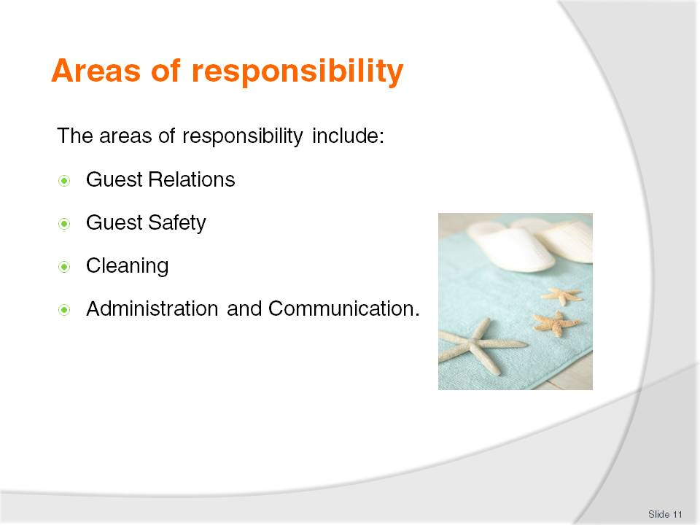
Slide No | Trainer Notes
Guest Relations
Every employee of a hotel, including the room attendant, is expected to warmly greet guests and to be friendly and professional.
In many cases they need to work independently from other colleagues and must handle any problems that arise, without the assistance or guidance of others.
If there is a complaint about the room or its furnishings or fixtures, in many cases the room attendant must not only handle to issue, but take ownership to ensure it is resolved in a timely manner.
Guest Safety
The job description of a room attendant includes ensuring the safety and well being of guests and their property.
Cleaning
They are required to ensure all aspects of a guest room are clean and tidy.
Administration and Communication
Room attendants must ensure they understand what rooms they are to clean and in which order. Administration and communication is vital to ensure rooms are returned ‘clean’ ready for new guests.

Slide
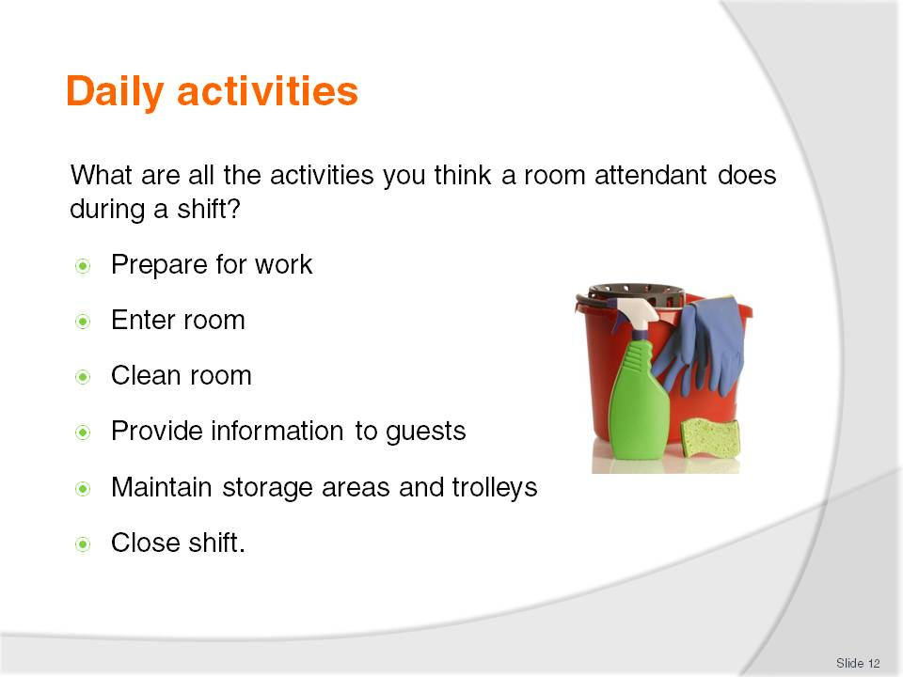
Slide No | Trainer Notes
Class Activity – Group work
The trainer should get the trainees into small groups.
Allocate one of the topics in this slide to each group.
Get them to identify all the activities that would be completed in a normal day.
Get the trainees to discuss or list on board.
This activity is designed to get people thinking about the diversity of the role of room attendant. Each of these topics will be discussed in more detail over the next few slides.

Slide
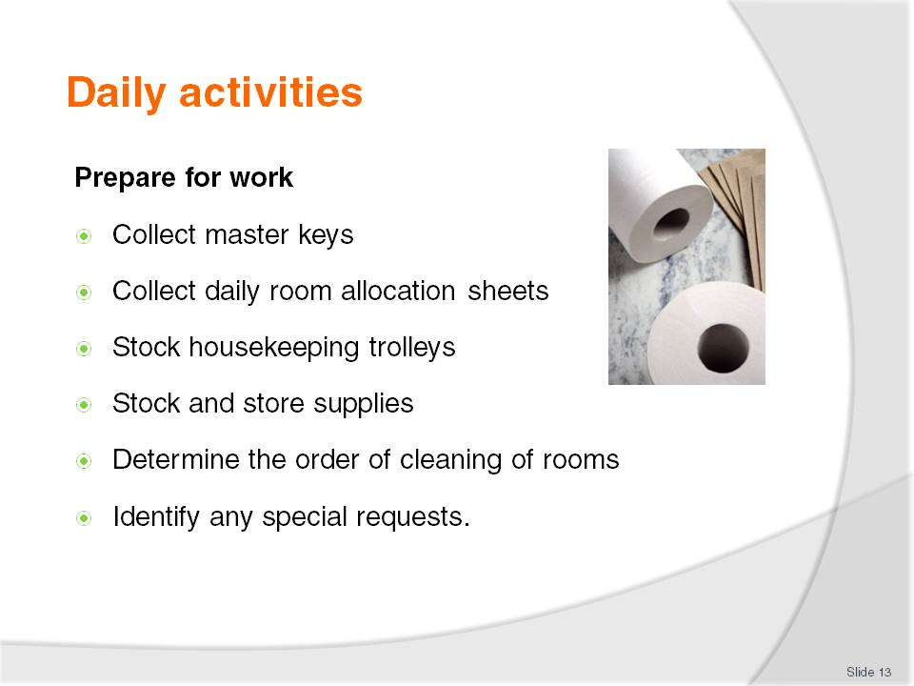
Slide No | Trainer Notes
Class Activity – General Discussion
Trainer to discuss topics in slide, providing examples where possible.

Slide
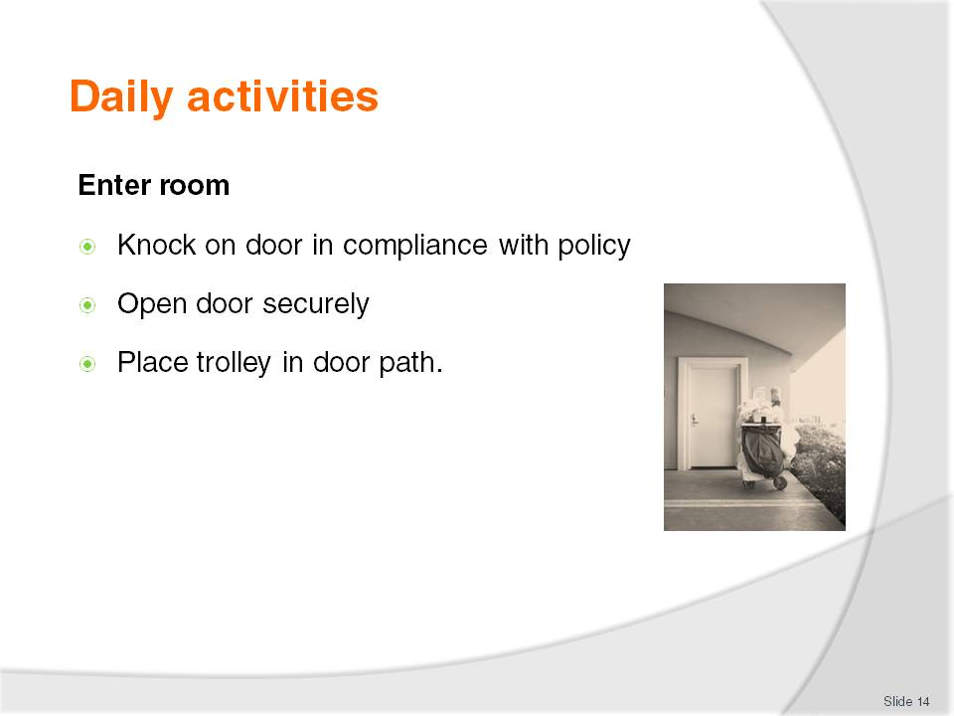
Slide No | Trainer Notes
Class Activity – General Discussion
Trainer to discuss topics in slide, providing examples where possible.

Slide
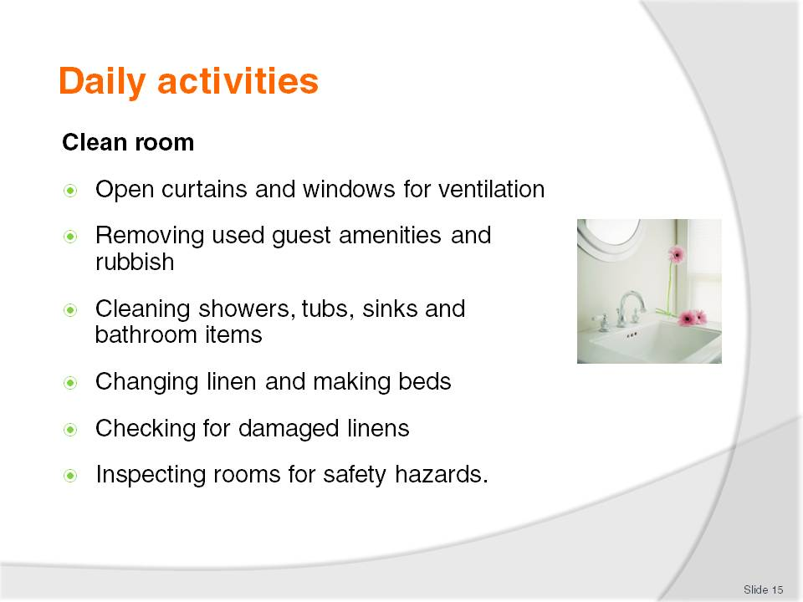
Slide No | Trainer Notes
Class Activity – General Discussion
Trainer to discuss topics in slide, providing examples where possible.

Slide
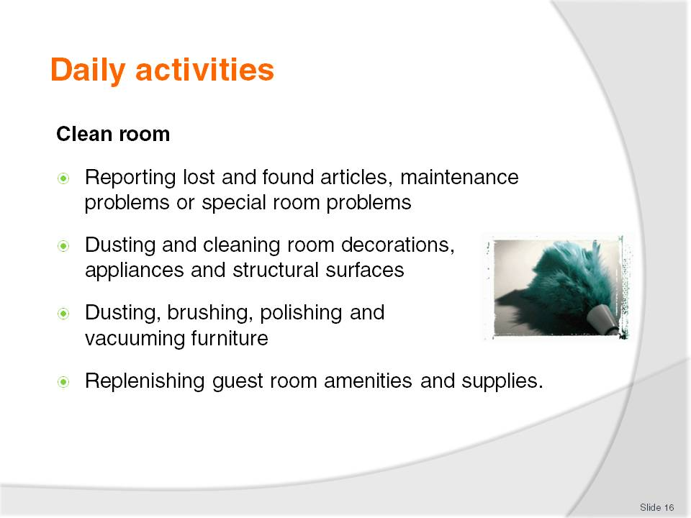
Slide No | Trainer Notes
Class Activity – General Discussion
Trainer to discuss topics in slide, providing examples where possible.

Slide
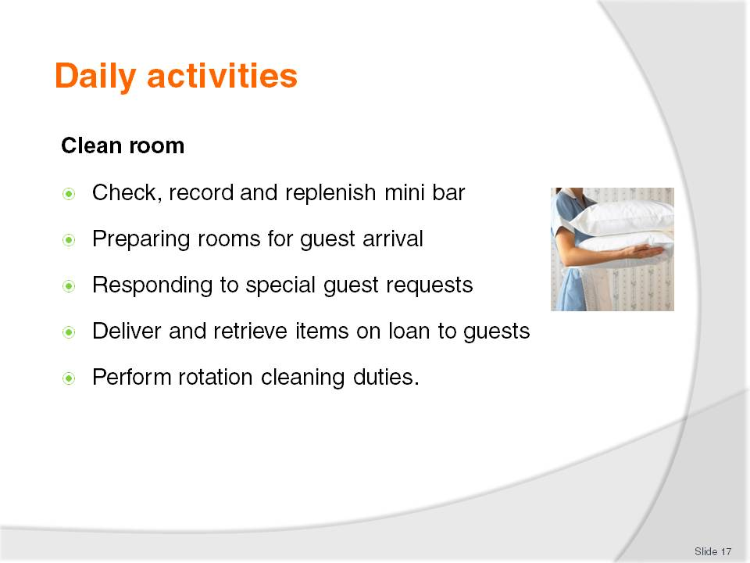
Slide No | Trainer Notes
Class Activity – General Discussion
Trainer to discuss topics in slide, providing examples where possible.

Slide
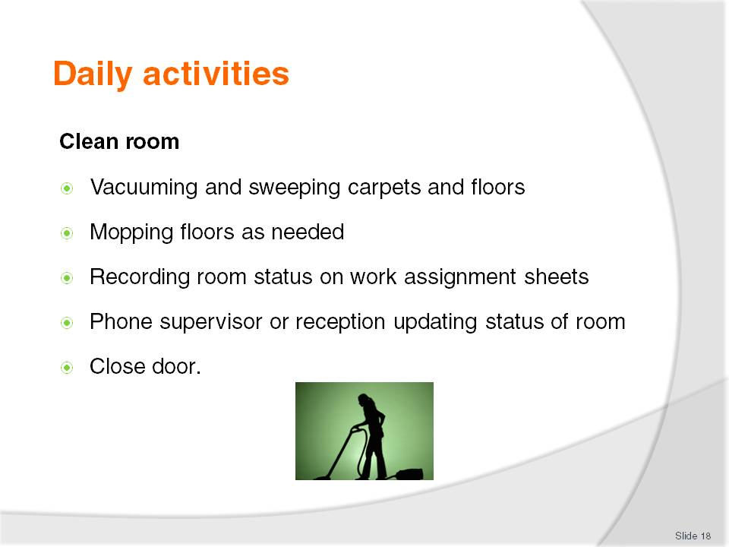
Slide No | Trainer Notes
Class Activity – General Discussion
Trainer to discuss topics in slide, providing examples where possible.

Slide
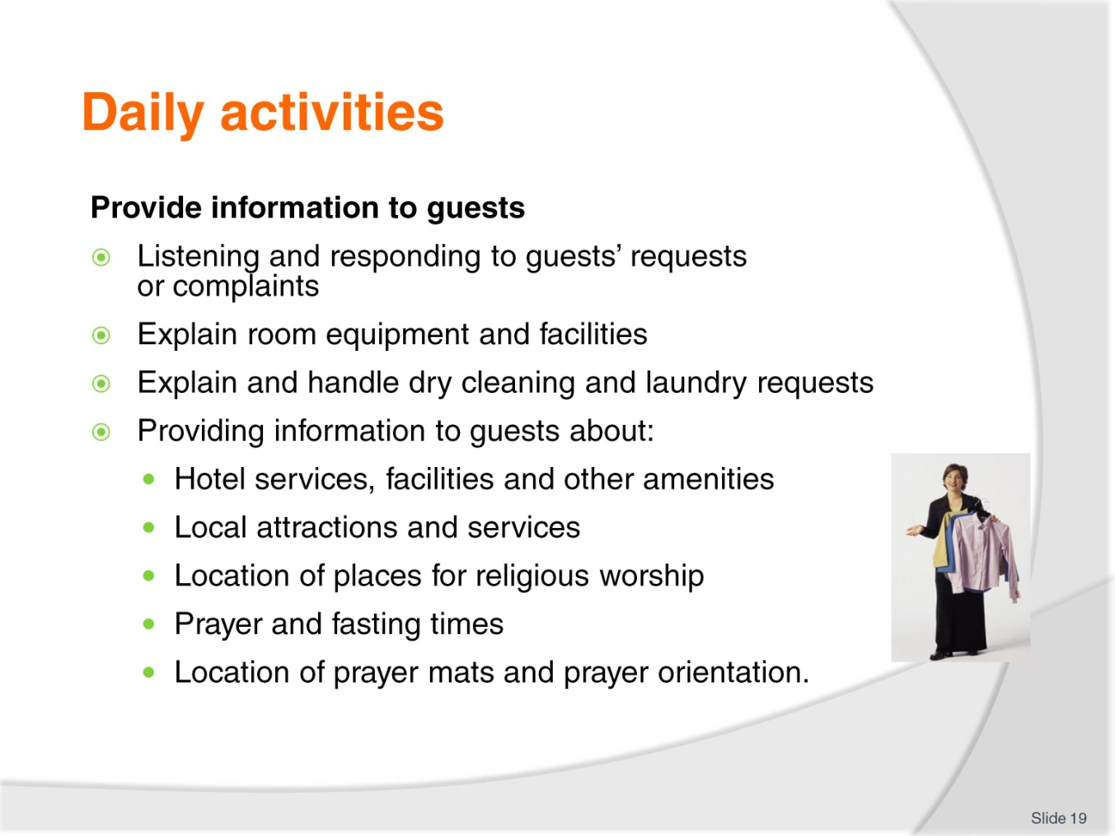
Slide No | Trainer Notes
Class Activity – General Discussion
Trainer to discuss topics in slide, providing examples where possible.

Slide
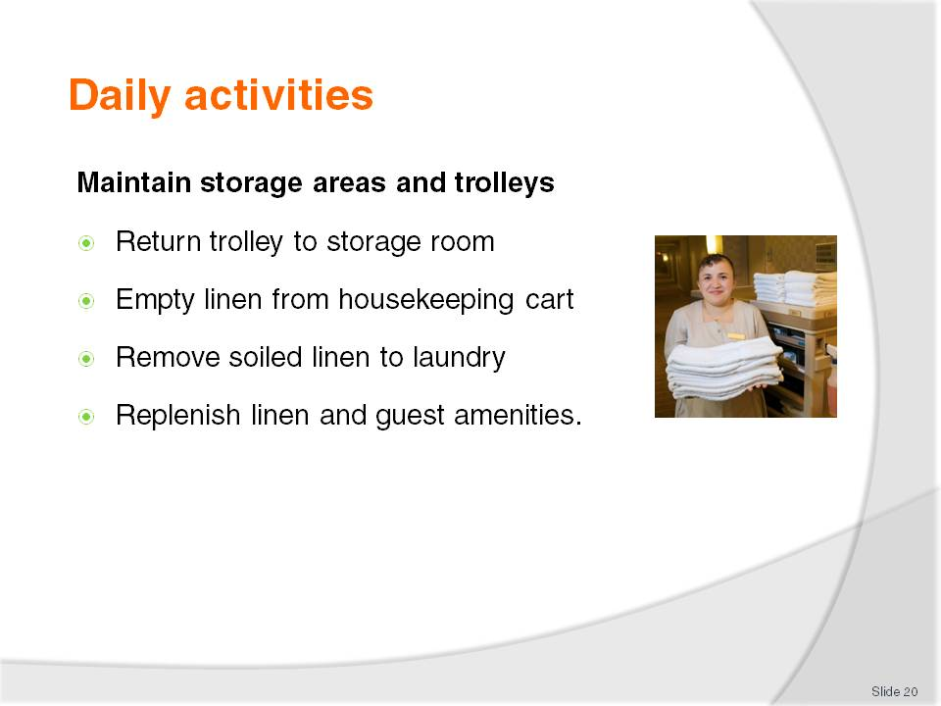
Slide No | Trainer Notes
Class Activity – General Discussion
Trainer to discuss topics in slide, providing examples where possible.

Slide
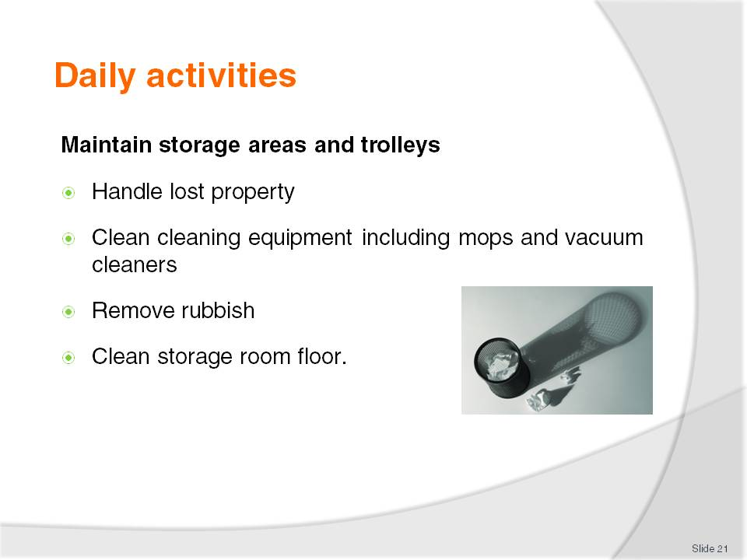
Slide No | Trainer Notes
Class Activity – General Discussion
Trainer to discuss topics in slide, providing examples where possible.

Slide
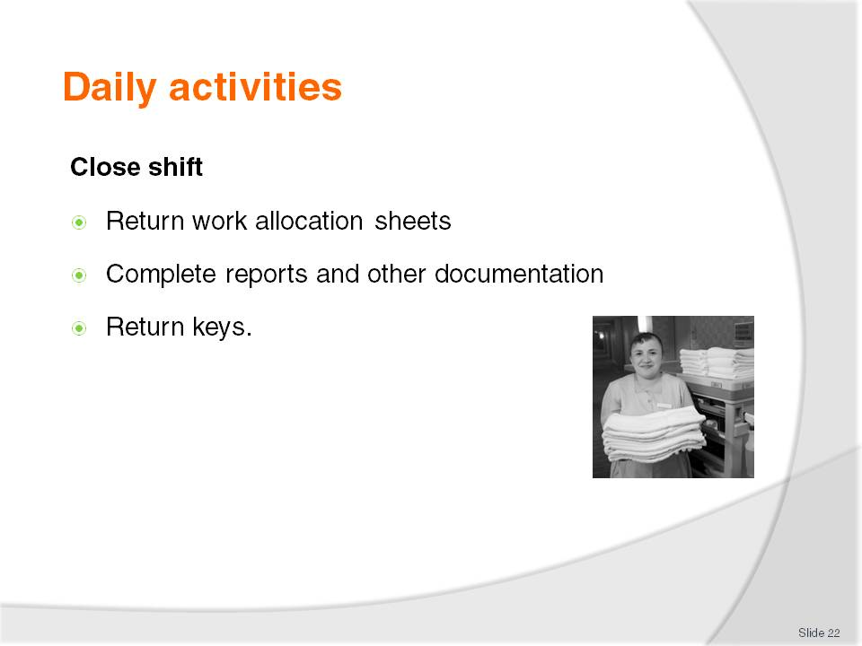
Slide No | Trainer Notes
Class Activity – General Discussion
Trainer to discuss topics in slide, providing examples where possible.

Slide
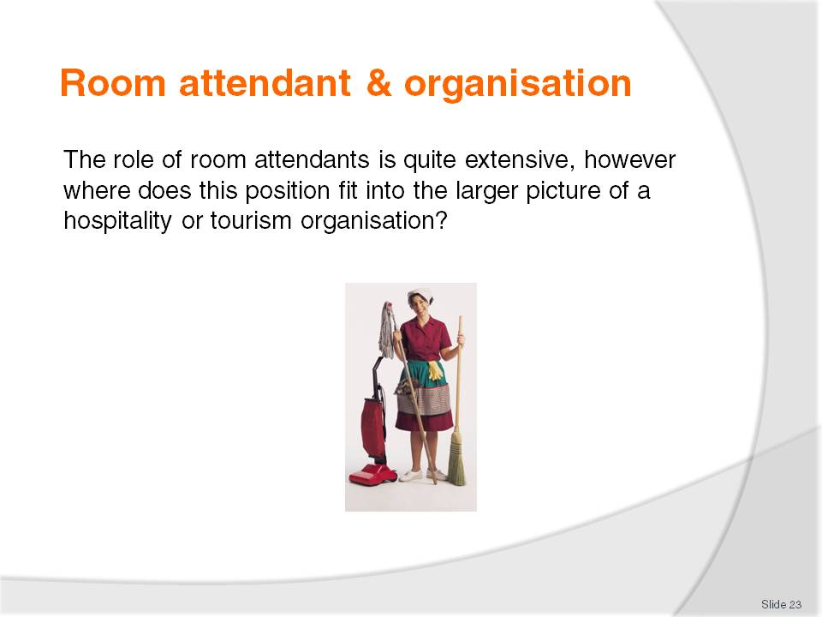
Slide No | Trainer Notes
Class Activity – General Discussion
Where does a room attendant work in a hotel?
Who is their manager?
Who are their colleagues?
Are they managers of anyone?

Slide
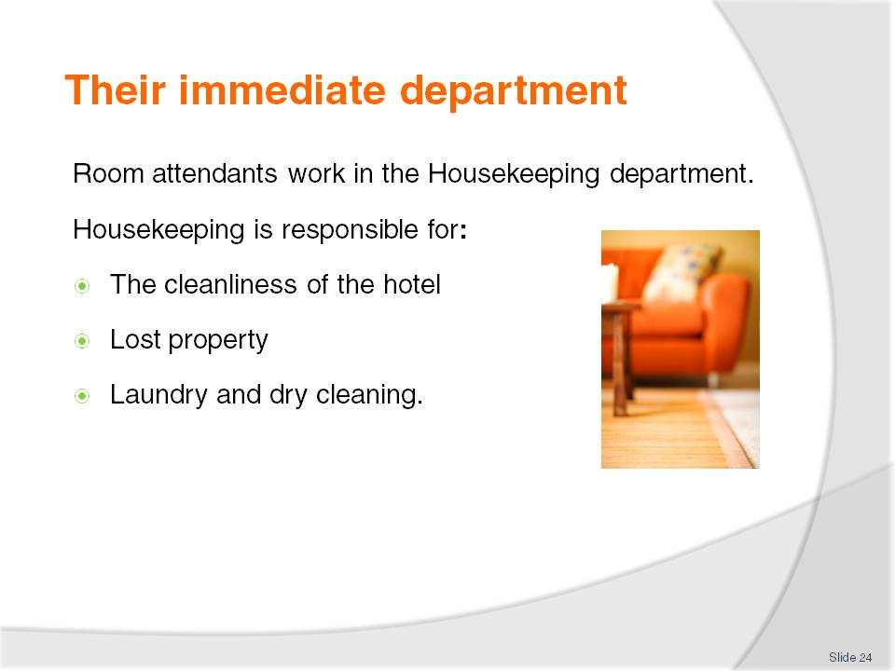
Slide No | Trainer Notes
Class Activity – General Discussion
What are all the activities housekeeping perform under these three categories?

Slide
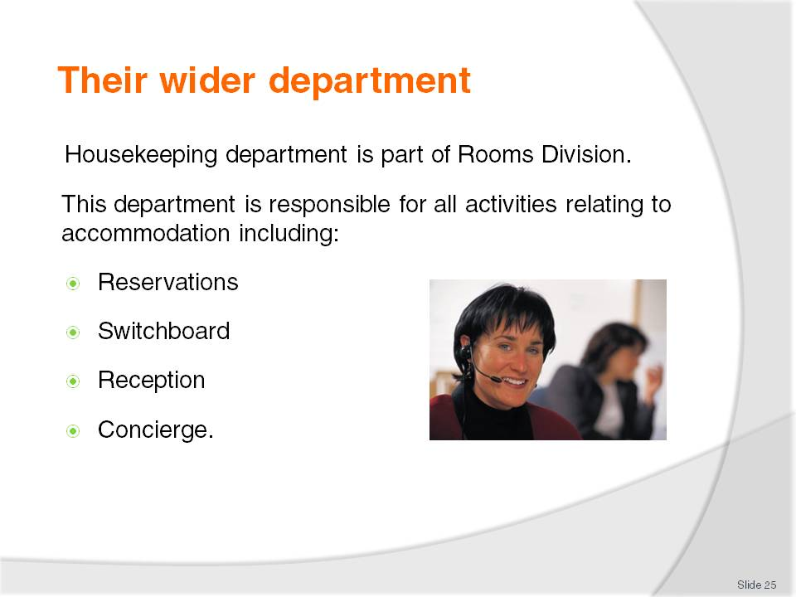
Slide No | Trainer Notes
Class Activity – General Discussion
What are all the activities perform under these categories?

Slide
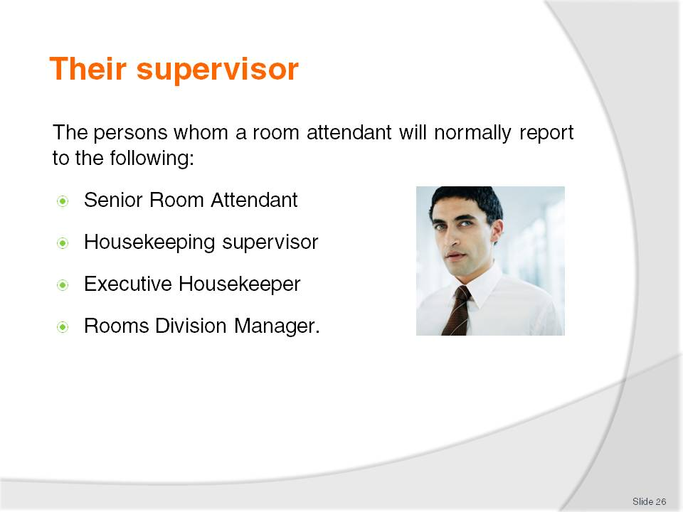
Slide No | Trainer Notes
Class Activity – General Discussion
What does each of these people do?
A senior room attendant or Housekeeping supervisor - This person is normally responsible for the allocation of rooms and to check rooms up on completion of cleaning by room attendants.
The head of Housekeeping is called the Executive Housekeeper – responsible for Housekeeping department. This person will report to the Rooms Division Manager – responsible for Front Office and Housekeeping departments.

Slide
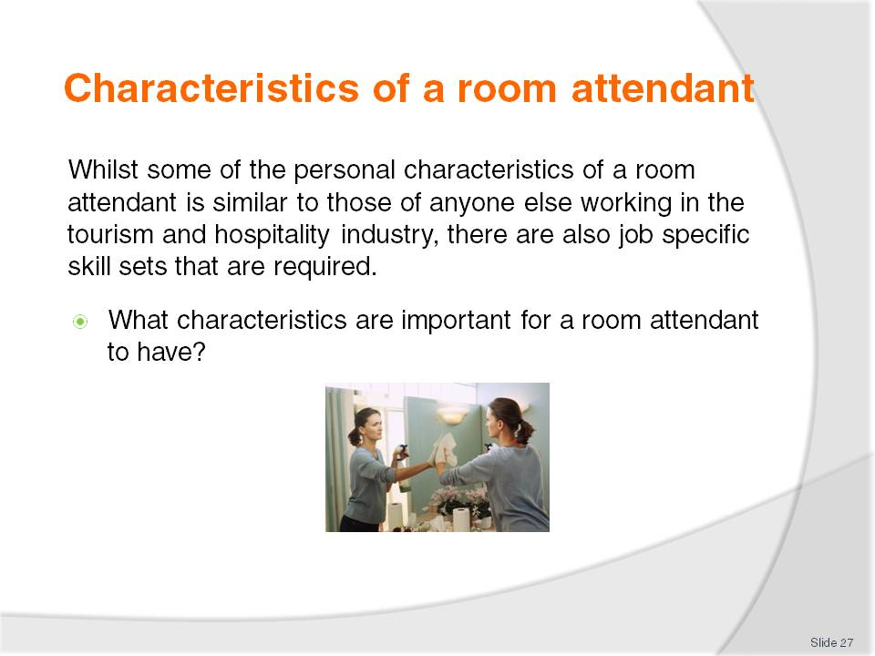
Slide No | Trainer Notes
Class Activity – General Discussion
What characteristics are important for a room attendant to have?

Slide
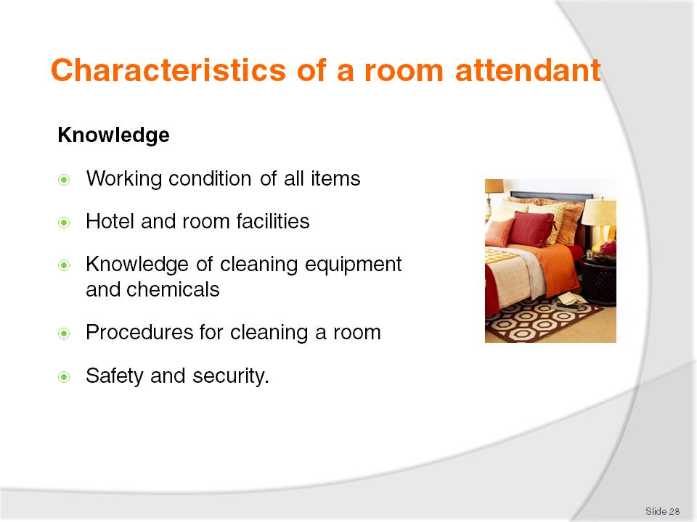
Slide No | Trainer Notes
Class Activity – General Discussion
What information do they need to know about the hotel?
What information do they need to know about the hotel?
What cleaning products do they use?

Slide
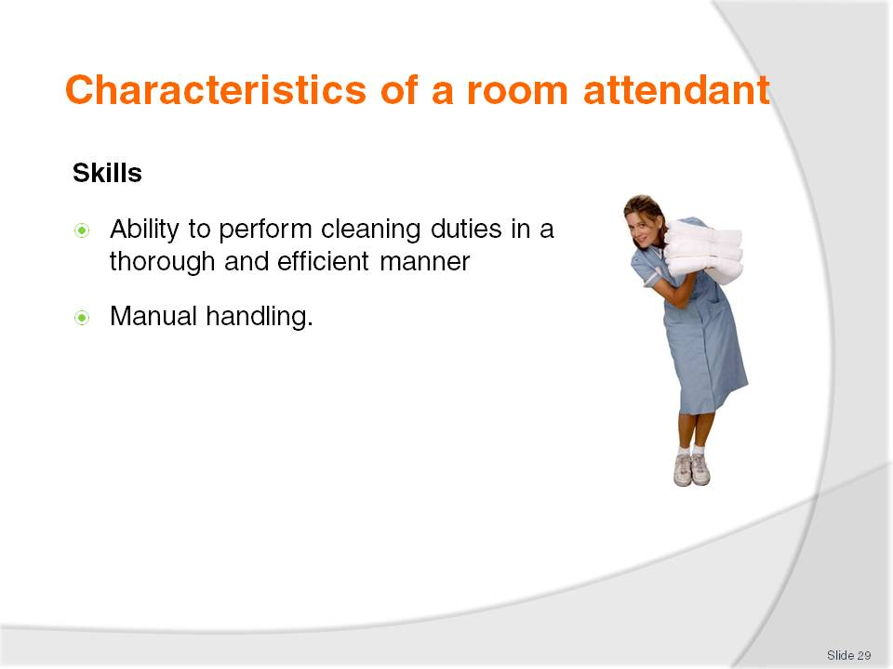
Slide No | Trainer Notes
Class Activity – General Discussion
What is manual handling?

Slide
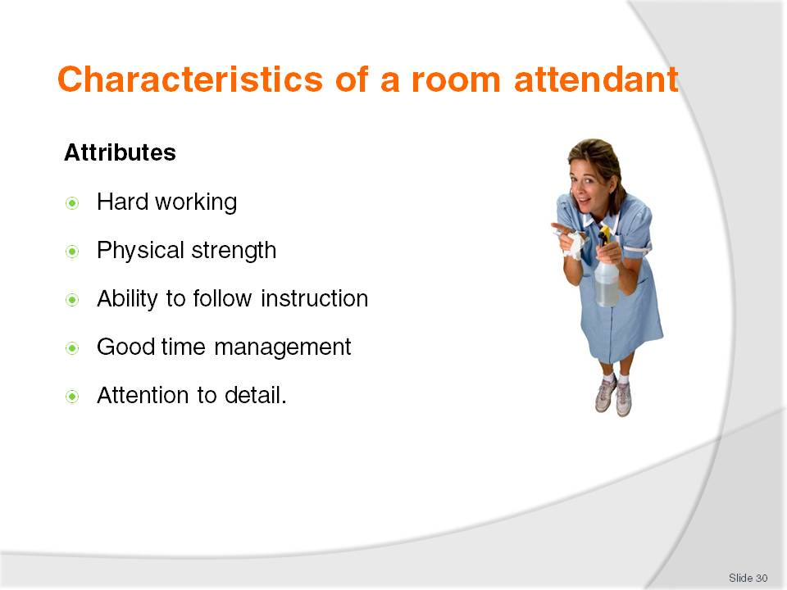
Slide No | Trainer Notes
Class Activity – General Discussion
Hard working
Physical strength - mobility and stamina required to clean for large periods of time
Ability to follow instruction – most activities follow strict procedures
Good time management – most room attendants will need to clean approximately 12-20 rooms per shift, with no supervision
Attention to detail – ability to ensure cleaning is performed to an extremely high standard.

Slide
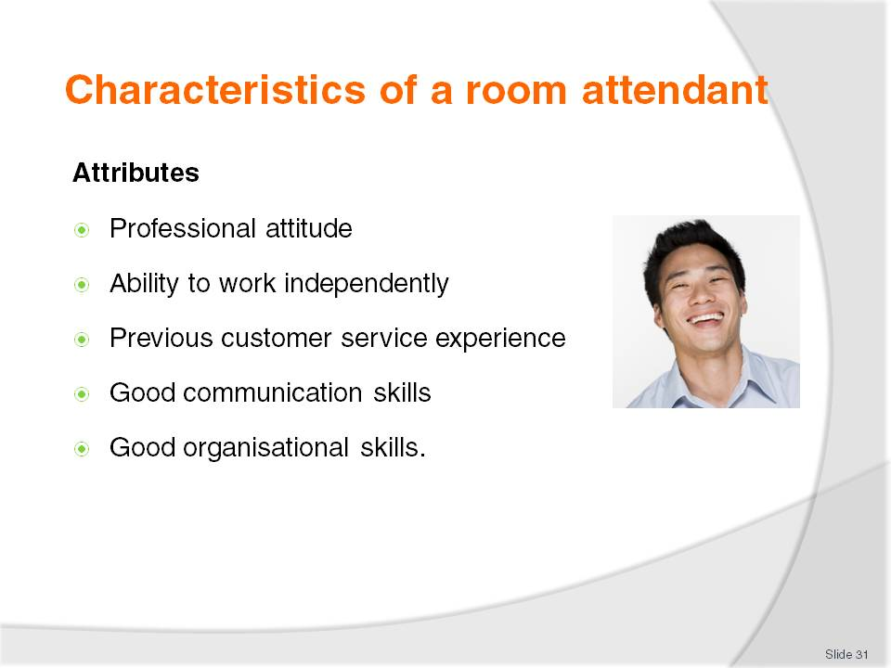
Slide No | Trainer Notes
Class Activity – General Discussion
Why are organisational skills important?
The trainer may want to mention organisational skills are vital because room attendants work by themselves, in remote locations and under strict timeframes.

Slide
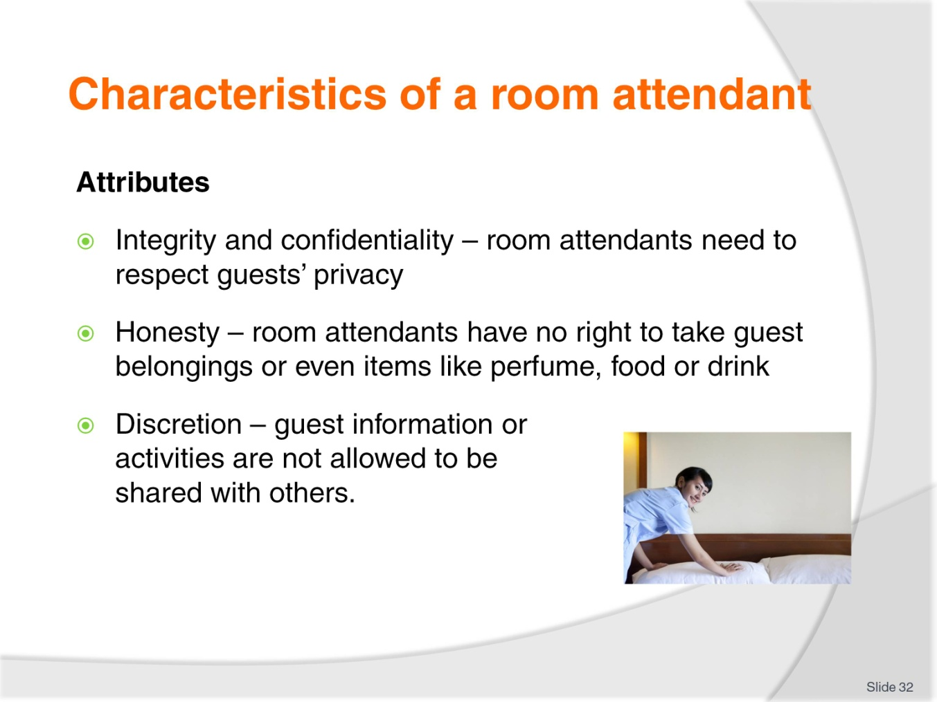
Slide No | Trainer Notes
Class Activity – General Discussion
Discuss in pairs:
- What are some of the ‘temptations’ a room attendant needs to resist when he/she has access to a guest’s room?
- Should a room attendant share information with others about a guest if he/she thinks what the guest is doing is morally wrong?
- In what instances can a room attendant report to management on a guest’s activities in their room?

Slide
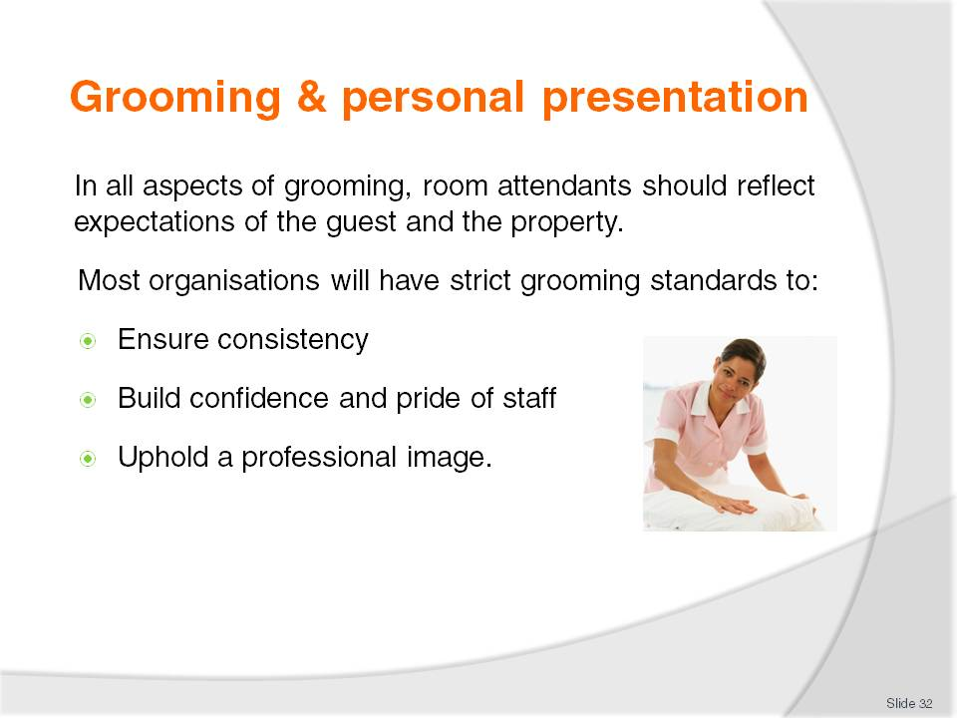
Slide No | Trainer Notes
Class Activity – General Discussion
Why are having grooming standards important?
What are common grooming standards?
Why is it harder to maintain grooming standards as a room attendant compared with other jobs?
How can you combat this?

Slide
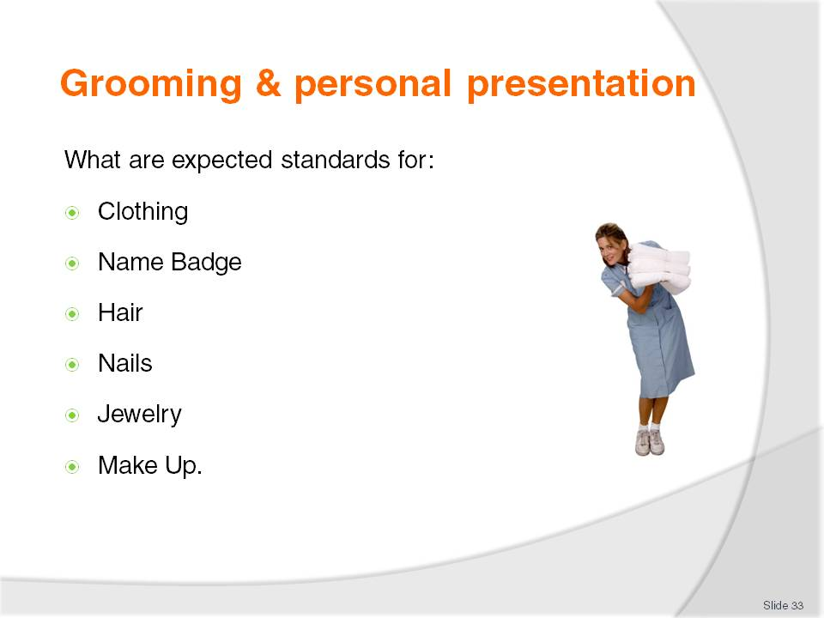
Slide No | Trainer Notes
Clothing
All clothes should be:
Clean at the start of each day
Replaced if soiled to a unsuitable standard
Worn in its correct manner
Shoes to be suitable for the role.
Name Badge
A staff member must wear their name badge at all times
This is normally in a particular position on each staff member.
Hair
Short and neat cut hair for men
Tight or pulled back hair for women
Natural hair colour
Men to have well trimmed facial hair or to be clean shaved.
Nails
Short and well trimmed
No bright nail polish
Cleaned on a regular basis.
Jewellery
One dress ring or wedding ring
Suitable watches
No other jewellery including bracelets, earrings, nose rings or necklaces.
Make up
No excessive make up
No visible tattoos.

Slide
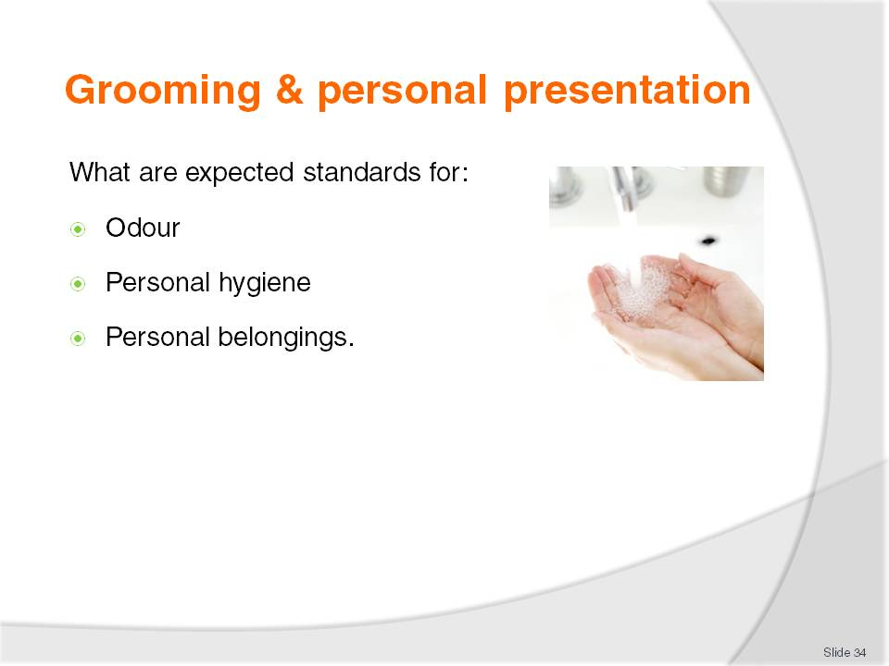
Slide No | Trainer Notes
Odour
No excessive perfumes
Staff should use deodorant on a regular basis. This is important in a labour intensive role like cleaning rooms.
Personal hygiene
Bath or shower before work
Teeth must be brushed
Hands and face must be washed and cleaned.
Personal belongings
No personal bags in work areas – to reduce chance of theft
No mobile phones.

Slide
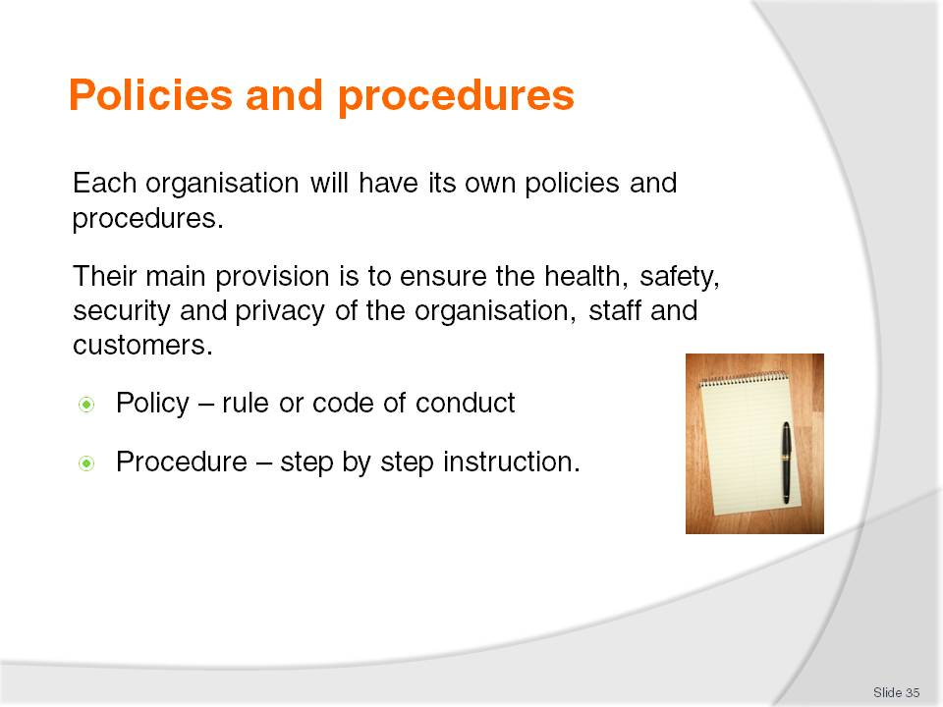
Slide No | Trainer Notes
Class Activity – General Discussion
What are common policies and procedures in any work place regardless of position?
What are common policies and procedures specific to room attendants?

Slide
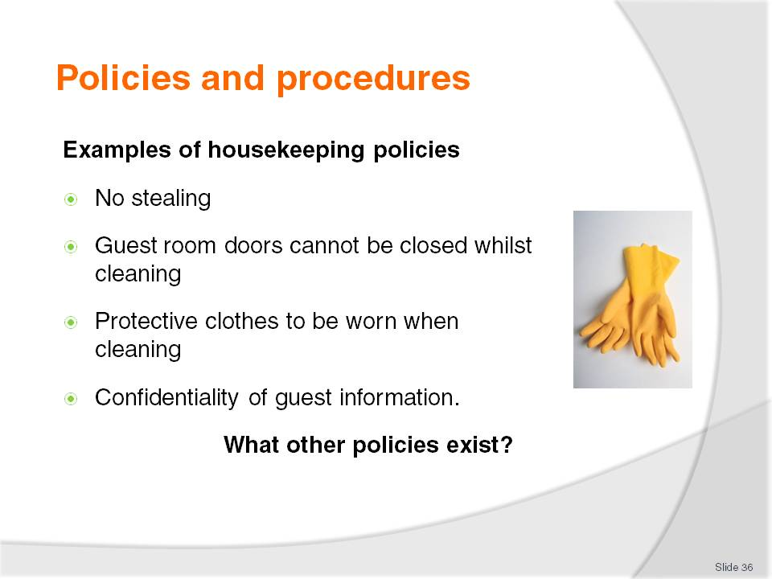
Slide No | Trainer Notes
Class Activity – General Discussion
Get the trainees to think of other policies that are directly related to room attendants.

Slide
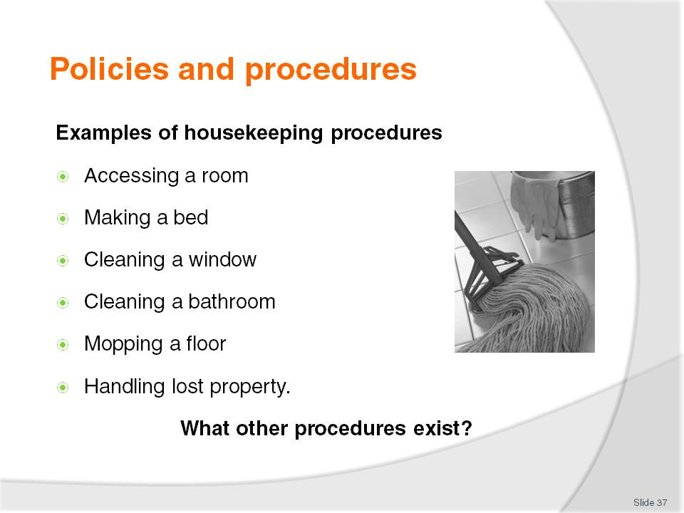
Slide No | Trainer Notes
Class Activity – General Discussion
Get the trainees to think of other procedures that are directly related to room attendants.

Slide
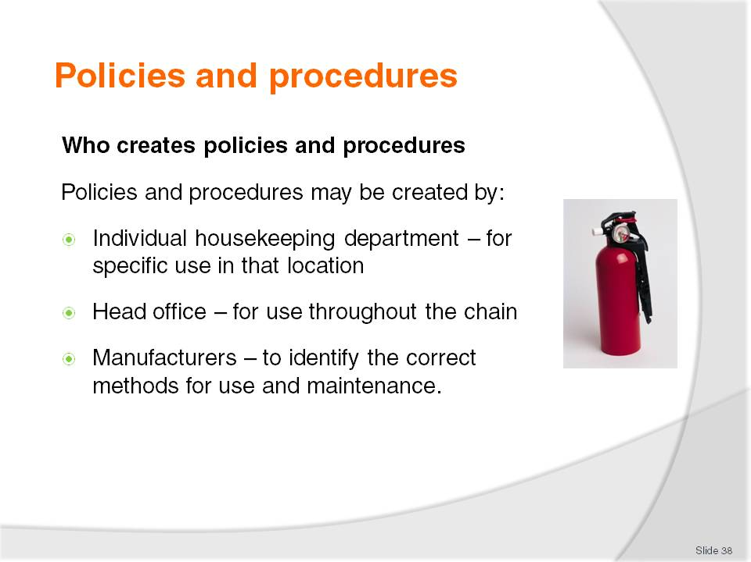
Slide No | Trainer Notes
Class Activity – General Discussion
Get the trainees to identify different policies and procedures that would come from each area identified in the slide.

Slide
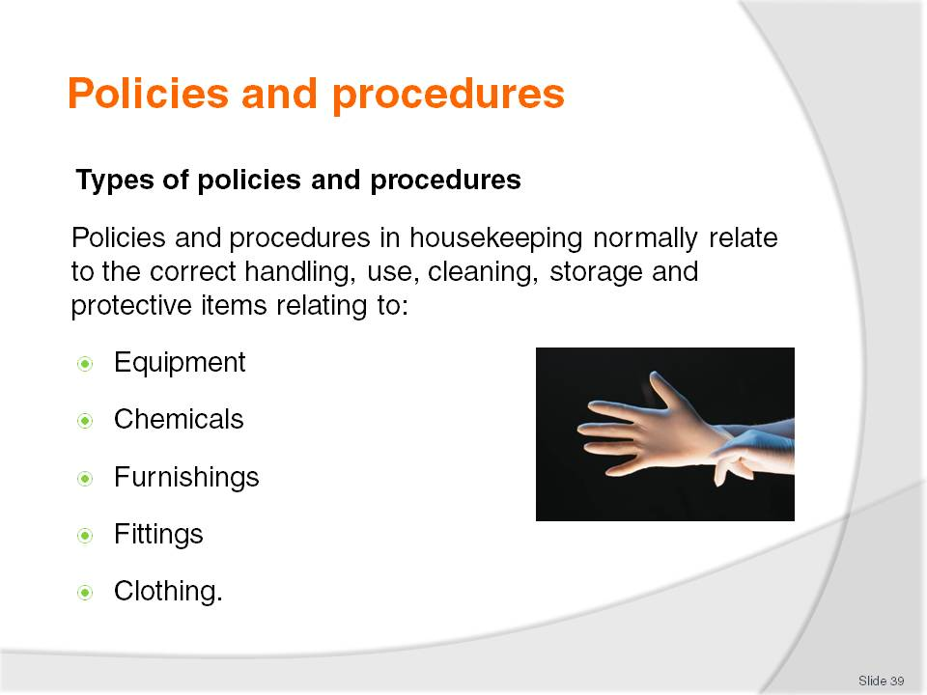
Slide No | Trainer Notes
Types of policies and procedures
Policies and procedures in housekeeping normally relate to the correct handling, use, cleaning, storage and protective items relating to:
Equipment – housekeeping cleaning equipment including vacuum cleaners, waxing machines, trolleys
Chemicals – including all cleaning products and items used to clean including cloths, rags, mops
Furnishings – bedding, tables, couches, kitchens, televisions, carpets
Fittings – lights, electricals, air conditioners
Clothing – uniforms and protective clothing.

Slide
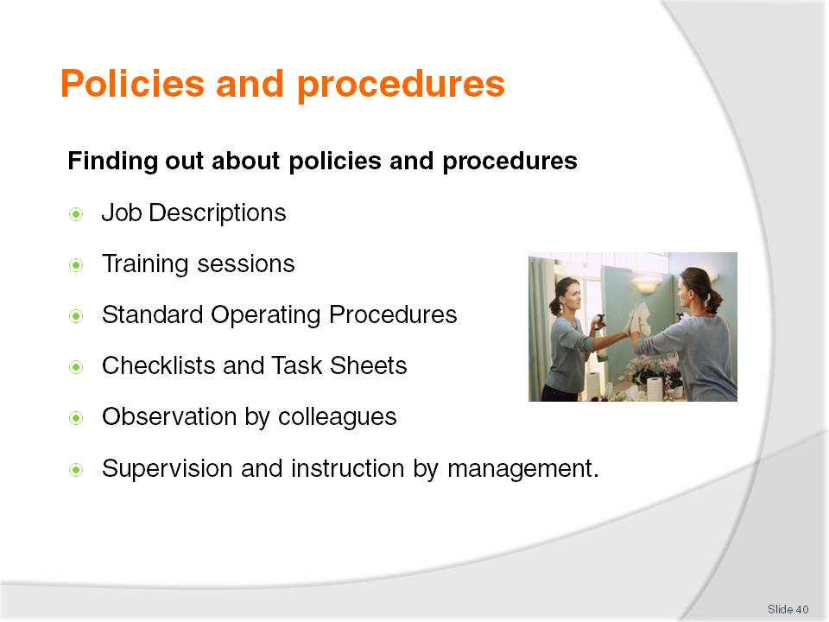
Slide No | Trainer Notes
Class Activity – General Discussion
In your point of view, what is the best way to ensure staff know and understand policies and procedures?

Slide
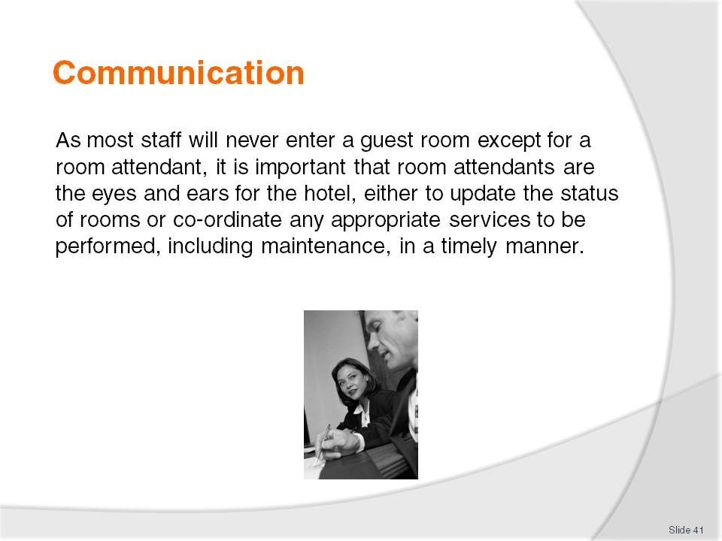
Slide No | Trainer Notes
Class Activity – General Discussion
What types of information are communicated by room attendants?
Who do they communicate with?

Slide
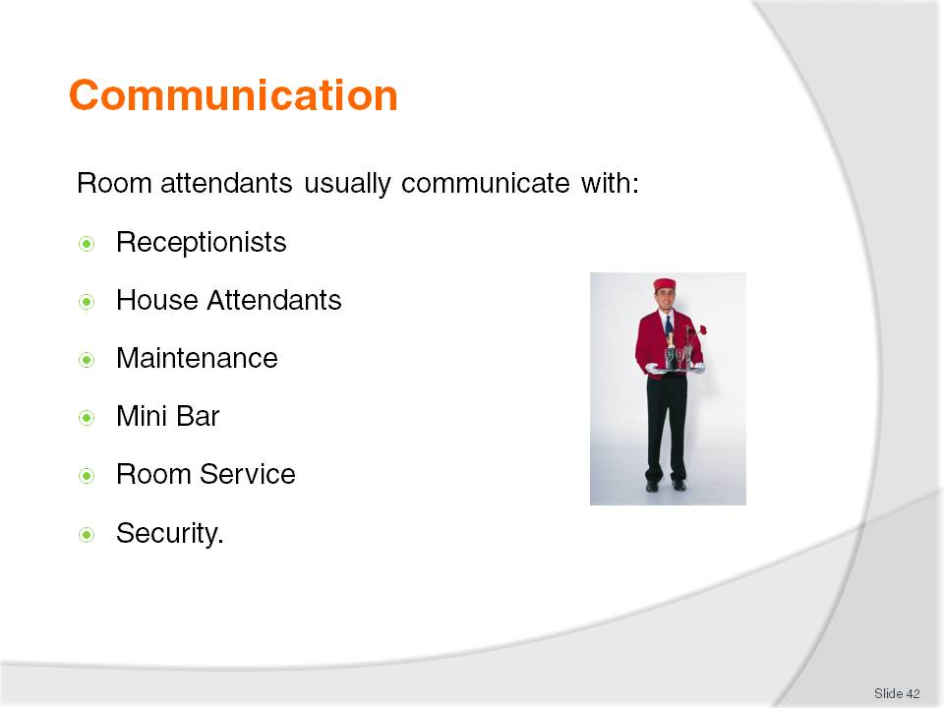
Slide No | Trainer Notes
Class Activity – General Discussion
For each of these positions what information is communicated?
Receptionists
Room attendants work closely with reception for a number of reasons including:
Identify vacant rooms - to find out when guests have checked out so they can start cleaning vacant dirty rooms
Report clean rooms - when rooms are clean and ready for new guests
Handle special requirements - for incoming guests including VIP’s
Handle guest requests - relating to the room including additional towels and pillows, buckets of ice and for laundry to collected
Co-ordinate internet access.
House Attendants
These people will normally be responsible for the distribution of items to/from the housekeeping office to the store rooms on each floor, for easier access by room attendants.
These items include:
Cleaning products - sprays, agents and cleaning clothes
Equipment – buckets and mops
Linen – bed sheets, pillow cases, blankets, bath towels, floor mats, hand towels and face cloths
Room supplies – including shampoo, conditioners, stationery, matches, soaps etc
Fresh produce – milk and biscuits for tea and coffee facilities
Removal of dirty items – soiled bedding and rubbish
Collection of return of laundry or dry cleaning
As a room attendant will normally be stationed on a selected floor, they will communicate with house attendants if items need to be replenished.
Maintenance
Room attendants will often call maintenance to fix or replace light bulbs and any faulty furnishings or equipment. In most cases any calls will be made relating to faulty televisions and air conditions.
Mini Bar
In some organisations, the room attendant may be responsible for replenishing mini bar items and charging them to the guest rooms themselves or may contact mini bar for this service to be performed.
Room Service
When cleaning rooms, room attendants will remove used room service trays which must be placed out of guest sight and placed in the appropriate storage area on each guest floor. They will communicate with room service for the trays to be collected from the storage areas.
Security
With room attendants spending the majority of their shift working on guest floors, it is their responsibility to observe activities that take place around them. They must constantly listen and watch to ensure guest activities are conducted in a safe and secure manner. If there are any issues which they cannot resolve, security must be contacted quickly.

Slide
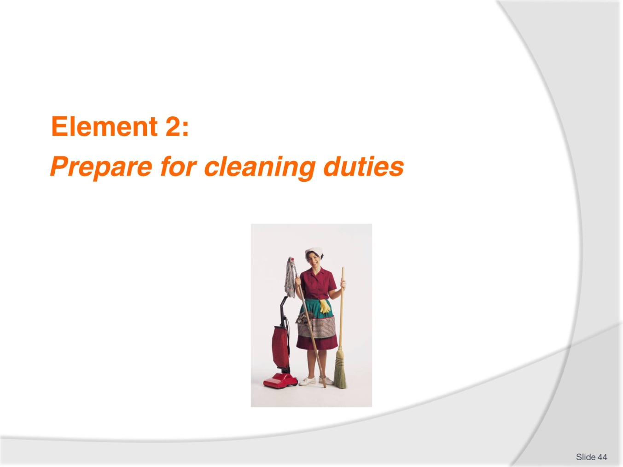
Slide No | Trainer Notes
Introduce topic.
Class Activity – General Discussion
Ask general questions:
What cleaning duties are performed?
What preparation do they need to do before they can start cleaning?

Slide
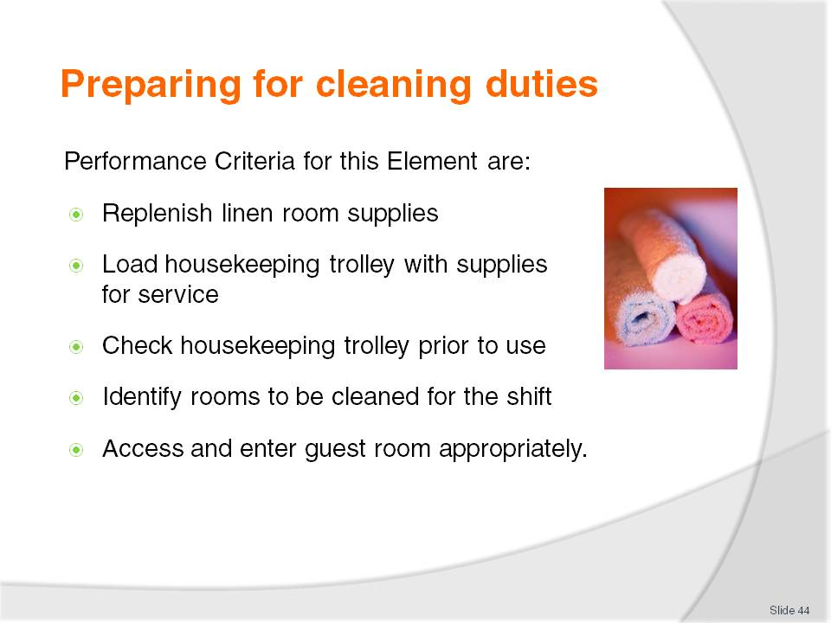
Slide No | Trainer Notes
 | Trainer identifies the Performance Criteria for this Element, as listed on the slide.

Slide
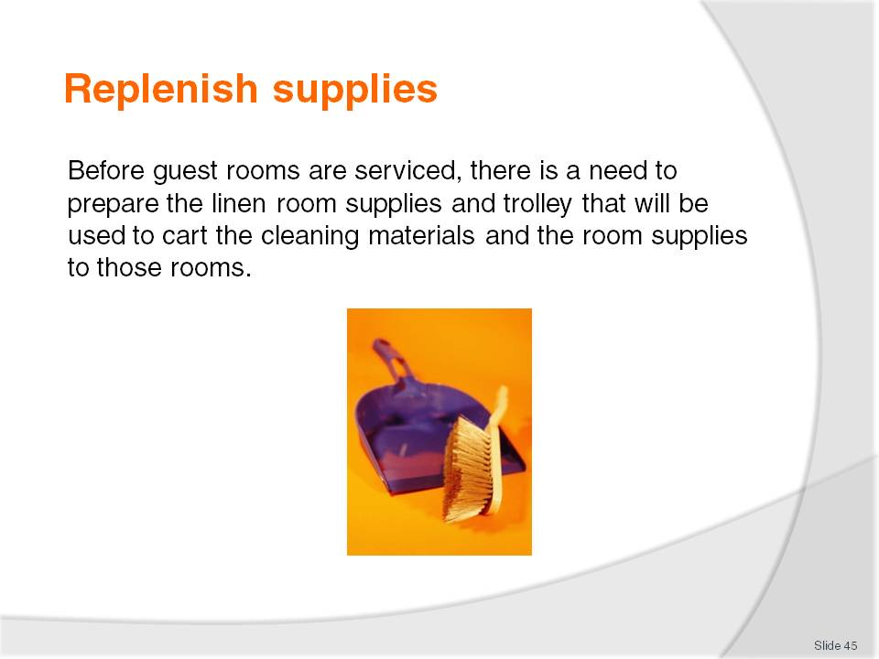
Slide No | Trainer Notes
Class Activity – General Discussion
What items need to be replenished?
For each item: Where do they go – in a linen store or straight on a trolley?

Slide
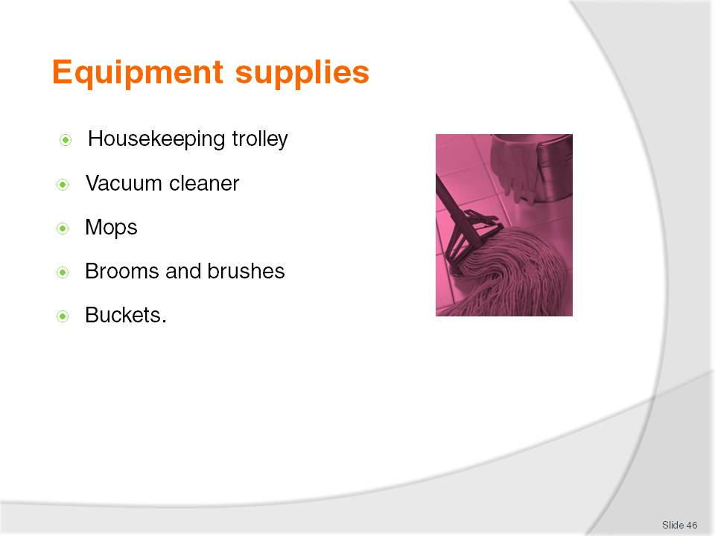
Slide No | Trainer Notes
Class Activity – General Discussion
What is the purpose of each piece of equipment identified in this slide?
When preparing the equipment what would you need to do?

Slide
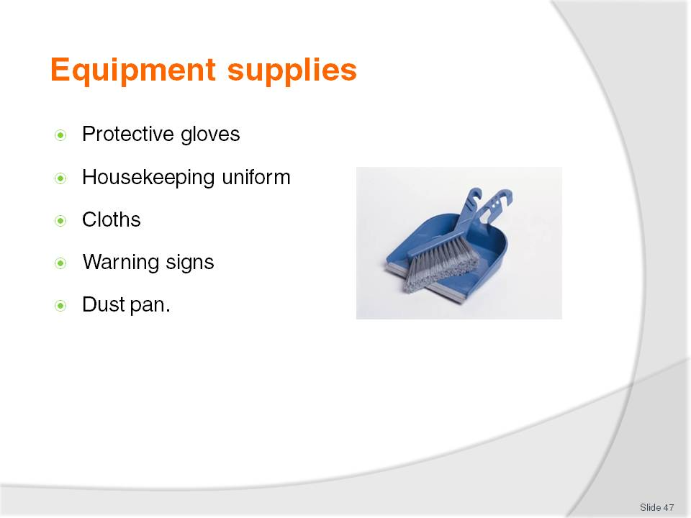
Slide No | Trainer Notes
Class Activity – General Discussion
What is the purpose of each piece of equipment identified in this slide?
When preparing the equipment what would you need to do?

Slide
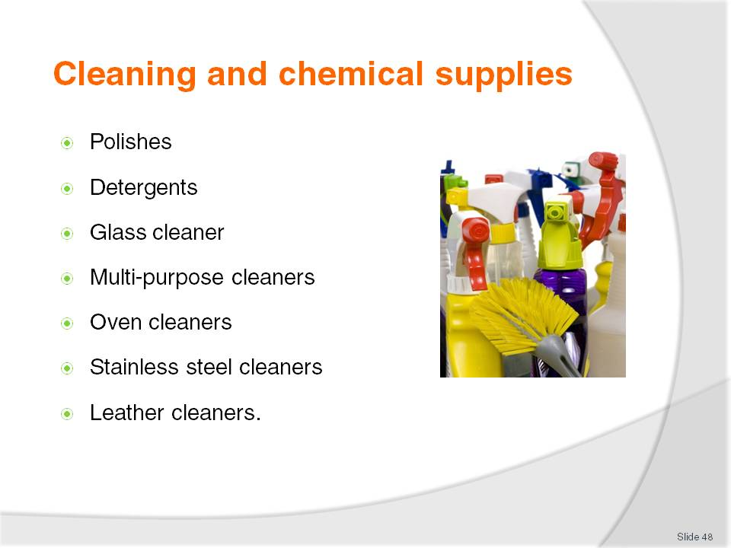
Slide No | Trainer Notes
Class Activity – General Discussion
What is the purpose of each of the cleaning supplies identified in this slide?

Slide
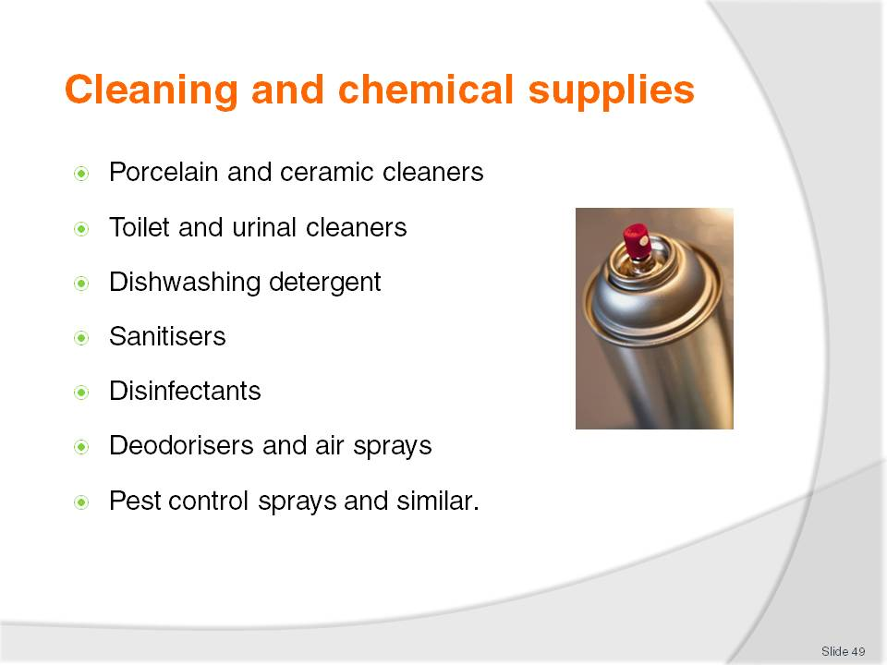
Slide No | Trainer Notes
Class Activity – General Discussion
What is the purpose of each of the cleaning supplies identified in this slide?

Slide
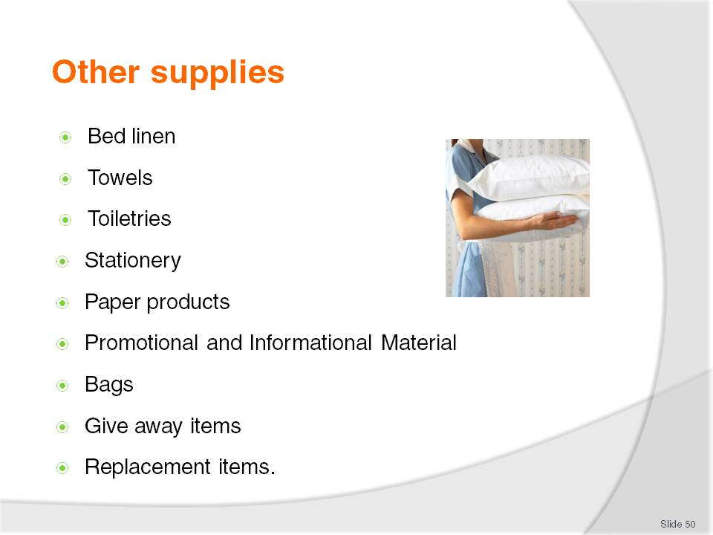
Slide No | Trainer Notes
Class Activity – Group work
The trainer arranges the trainees into small groups.
Allocate one of the topics in this slide to each group.
Get them to identify all the supplies that would be allocated to each section.
Get the trainees to discuss or list on board.

Slide
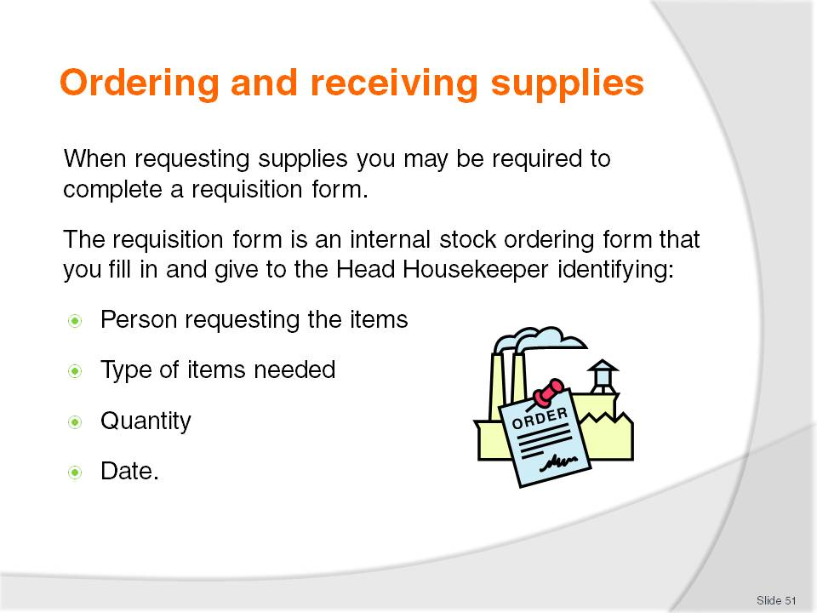
Slide No | Trainer Notes
Class Activity – Review documents
The trainer should get a copy of a ordering or requisitioning document and explain it to the class.

Slide
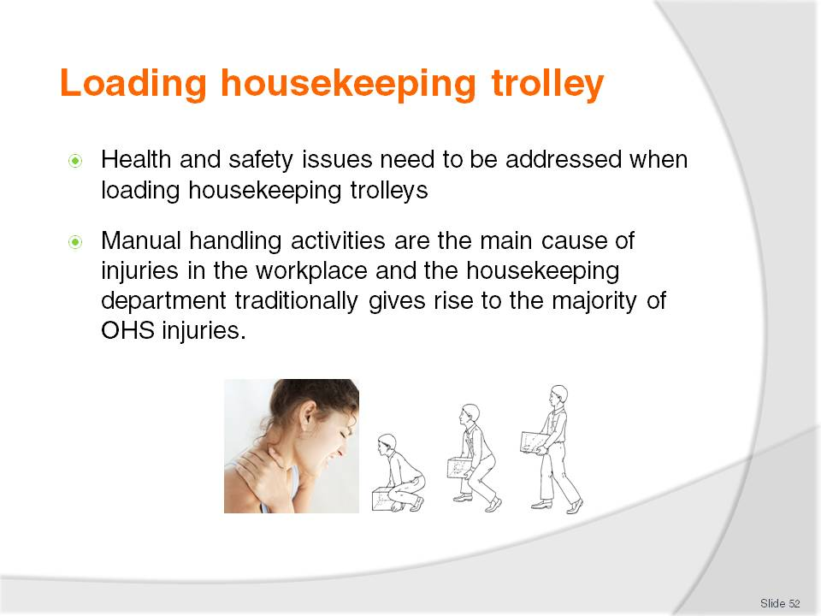
Slide No | Trainer Notes
Class Activity – General Discussion
What is manual handling?
Why is it important not just in loading trolleys, but when completing all tasks as a room attendant?

Slide
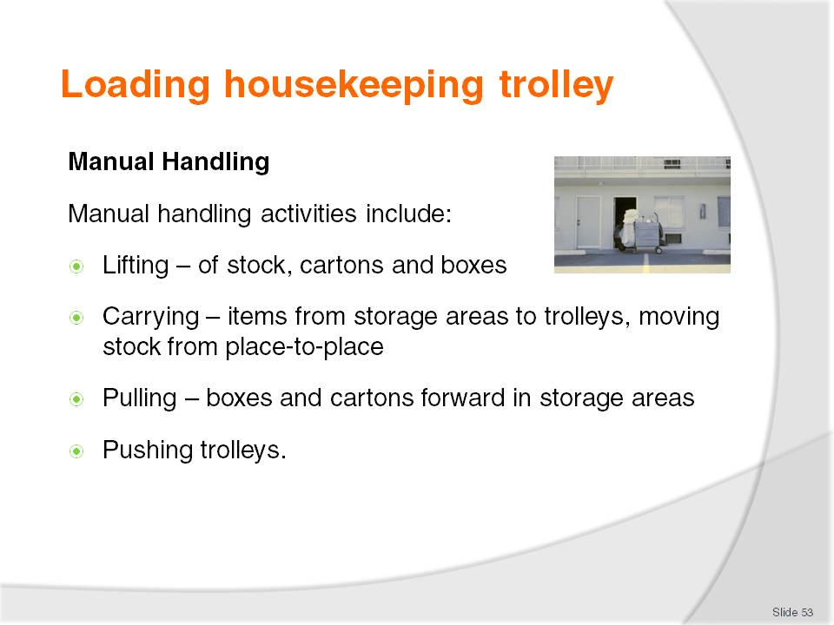
Slide No | Trainer Notes
Class Activity – General Discussion
What items do room attendants normally:
- Lift
- Carry
- Pull
- Push.
The trainer should demonstrate the best way to do these movements.
Also get the audience to think of strategies to prevent injury (use of specific equipment etc) when using these range of movements.

Slide
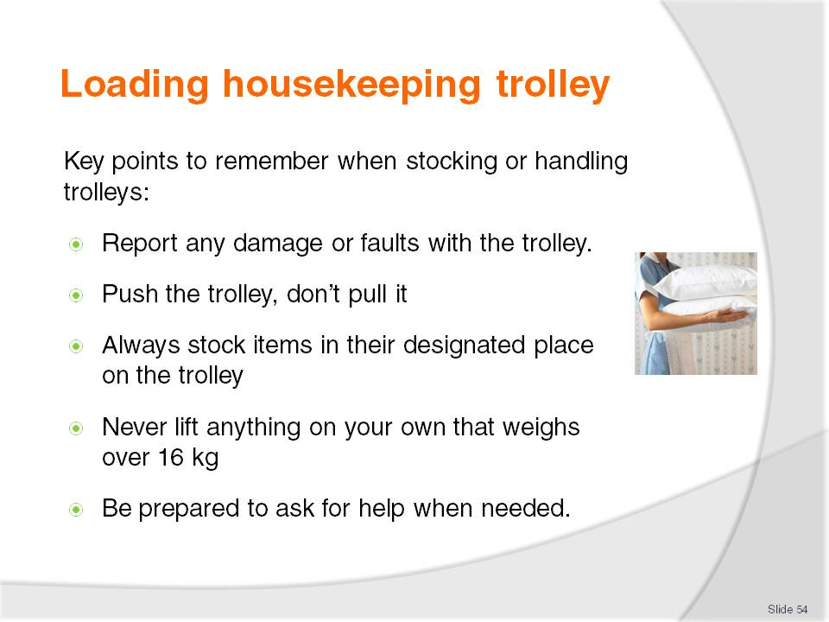
Slide No | Trainer Notes
Class Activity – General Discussion
Discuss the points in the slide and why they are important.

Slide
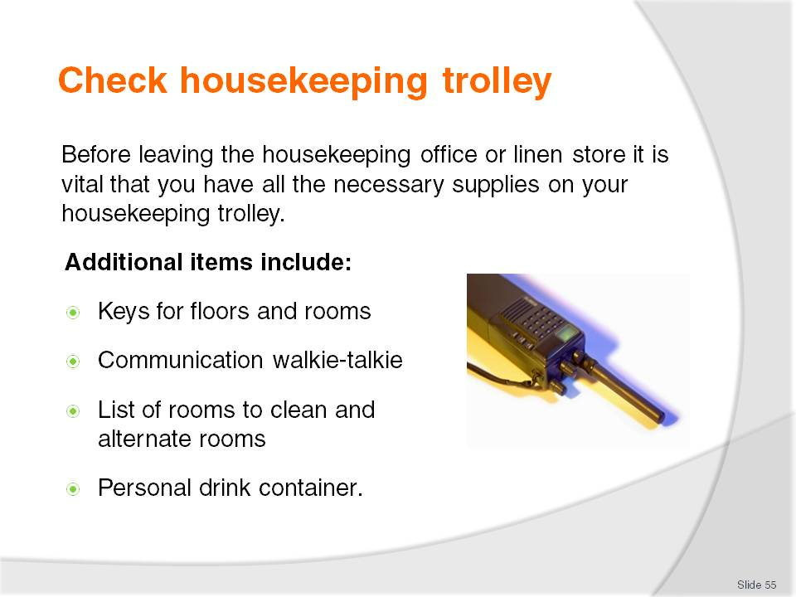
Slide No | Trainer Notes
Class Activity – General Discussion
Discuss the points in the slide and why they are important
These are not considered as supplies, but are vital.

Slide
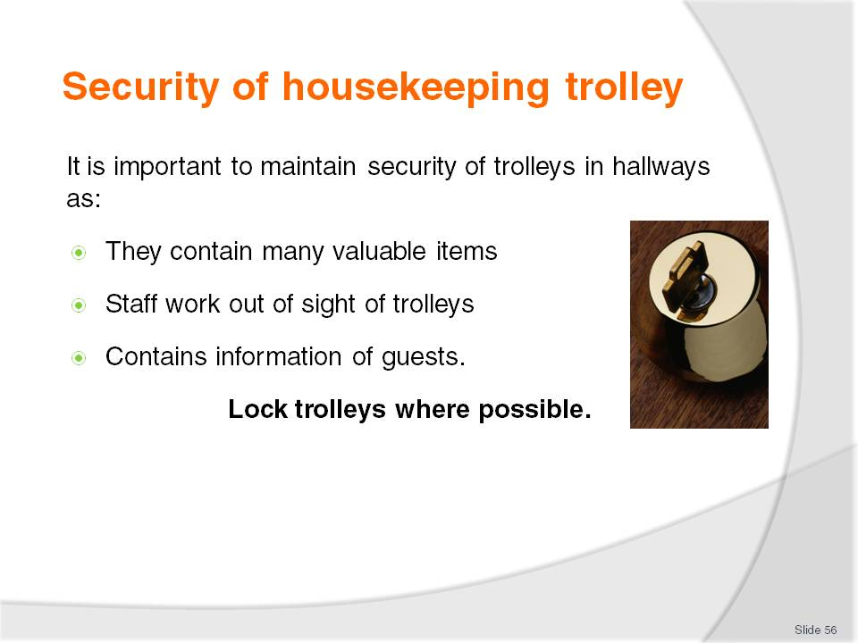
Slide No | Trainer Notes
Class Activity – General Discussion
Why is it easy for guests to steal from trolleys? If you were a guest how could you do it?
What would you steal?
How can staff prevent this?

Slide
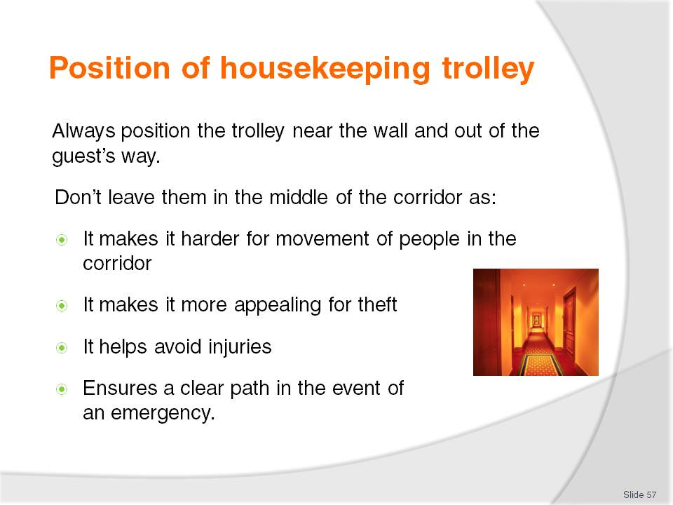
Slide No | Trainer Notes
Class Activity – General Discussion
Most organisations require trolleys to be placed in front of the open door to the room they are cleaning.
What are the reasons for this?

Slide
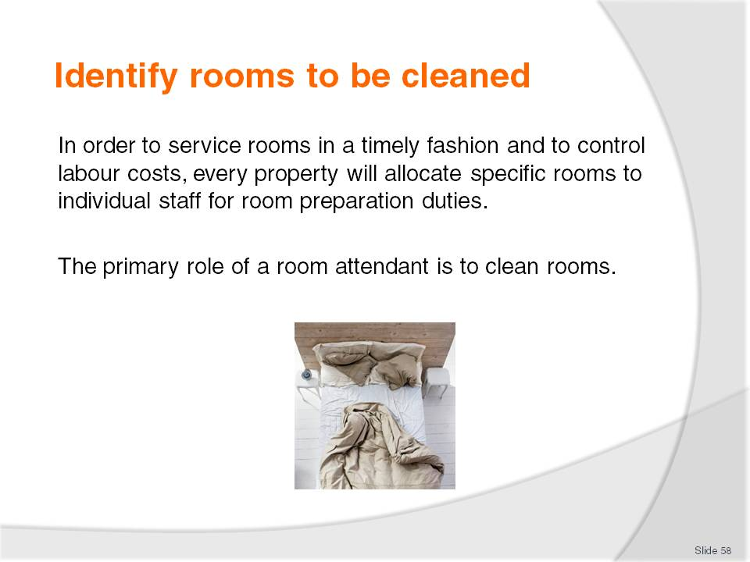
Slide No | Trainer Notes
Class Activity – General Discussion
What needs to be considered when identifying rooms to be cleaned, and in what order?

Slide
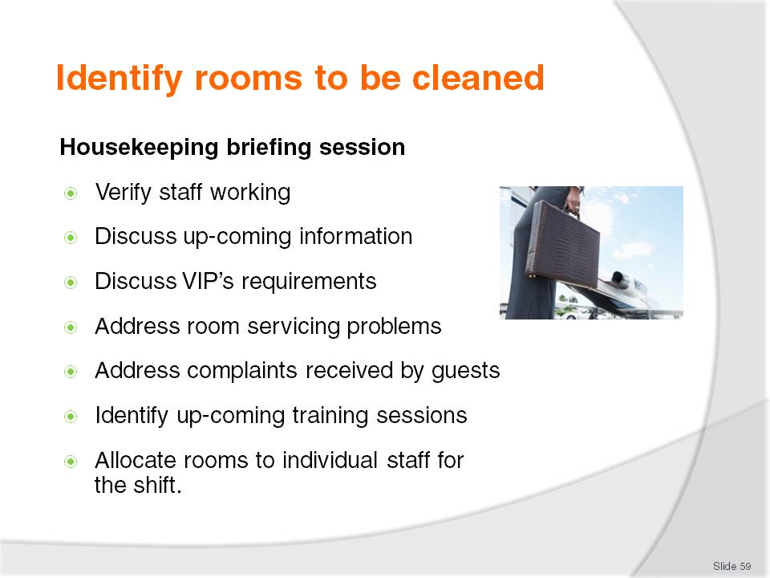
Slide No | Trainer Notes
Class Activity – General Discussion
When do briefings normally take place?
Who normally directs these sessions?
How long do they usually take?

Slide
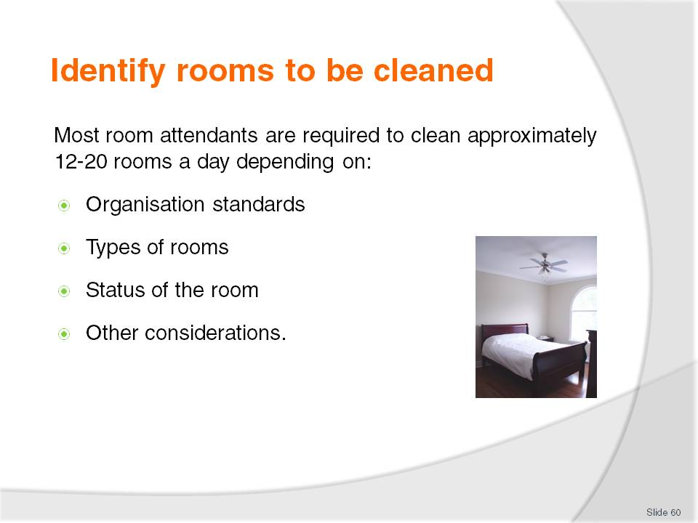
Slide No | Trainer Notes
Class Activity – General Discussion
What influences do each of the points in this slide have?

Slide
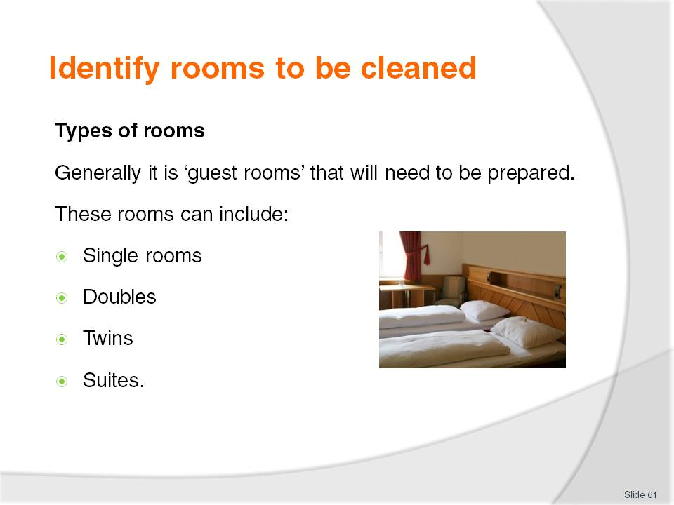
Slide No | Trainer Notes
Class Activity – General Discussion
What is the difference between each type of room?
Who are these rooms normally allocated to?
As a cleaner, which rooms take longer to clean and why?

Slide
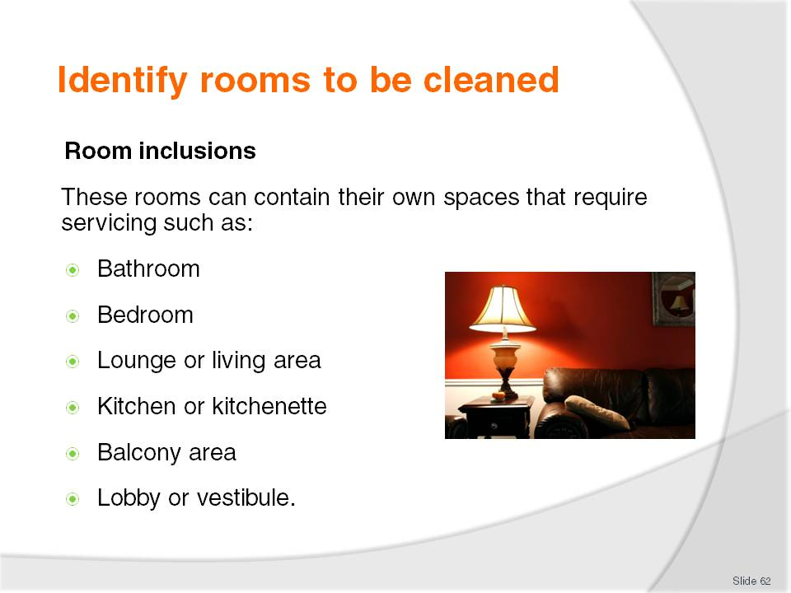
Slide No | Trainer Notes
Class Activity – General Discussion
Which inclusions are found in a ‘normal’ room?
As an exercise get the trainees to identify an approximate time it would take to clean each point identified in this slide providing explanation for the timing.

Slide
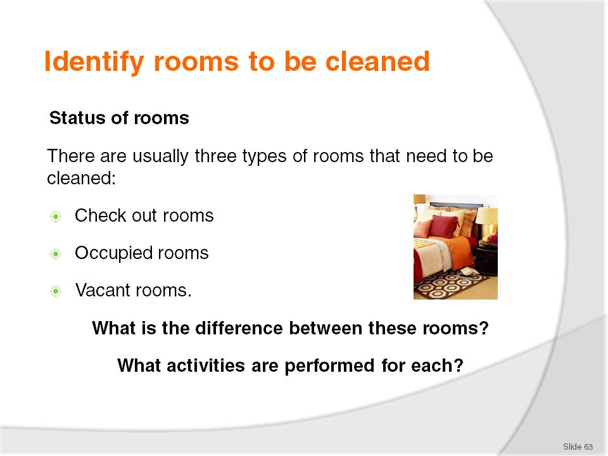
Slide No | Trainer Notes
Check out rooms
These are the rooms where guests are expected to check-out. They may be known as ‘departing rooms’, ‘going rooms’ or ‘vacated rooms’
These rooms will take longer to clean than a room that continues to be occupied because a full service is required. Approximately thirty minutes is allocated.
Occupied rooms
These are rooms where the guest will be staying for another night. They may also be known as ‘stay rooms’
Generally these rooms won’t take as long to clean as a check-out room, and approximately twenty minutes will be allocated.
Vacant rooms
You will also be required to inspect and provide basic service to vacant rooms.
These rooms, even though not being used, still require some attention such as:
Inspection – to identify anything that might have happened or gone wrong with or in the room
General dusting
Flushing of the toilet
Checking that the refrigerator is working properly
Ensuring the room has not been occupied by a guest for whom no information exists.

Slide
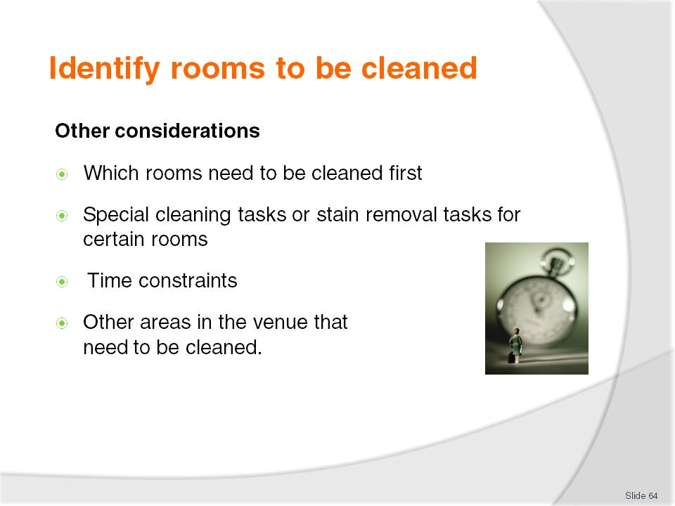
Slide No | Trainer Notes
Class Activity – General Discussion
Which rooms normally need to be cleaned first?
What time constraints exist?
What other areas do room attendants have to clean?
Is this part of their normal job?
If not, who does it and why would room attendants be required to help?

Slide
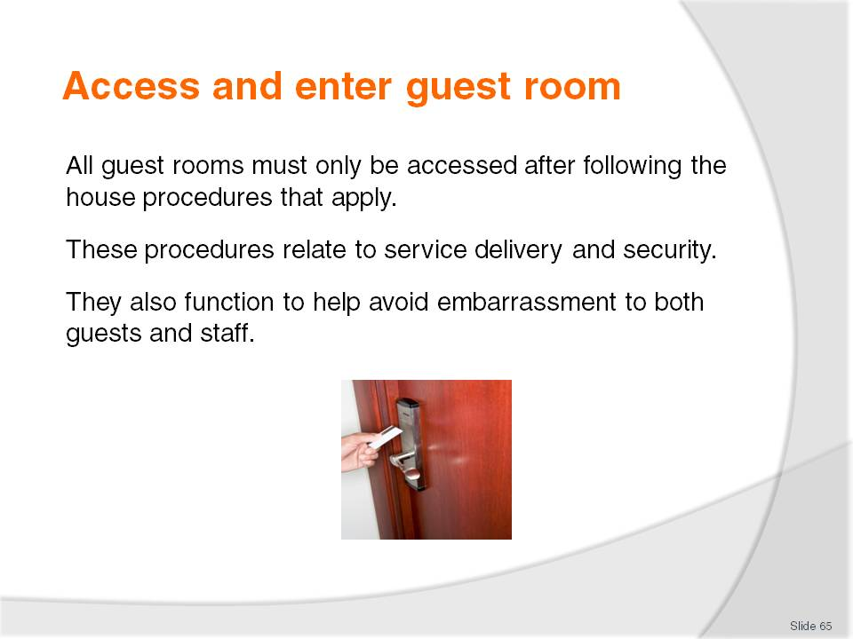
Slide No | Trainer Notes
Class Activity – General Discussion
What is the normal procedure for accessing and entering a room?
Why is it done this way?

Slide
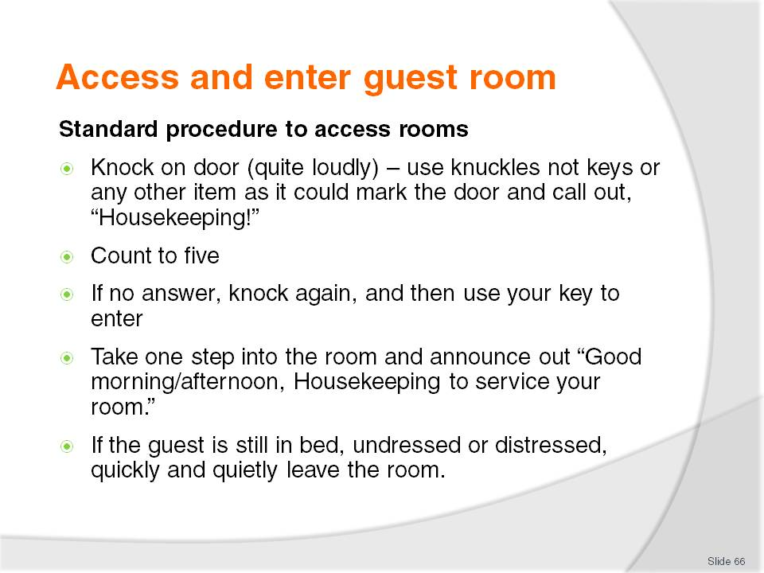
Slide No | Trainer Notes
Class Activity – General Discussion and Role Play
Trainer to explain why steps are done as identified in the slide.
Trainees to role play accessing and entering a room.

Slide
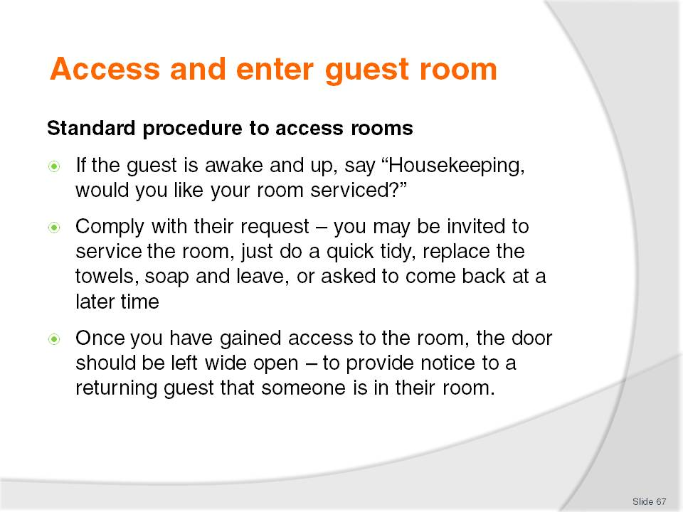
Slide No | Trainer Notes
Class Activity – General Discussion and Role Play
Trainer to explain why steps are done as identified in the slide.
Trainees to role play accessing and entering a room.

Slide
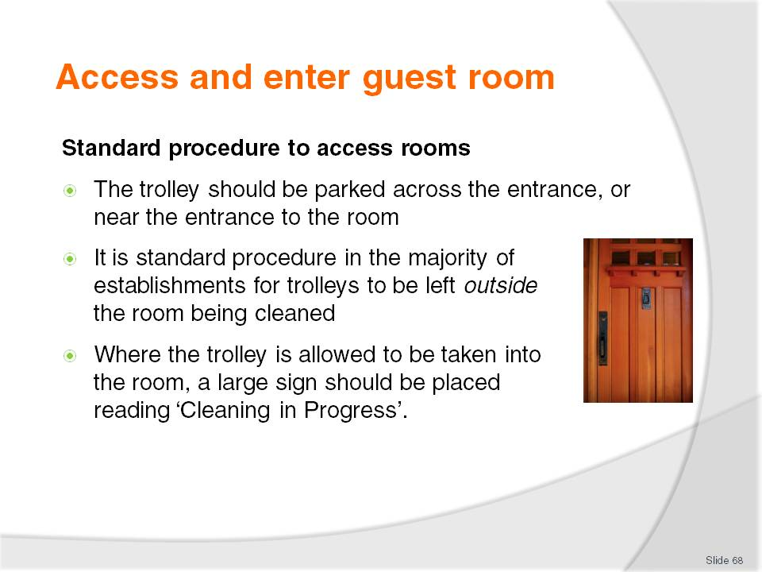
Slide No | Trainer Notes
Class Activity – General Discussion and Role Play
Trainer to explain why steps are done as identified in the slide.
Trainees to role play accessing and entering a room.

Slide
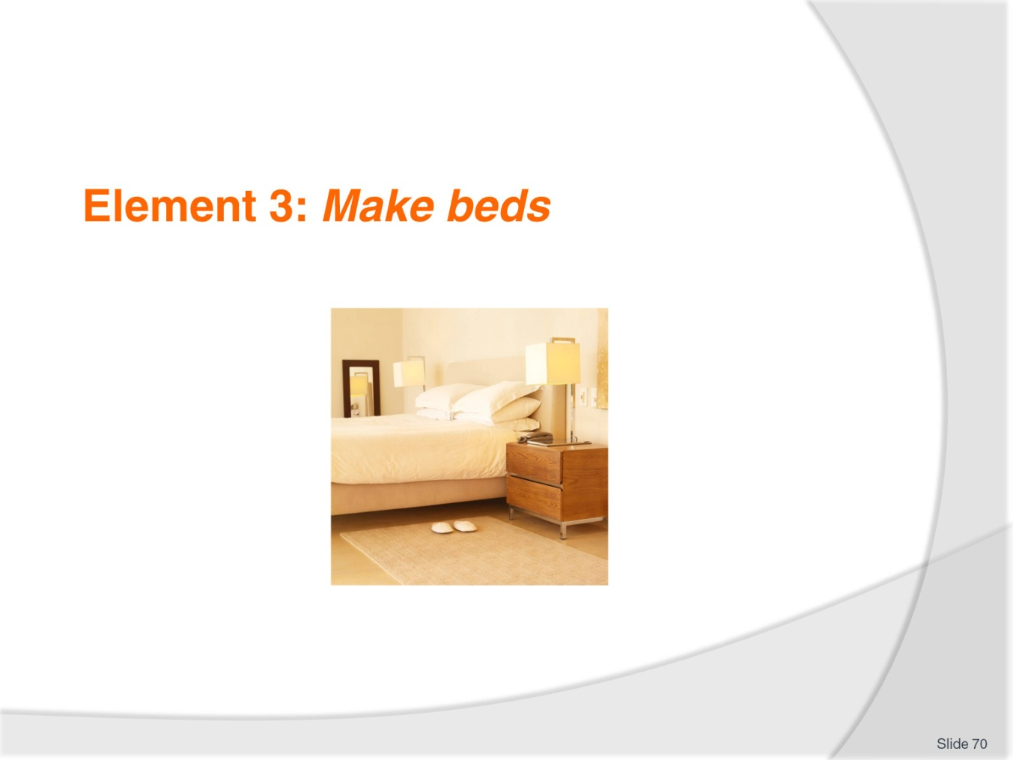
Slide No | Trainer Notes
Introduce topic.
Class Activity – General Discussion
Ask general questions:
What activities occur when making a bed?
Does this differ for a new guest compared with an existing guest?

Slide
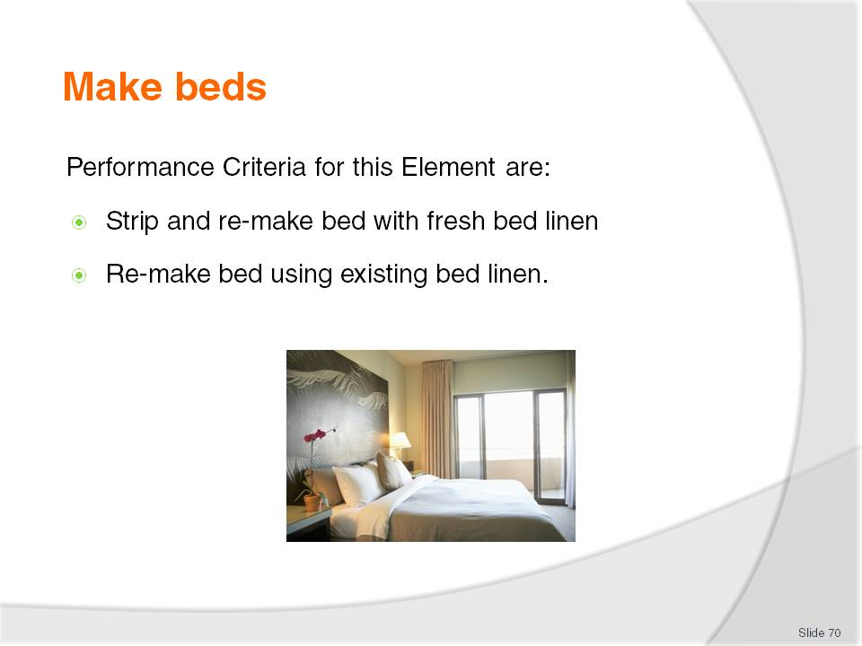
Slide No | Trainer Notes
 | Trainer identifies the Performance Criteria for this Element, as listed on the slide.

Slide
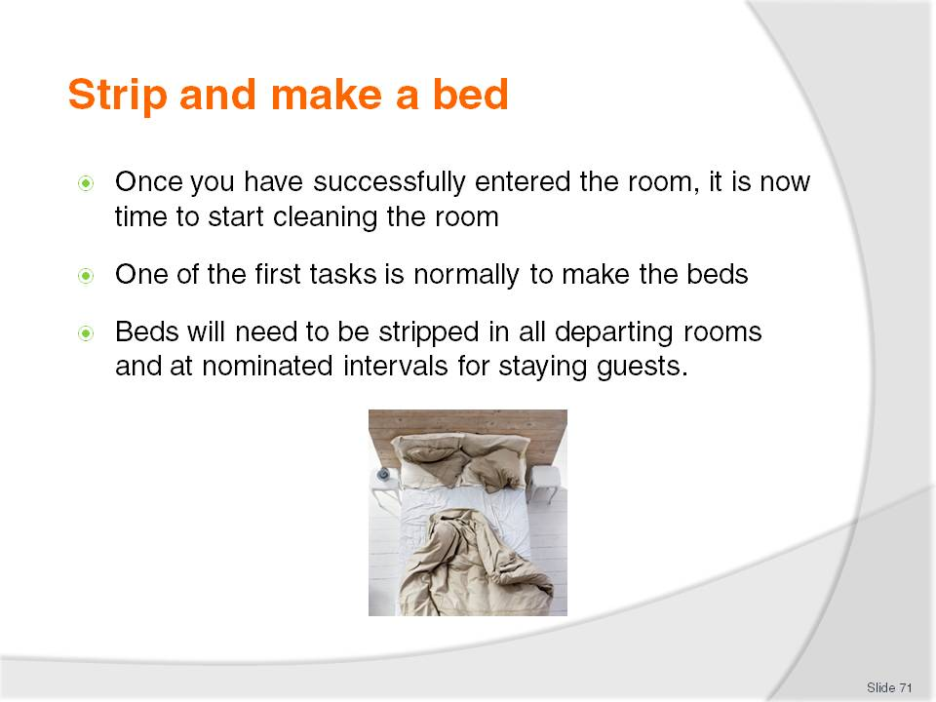
Slide No | Trainer Notes
Class Activity – General Discussion
What does stripping a bed involve?
Where should you place the items you have stripped?

Slide
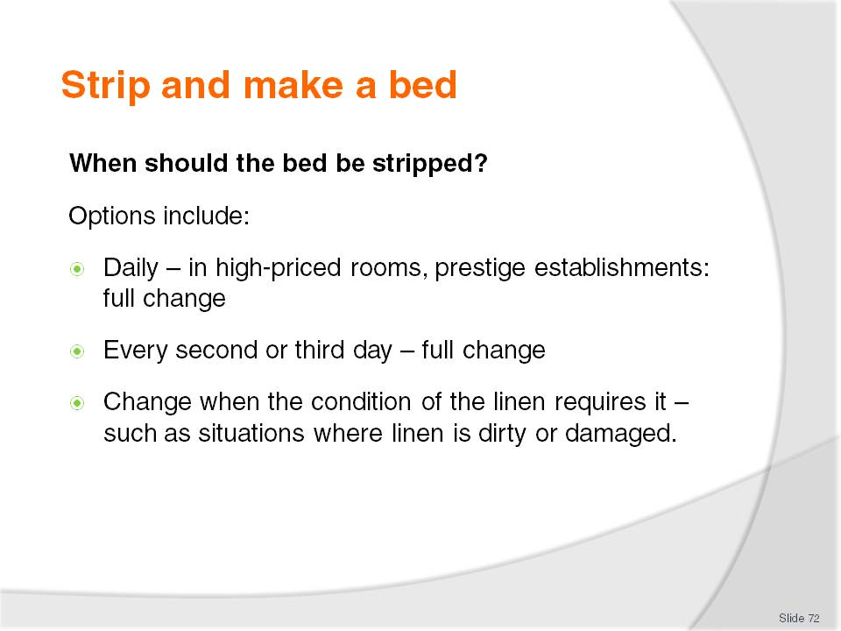
Slide No | Trainer Notes
Class Activity – General Discussion
What do you think is a suitable time frame?

Slide
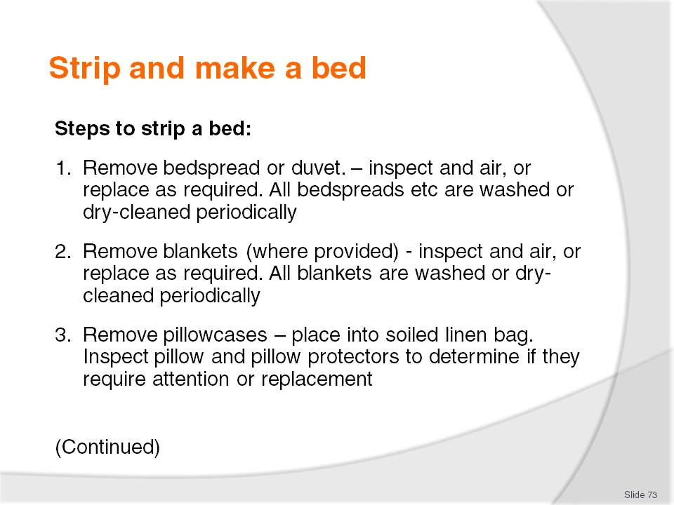
Slide No | Trainer Notes
Class Activity – General Discussion and Demonstration
Trainer to demonstrate and explain why steps are done as identified in the slide.
Trainees to practice stripping a bed.

Slide
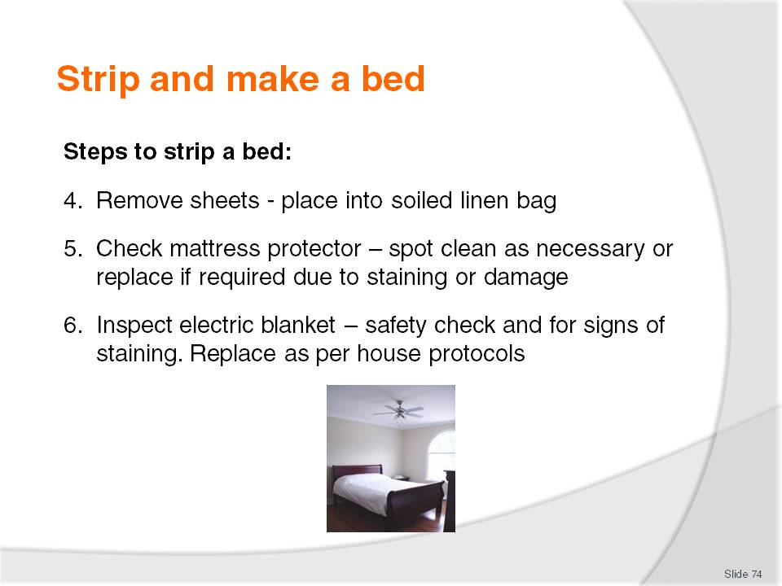
Slide No | Trainer Notes
Class Activity – General Discussion and Demonstration
Trainer to demonstrate and explain why steps are done as identified in the slide.
Trainees to practice stripping a bed.

Slide
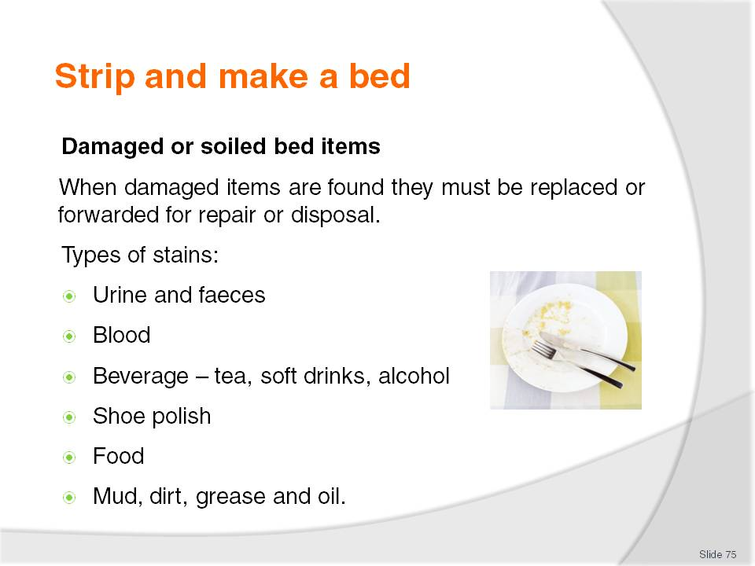
Slide No | Trainer Notes
Class Activity – General Discussion
What are common stains on bed items?

Slide
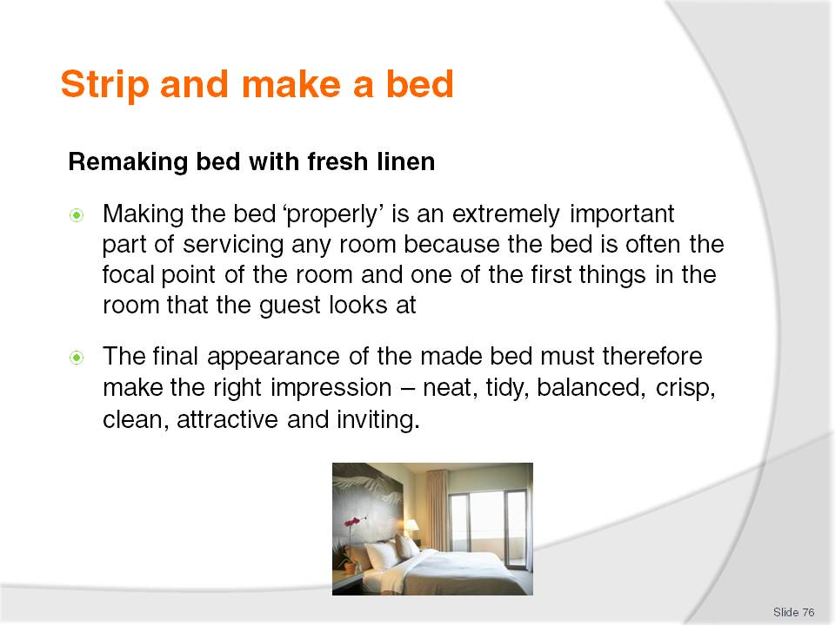
Slide No | Trainer Notes
Class Activity – General Discussion
What is involved in making a bed?

Slide
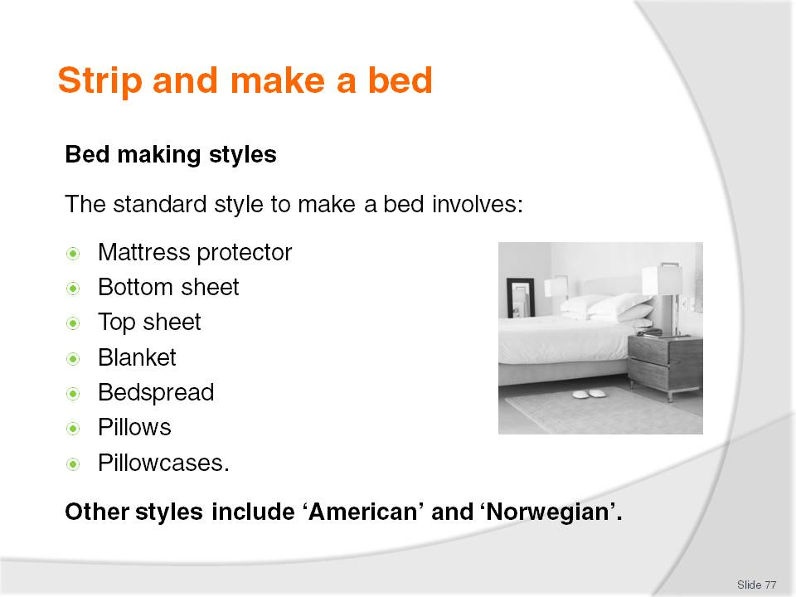
Slide No | Trainer Notes
Class Activity – General Discussion
What is the purpose of each bedding item?
Trainer to explain how the ‘American’ and ‘Norwegian’ (refer to notes) styles differ and why they are used.

Slide
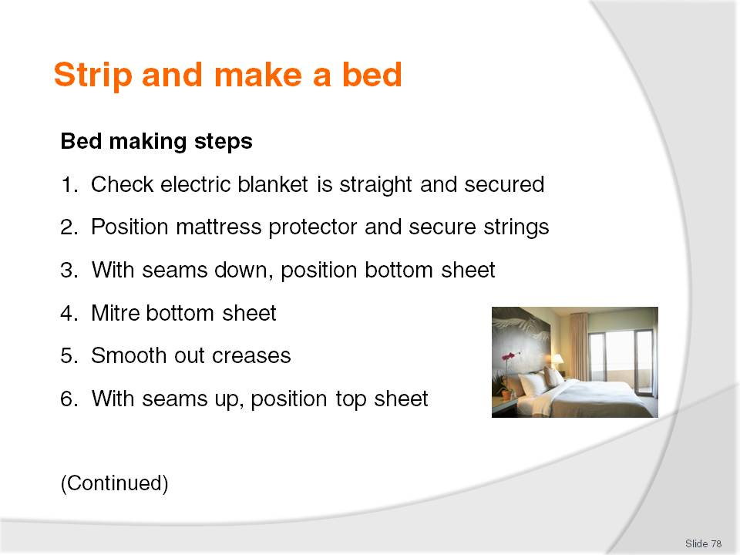
Slide No | Trainer Notes
Class Activity – General Discussion and Demonstration
Trainer to demonstrate and explain why steps are done as identified in the slide.
Trainees to practice making a bed.

Slide
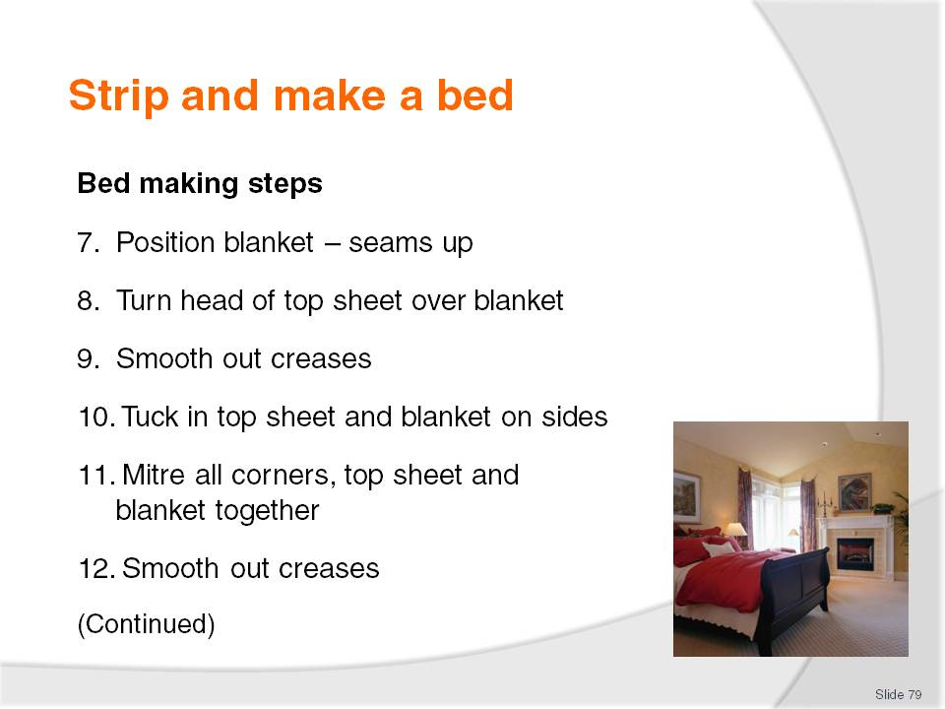
Slide No | Trainer Notes
Class Activity – General Discussion and Demonstration
Trainer to demonstrate and explain why steps are done as identified in the slide.
Trainees to practice making a bed.

Slide
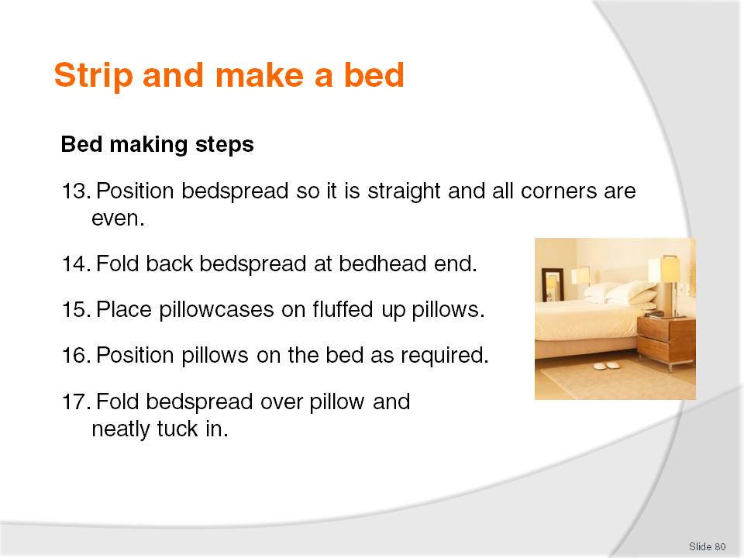
Slide No | Trainer Notes
Class Activity – General Discussion and Demonstration
Trainer to demonstrate and explain why steps are done as identified in the slide.
Trainees to practice making a bed.

Slide
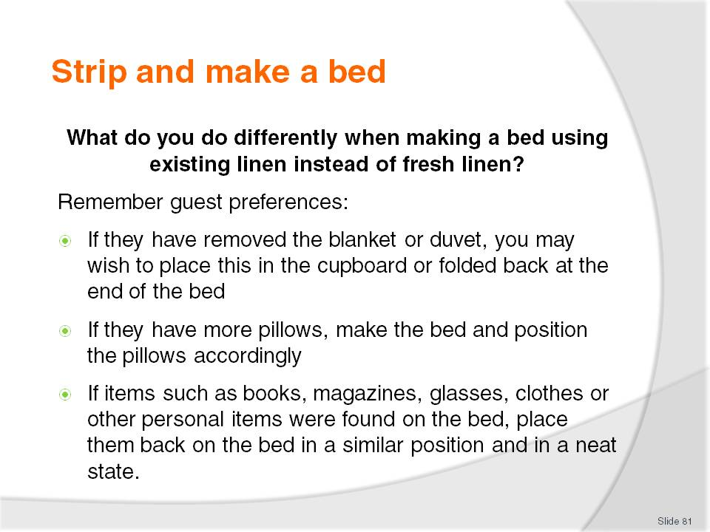
Slide No | Trainer Notes
Remaking a bed using existing bed linen
Whilst the instructions may reflect those previously given in Section 3.1, it is important that clear procedures are identified when making a bed for an occupied room.
1. Remove pillows and place them on a clean surface, checking for stains or need for replacement
2. Remove or pull back any blankets or duvets, again checking for stains or need for replacement
3. Straighten bottom sheet, again checking for stains or need for replacement. If a new sheet is required, change accordingly.
4. Re-tuck in sheet
5. Smooth out creases
6. With seams up, position top sheet – top edge even with mattress at bed head
7. Position blanket – seams up
8. Turn head of top sheet over blanket
9. Smooth out creases
10. Tuck in top sheet and blanket on sides
11. Mitre all corners, top sheet and blanket together
12. Smooth out creases
13. Position bedspread so it is straight and all corners are even
14. Fold back bedspread at bedhead end
15. Place pillowcases on fluffed up pillows
16. Position pillows on the bed as required
17. Fold bedspread over pillow and neatly tuck in.

Slide
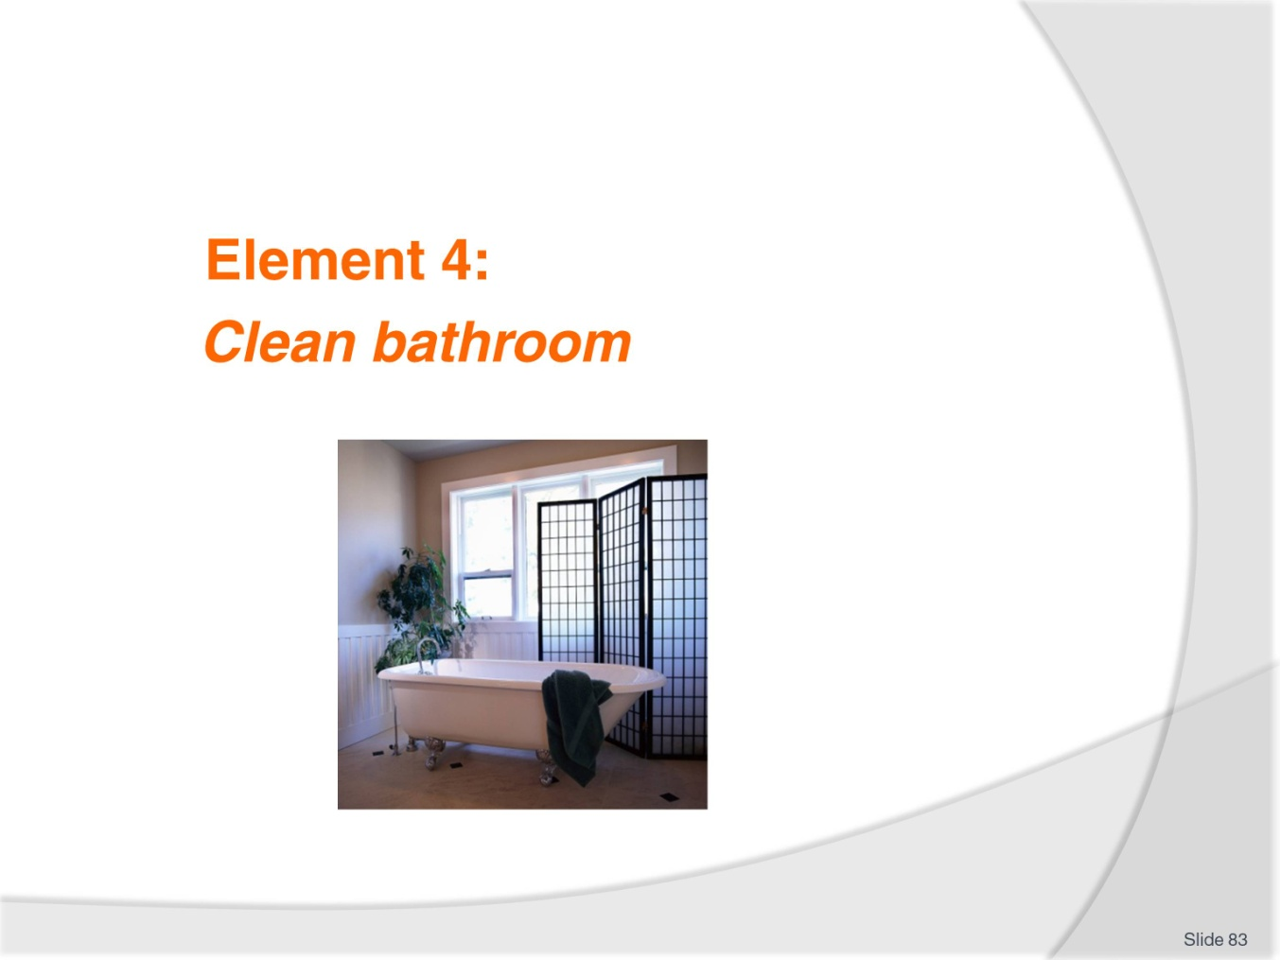
Slide No | Trainer Notes
Introduce topic.
Class Activity – General Discussion
Ask general questions:
What activities occur when cleaning a bathroom?
How long should it take to clean a bathroom?

Slide
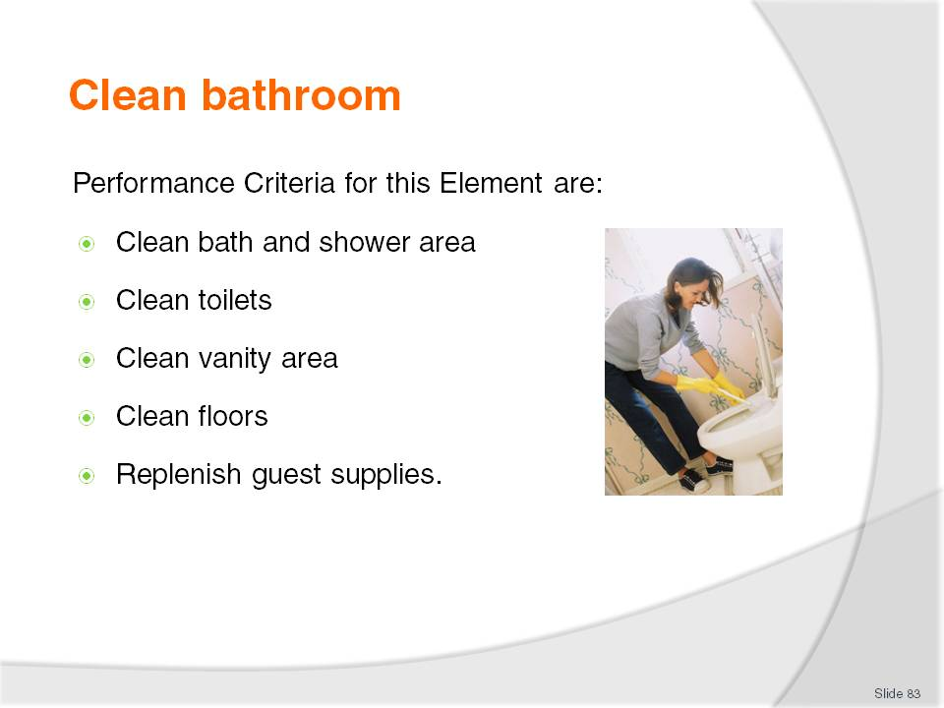
Slide No | Trainer Notes
 | Trainer identifies the Performance Criteria for this Element, as listed on the slide.

Slide
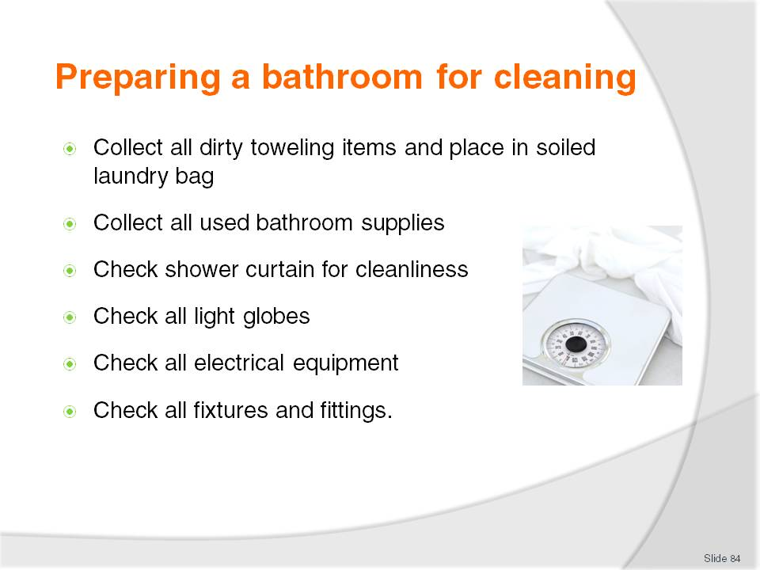
Slide No | Trainer Notes
Class Activity – General Discussion
Discuss the points explaining why they are important to undertake.

Slide
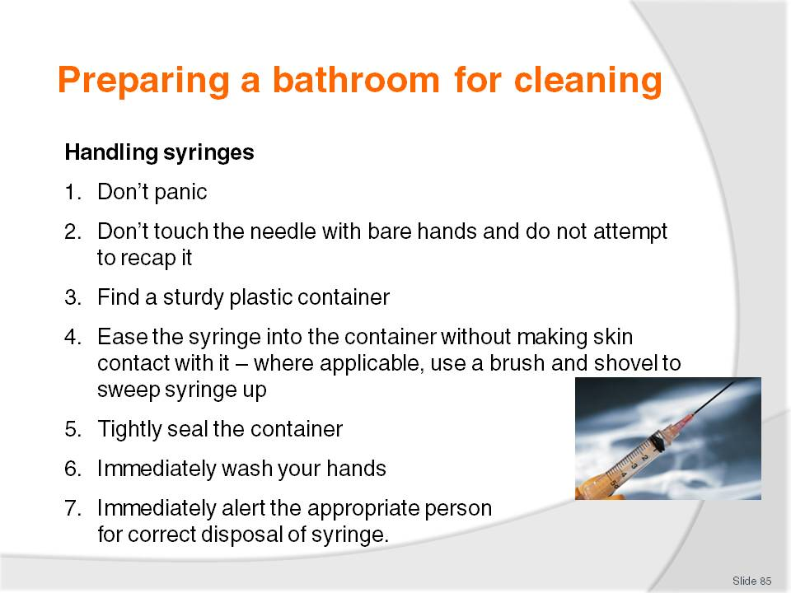
Slide No | Trainer Notes
Class Activity – General Discussion
Why is it so important to handle syringes in the right manner?
Why are syringes commonly found in rooms?

Slide
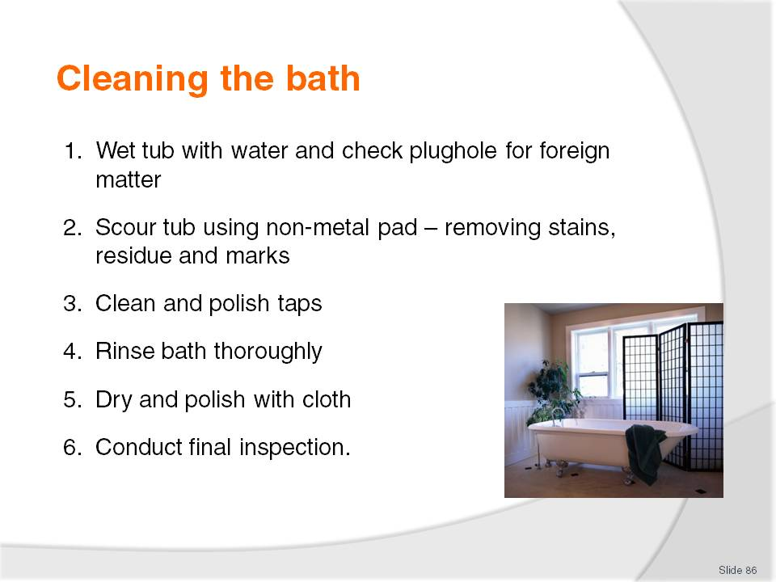
Slide No | Trainer Notes
Class Activity – General Discussion and Demonstration
Trainer to demonstrate and explain why steps are done as identified in the slide.
Trainees to practice cleaning a bath.

Slide
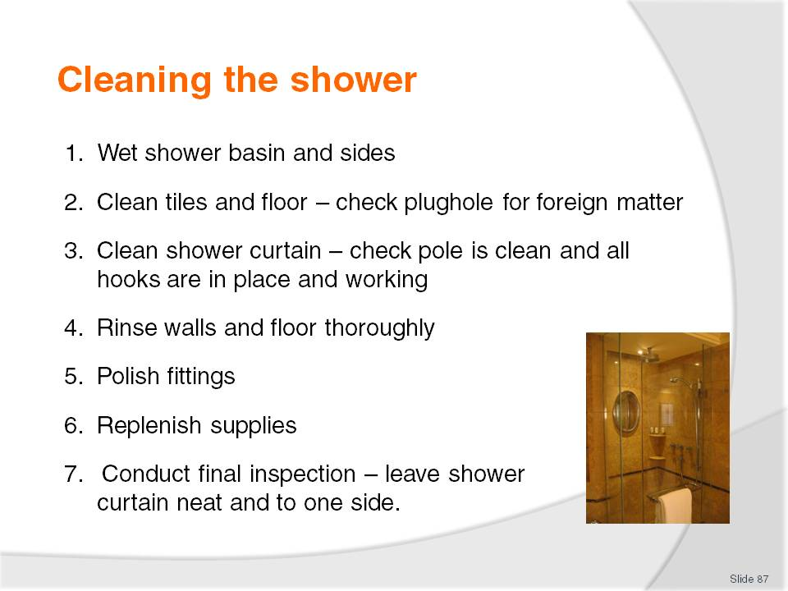
Slide No | Trainer Notes
Class Activity – General Discussion and Demonstration
Trainer to demonstrate and explain why steps are done as identified in the slide.
Trainees to practice cleaning a shower.

Slide
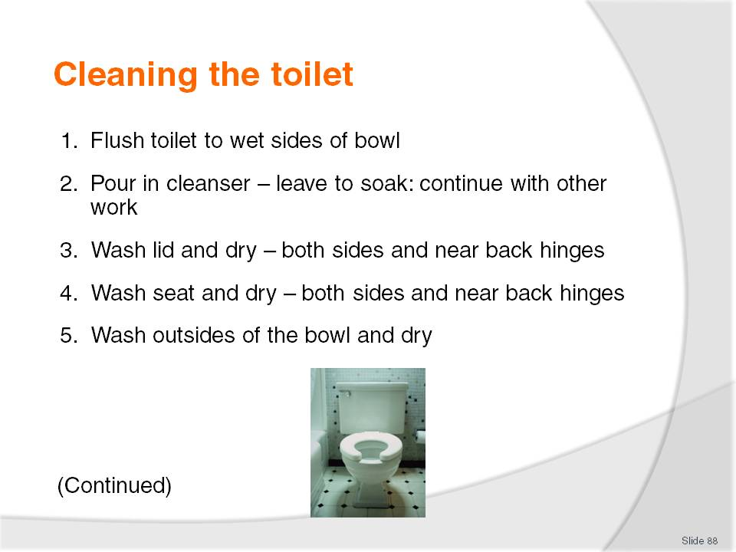
Slide No | Trainer Notes
Class Activity – General Discussion and Demonstration
Trainer to demonstrate and explain why steps are done as identified in the slide.
Trainees to practice cleaning a toilet.

Slide
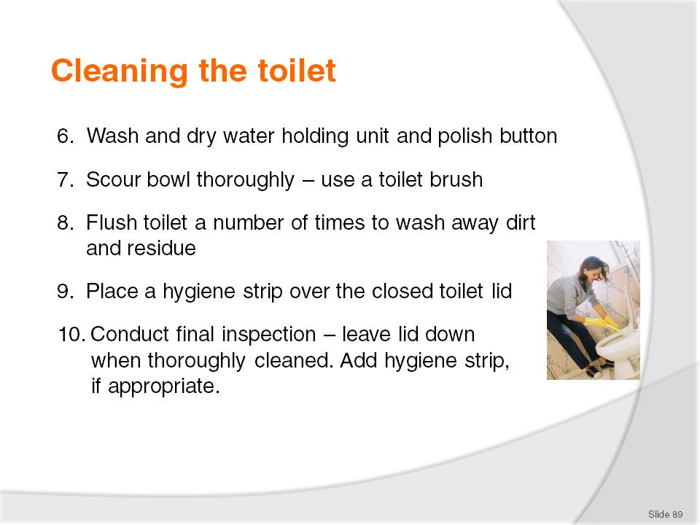
Slide No | Trainer Notes
Class Activity – General Discussion and Demonstration
Trainer to demonstrate and explain why steps are done as identified in the slide.
Trainees to practice cleaning a toilet.

Slide
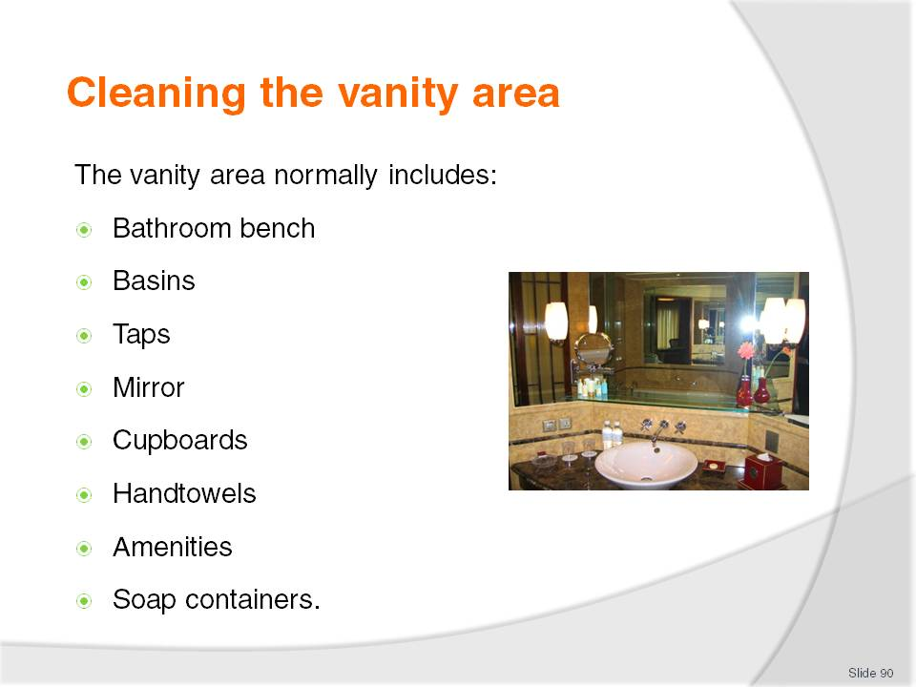
Slide No | Trainer Notes
Class Activity – General Discussion
Types of towels are used in a bathroom?
What amenities are normally supplied in the vanity area?
What are appropriate amenities for men?
What are appropriate amenities for women?

Slide
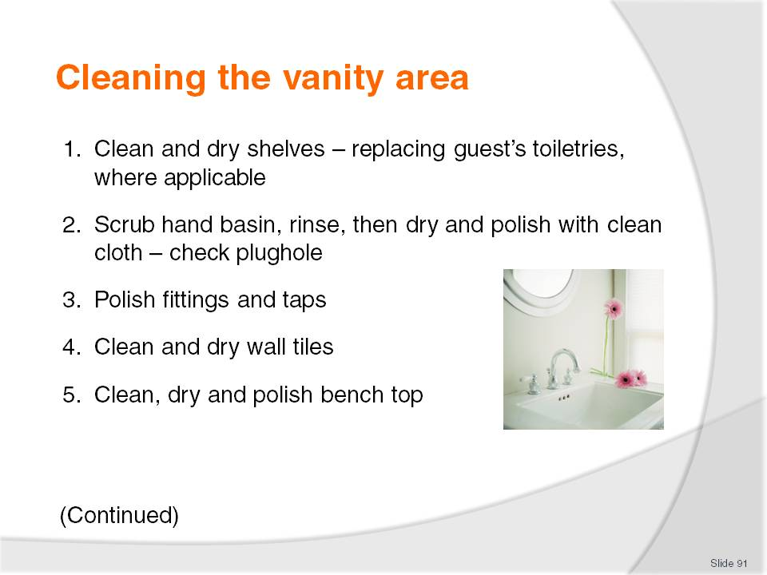
Slide No | Trainer Notes
Class Activity – General Discussion and Demonstration
Trainer to demonstrate and explain why steps are done as identified in the slide.
Trainees to practice cleaning a vanity area.

Slide
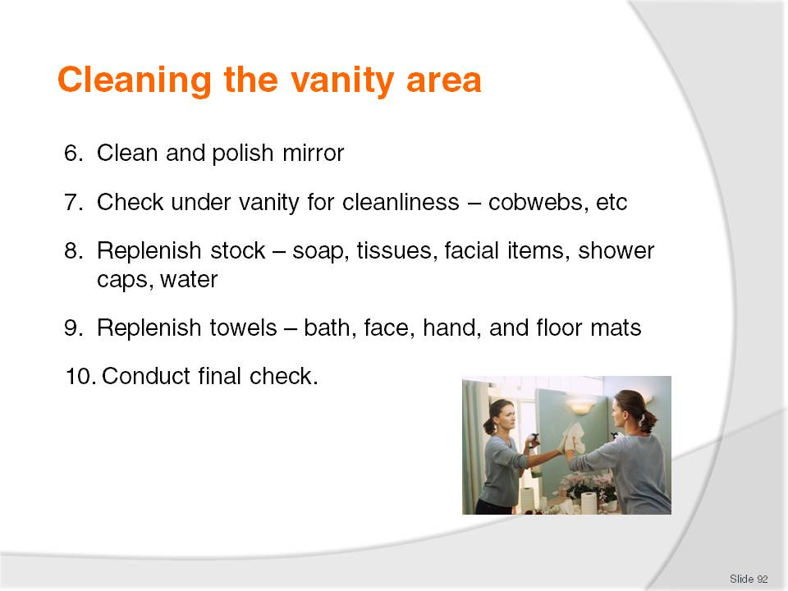
Slide No | Trainer Notes
Class Activity – General Discussion and Demonstration
Trainer to demonstrate and explain why steps are done as identified in the slide.
Trainees to practice cleaning a vanity area.

Slide
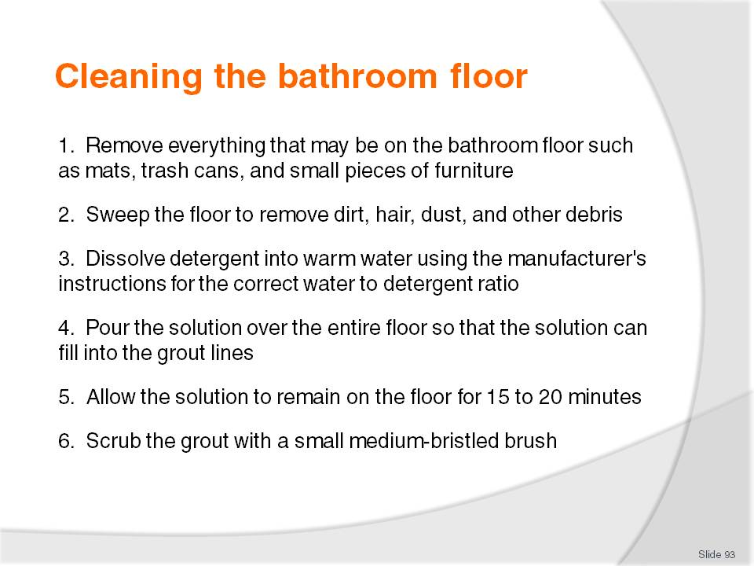
Slide No | Trainer Notes
Class Activity – General Discussion and Demonstration
Trainer to demonstrate and explain why steps are done as identified in the slide.
Trainees to practice cleaning the bathroom floor.

Slide
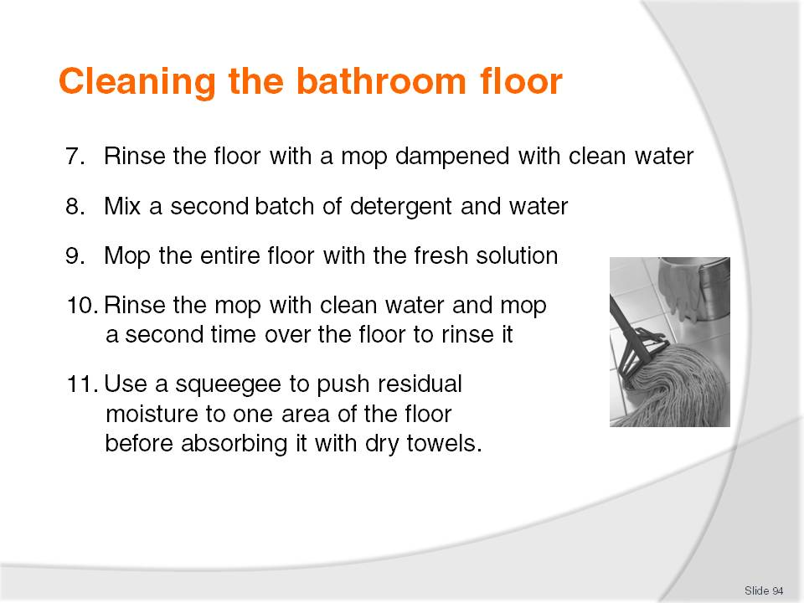
Slide No | Trainer Notes
Class Activity – General Discussion and Demonstration
Trainer to demonstrate and explain why steps are done as identified in the slide.
Trainees to practice cleaning the bathroom floor.

Slide
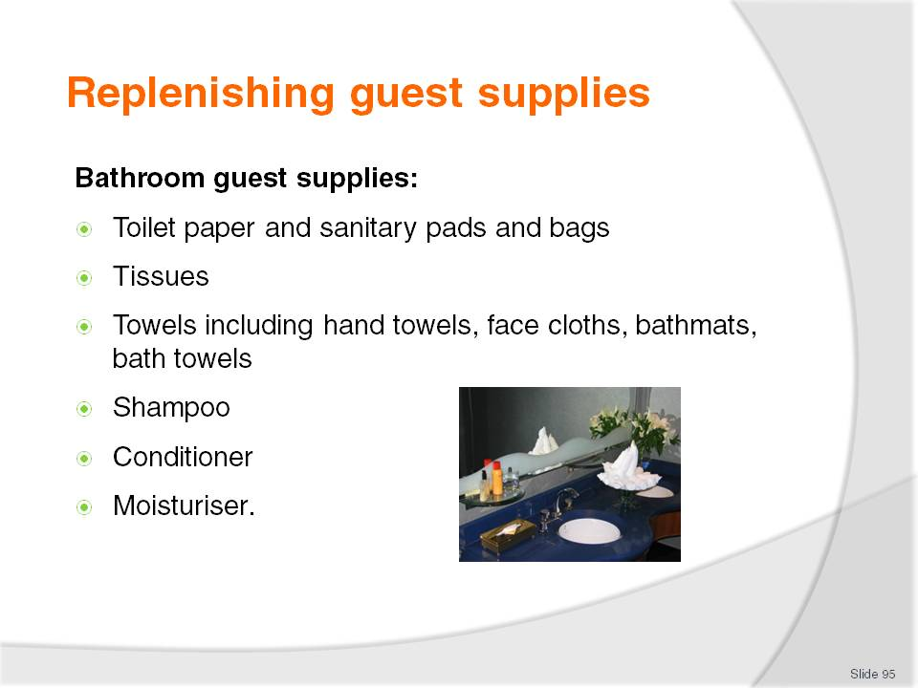
Slide No | Trainer Notes
 | Discuss why each of these amenities is included.

Slide
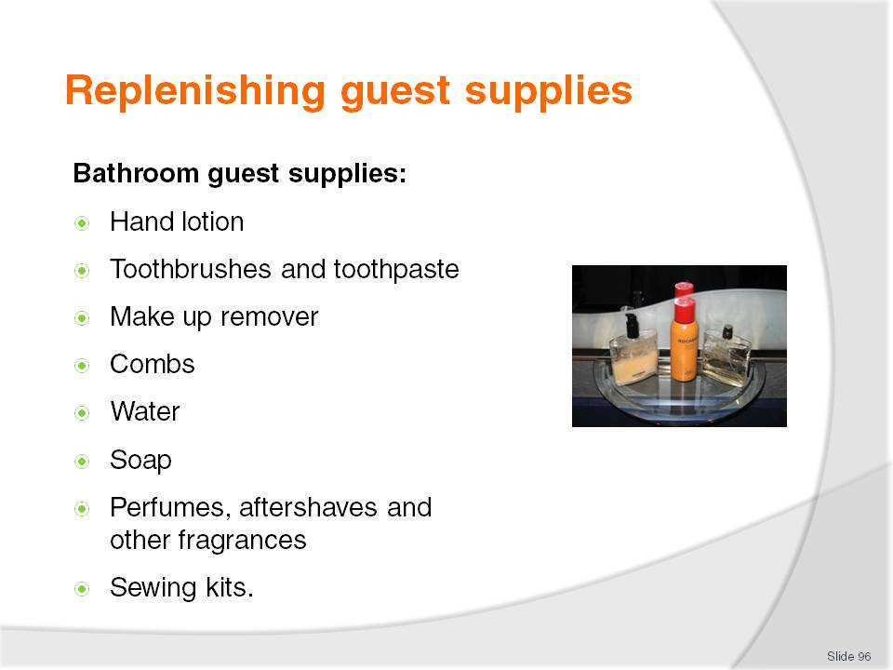
Slide No | Trainer Notes
Discuss why each of these amenities is included.
Are there any additional amenities that would be beneficial for guests?

Slide
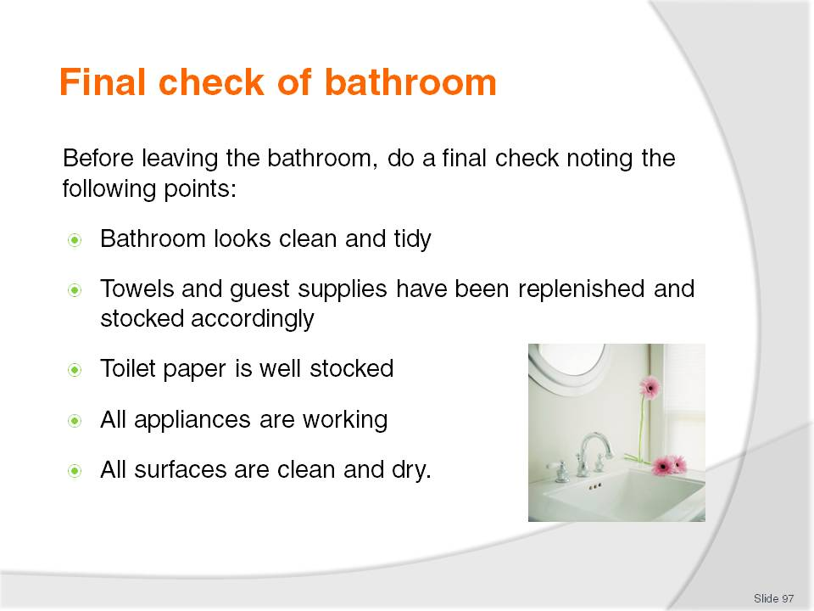
Slide No | Trainer Notes
 | Discuss why it is important to ensure the bathroom is completely clean before moving onto other tasks.

Slide
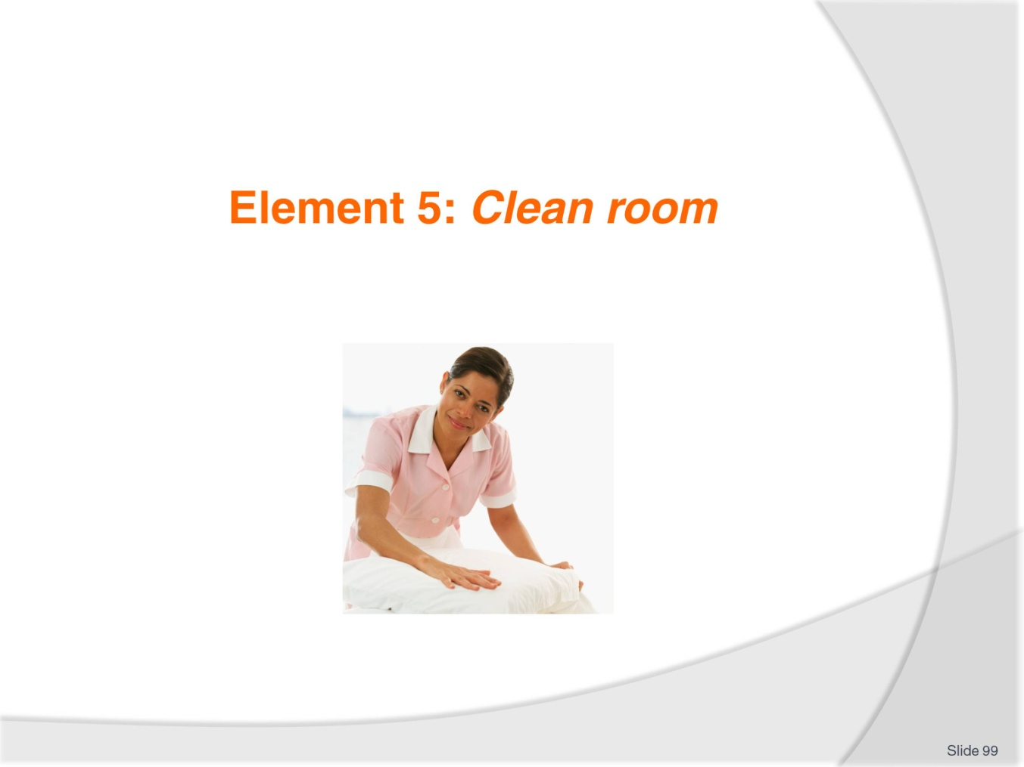
Slide No | Trainer Notes
Introduce topic.
Class Activity – General Discussion
Ask general questions:
What activities occur when cleaning a room?
How long should it take to clean a room?

Slide
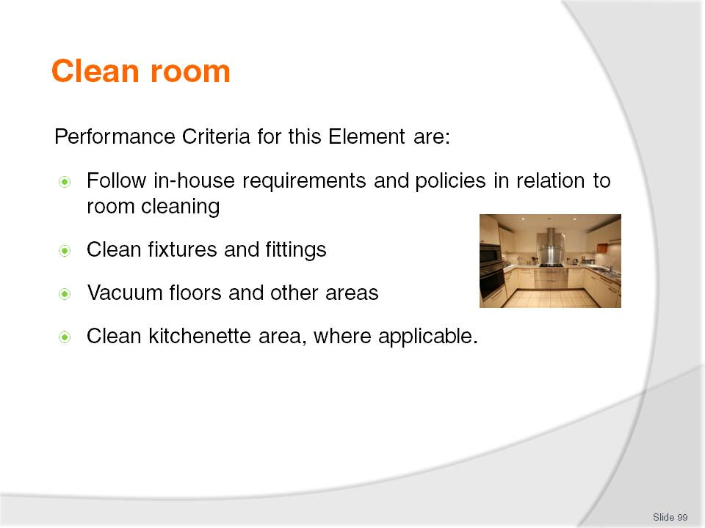
Slide No | Trainer Notes
 | Trainer identifies the Performance Criteria for this Element, as listed on the slide.

Slide
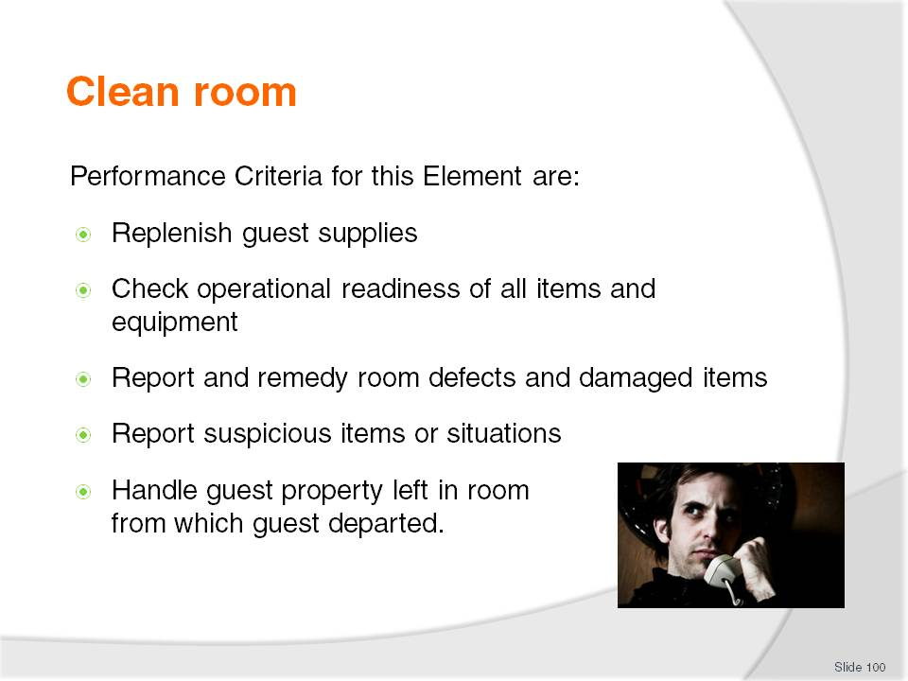
Slide No | Trainer Notes
 | Trainer identifies the Performance Criteria for this Element, as listed on the slide.

Slide
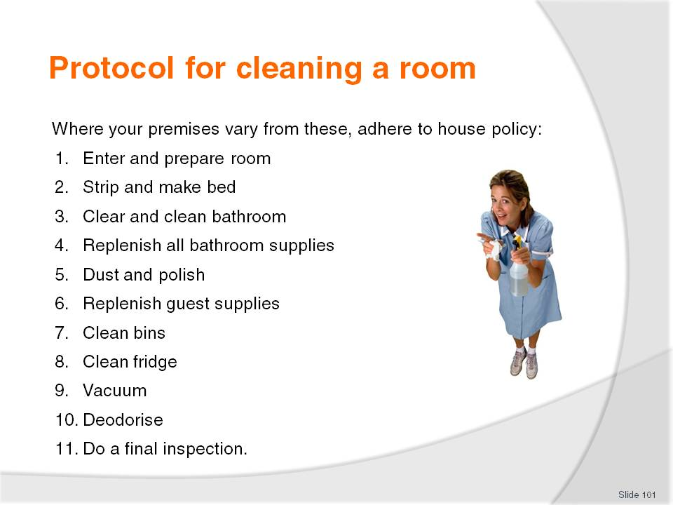
Slide No | Trainer Notes
Class Activity – General Discussion
The steps to cleaning a room may have already been clarified but it is good to revise and to be able to explain to trainees what we have currently covered to date.

Slide
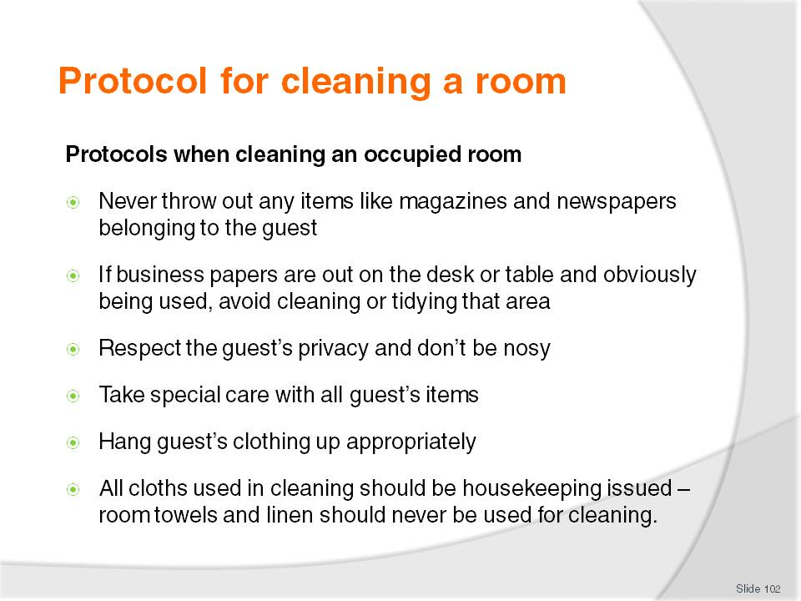
Slide No | Trainer Notes
Class Activity – General Discussion
Discuss the reasons why certain protocols exist when cleaning an occupied room.

Slide
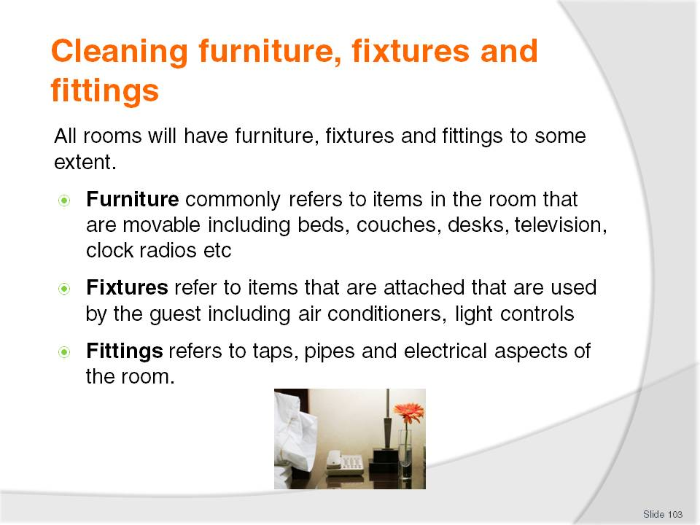
Slide No | Trainer Notes
Class Activity – General Discussion
What other furniture items are there in a room?
What other fixture items are there in a room?
What other fitting items are there in a room?
How do you clean these?

Slide
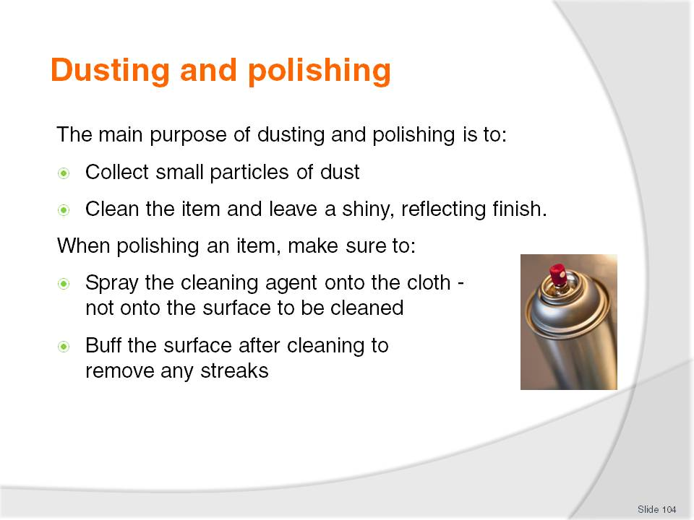
Slide No | Trainer Notes
Class Activity – General Discussion
What items do you dust and polish?
What is the difference between dusting and polishing?

Slide
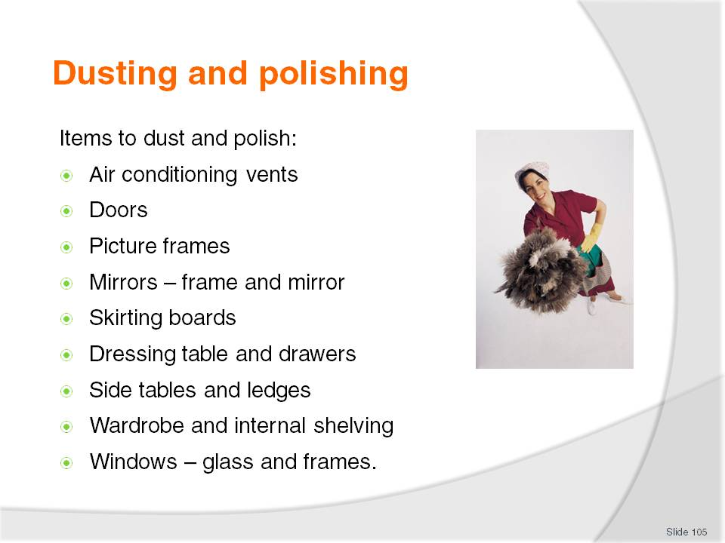
Slide No | Trainer Notes
Class Activity – General Discussion and Demonstration
Trainer to demonstrate and explain why steps are done as identified in the slide.
Trainees to practice polishing and dusting some items identified in the slide.

Slide
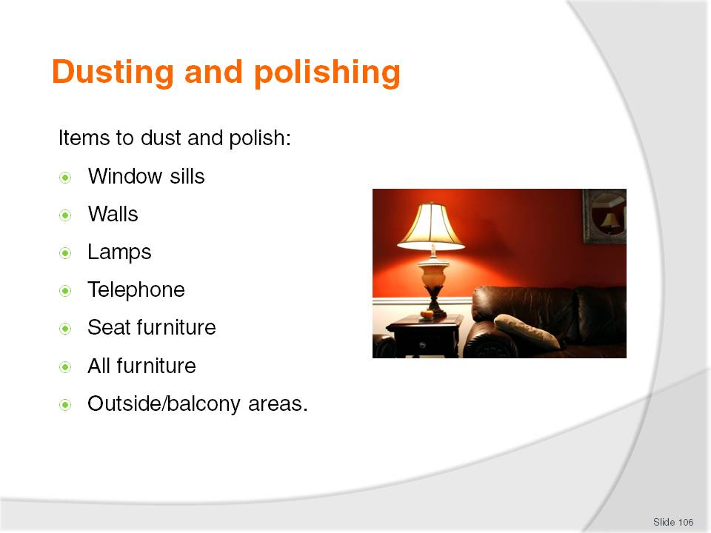
Slide No | Trainer Notes
Class Activity – General Discussion and Demonstration
Trainer to demonstrate and explain why steps are done as identified in the slide.
Trainees to practice polishing and dusting some items identified in the slide.
Window sills
Walls – check for cobwebs and marks
Lamps – base, shade and cord
Telephone – main unit and hand receiver
Seat furniture – don’t forget to remove cushions and check sides, legs, back and underneath
All furniture – top, sides, legs, and underneath each item; don’t forget to clean inside the drawers
Outside/balcony areas – furniture, ash trays.

Slide
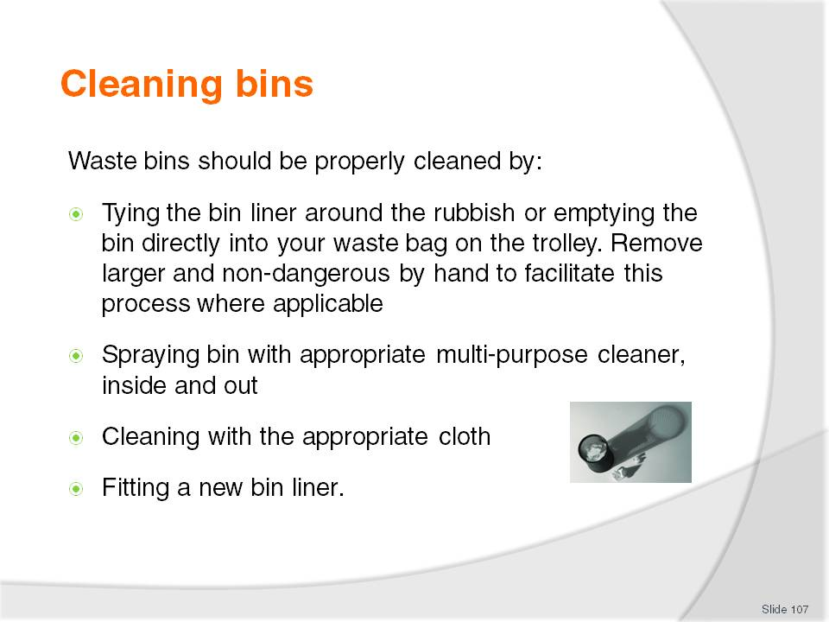
Slide No | Trainer Notes
Class Activity – General Discussion and Demonstration
Trainer to demonstrate and explain why steps are done as identified in the slide.
Trainees to clean a bin.

Slide
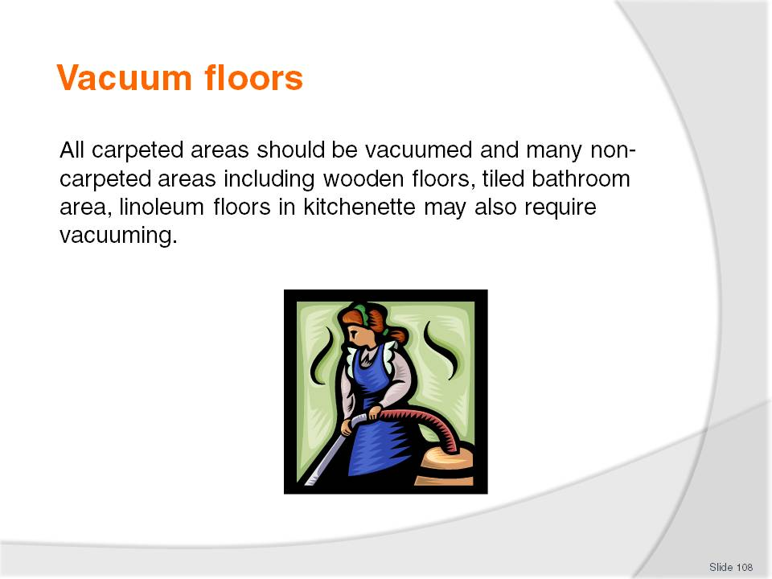
Slide No | Trainer Notes
Class Activity – General Discussion
What is the purpose of vacuuming?

Slide
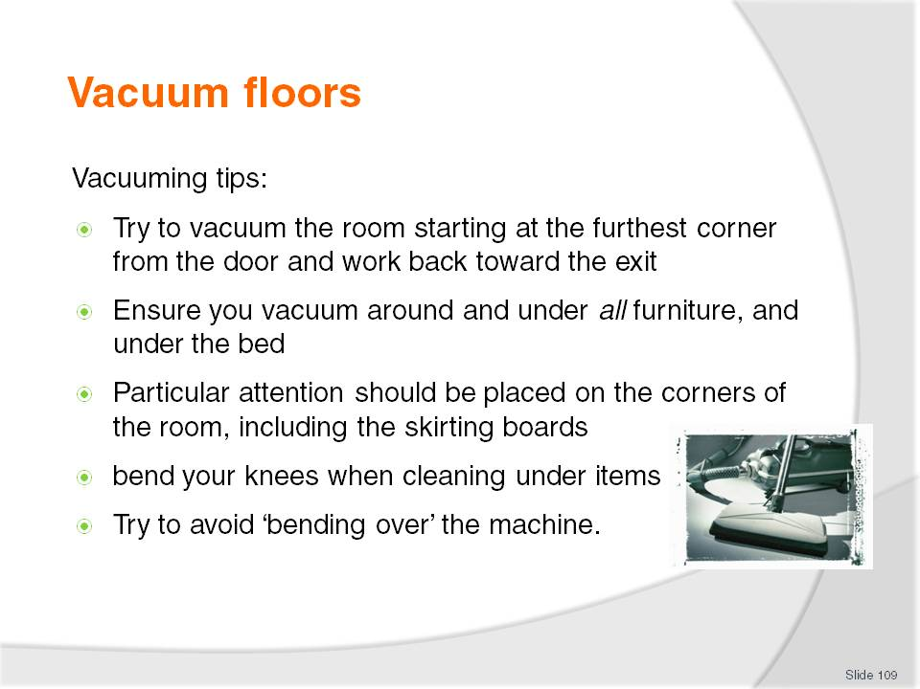
Slide No | Trainer Notes
Class Activity – General Discussion and Demonstration
Trainer to demonstrate and explain why steps are done as identified in the slide.
Trainees to practice vacuuming.

Slide
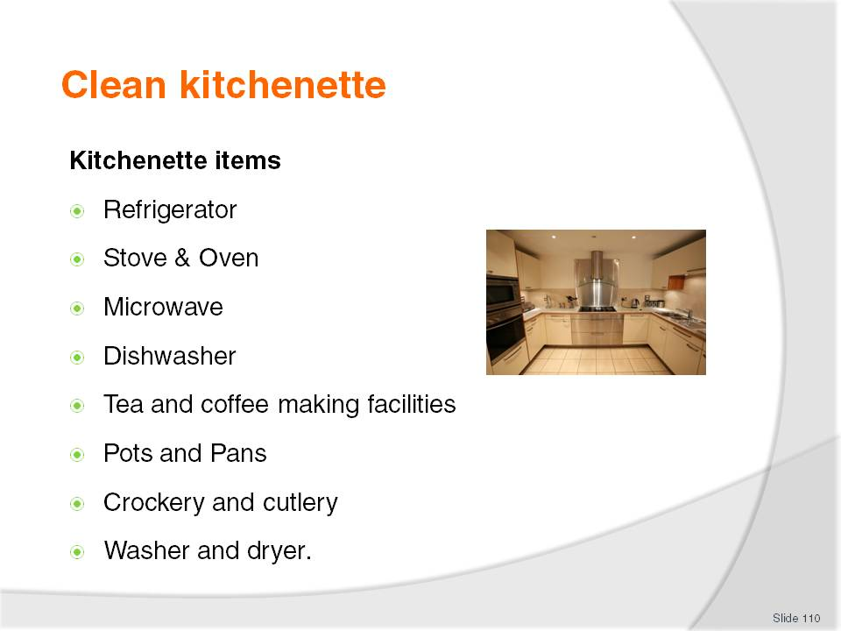
Slide No | Trainer Notes
Class Activity – General Discussion
What other items are often found in a kitchenette?
How long should it take to clean?
What steps are involved?

Slide
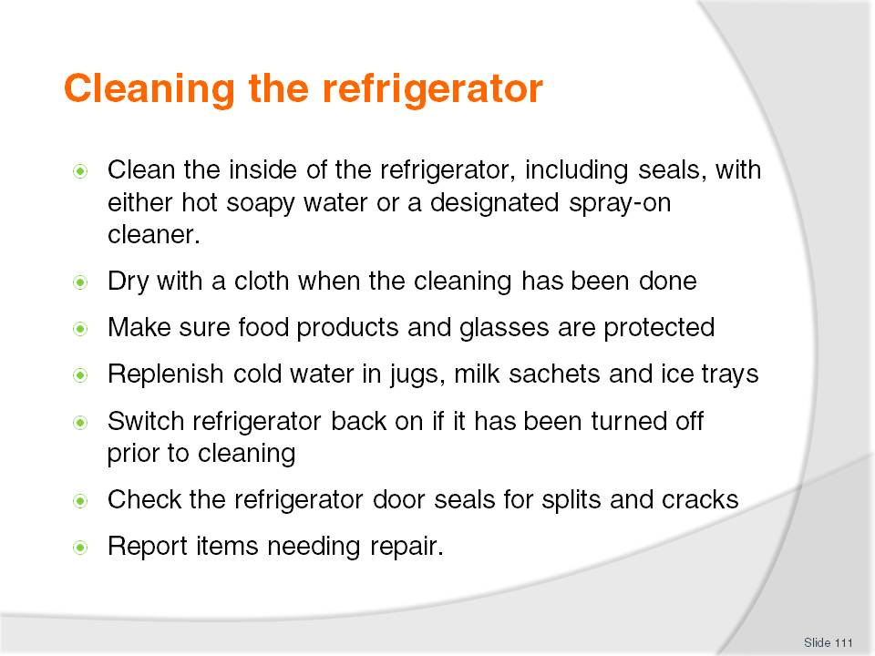
Slide No | Trainer Notes
Class Activity – General Discussion and Demonstration
Trainer to demonstrate and explain why steps are done as identified in the slide.
Trainees to practice cleaning a refrigerator.

Slide
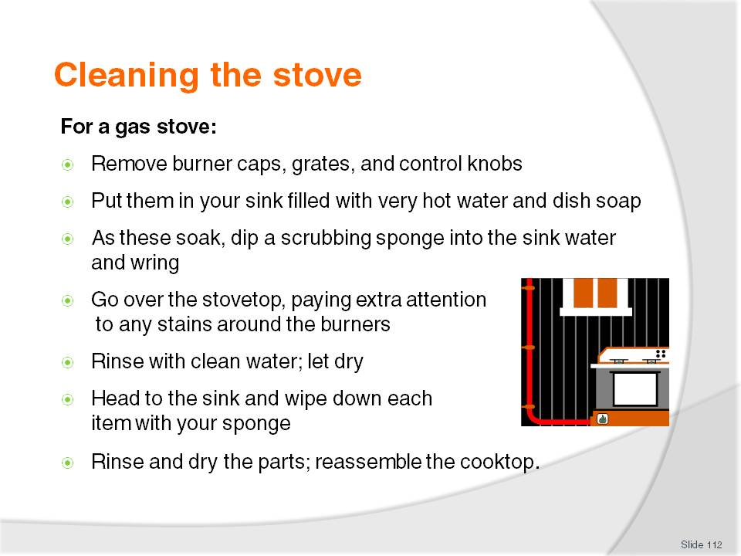
Slide No | Trainer Notes
Class Activity – General Discussion and Demonstration
Trainer to demonstrate and explain why steps are done as identified in the slide.
Trainees to practice cleaning a gas stove.

Slide
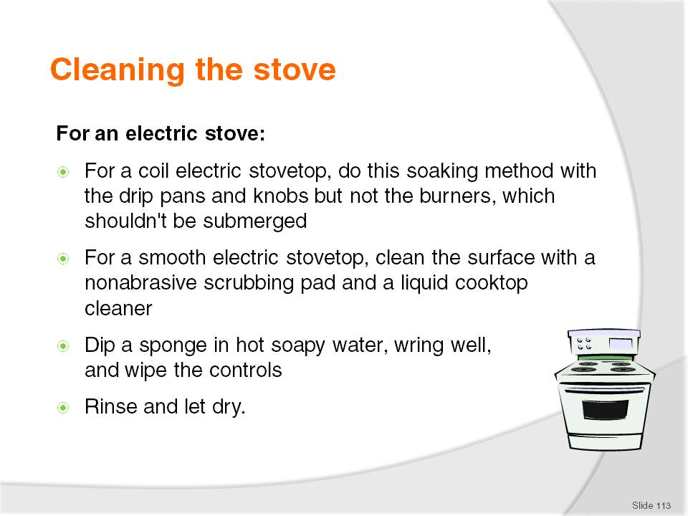
Slide No | Trainer Notes
Class Activity – General Discussion and Demonstration
Trainer to demonstrate and explain why steps are done as identified in the slide.
Trainees to practice cleaning an electric stove.

Slide
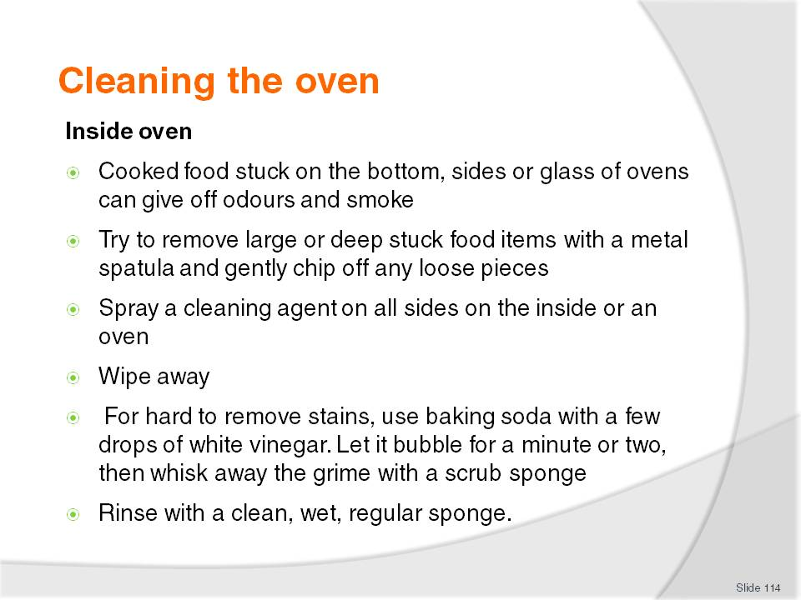
Slide No | Trainer Notes
Class Activity – General Discussion and Demonstration
Trainer to demonstrate and explain why steps are done as identified in the slide.
Trainees to practice cleaning an oven.

Slide
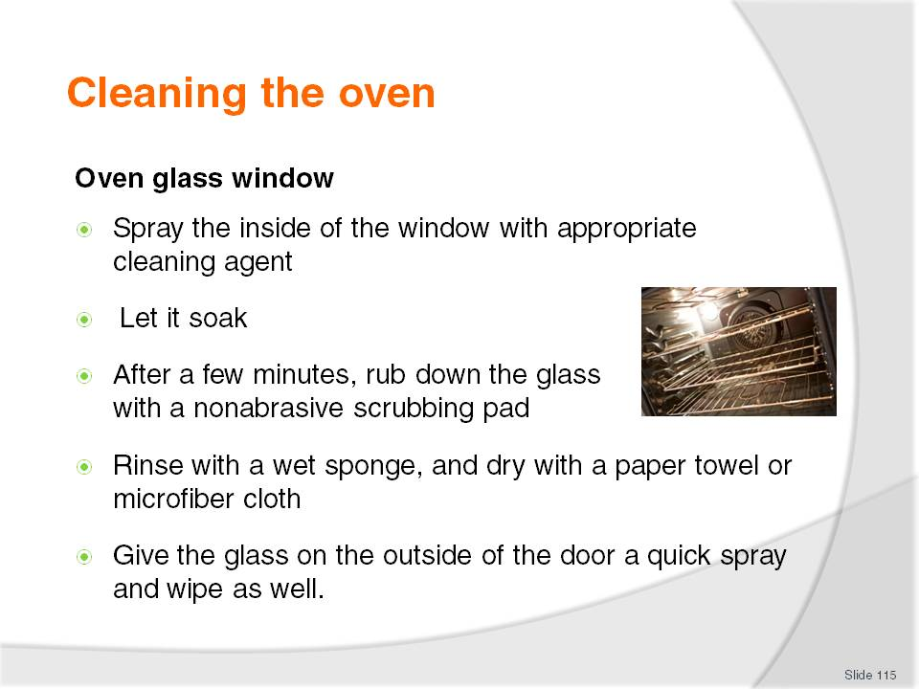
Slide No | Trainer Notes
Class Activity – General Discussion and Demonstration
Trainer to demonstrate and explain why steps are done as identified in the slide.
Trainees to practice cleaning an oven glass window.

Slide
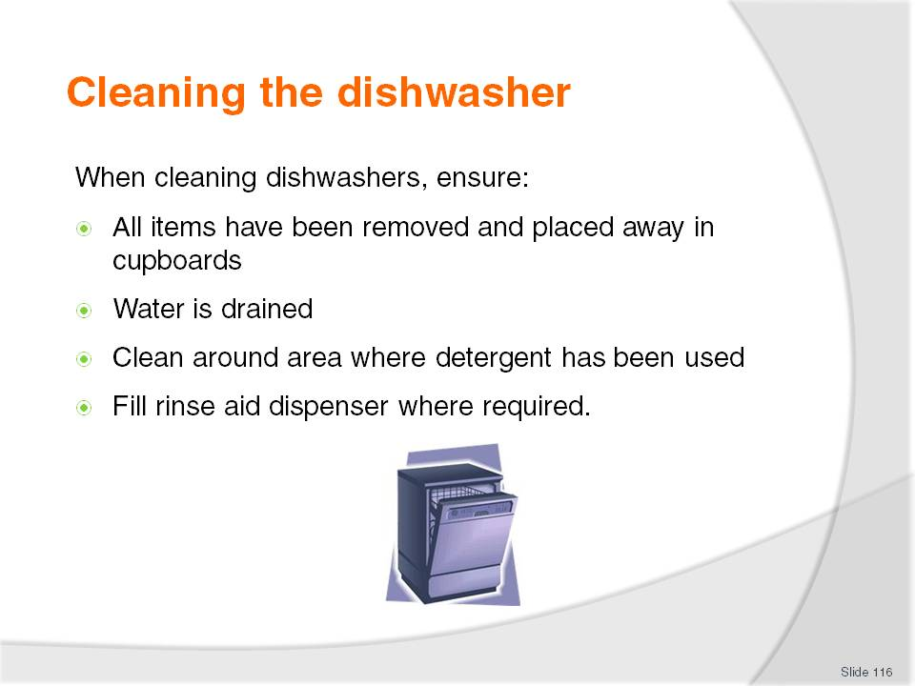
Slide No | Trainer Notes
Class Activity – General Discussion and Demonstration
Trainer to demonstrate and explain why steps are done as identified in the slide.
Trainees to practice cleaning a dishwasher.

Slide
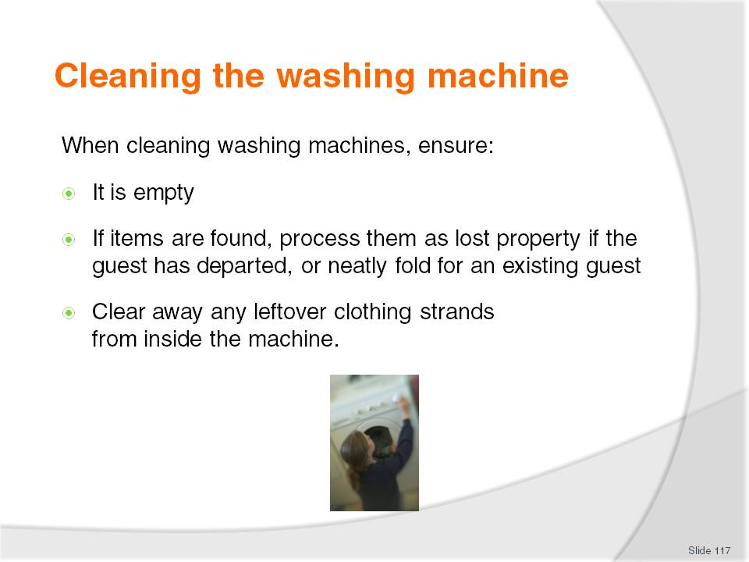
Slide No | Trainer Notes
Class Activity – General Discussion and Demonstration
Trainer to demonstrate and explain why steps are done as identified in the slide.
Trainees to practice cleaning a washing machine.

Slide
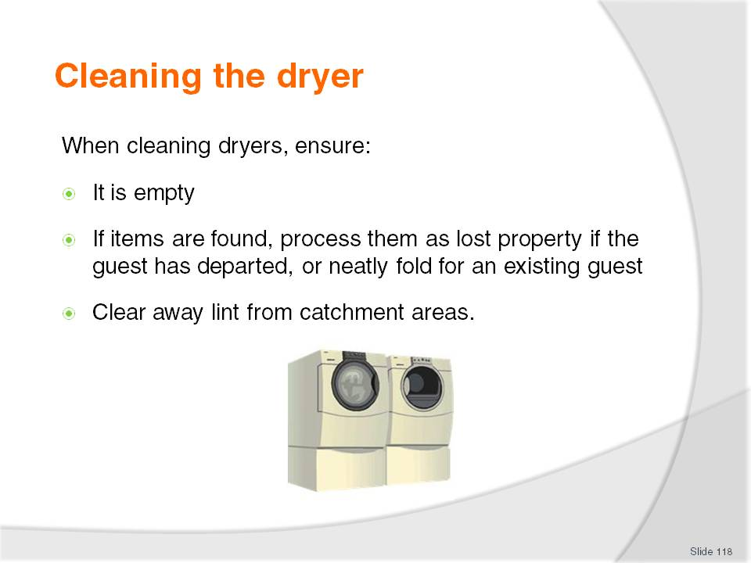
Slide No | Trainer Notes
Class Activity – General Discussion and Demonstration
Trainer to demonstrate and explain why steps are done as identified in the slide.
Trainees to practice cleaning a dryer.

Slide
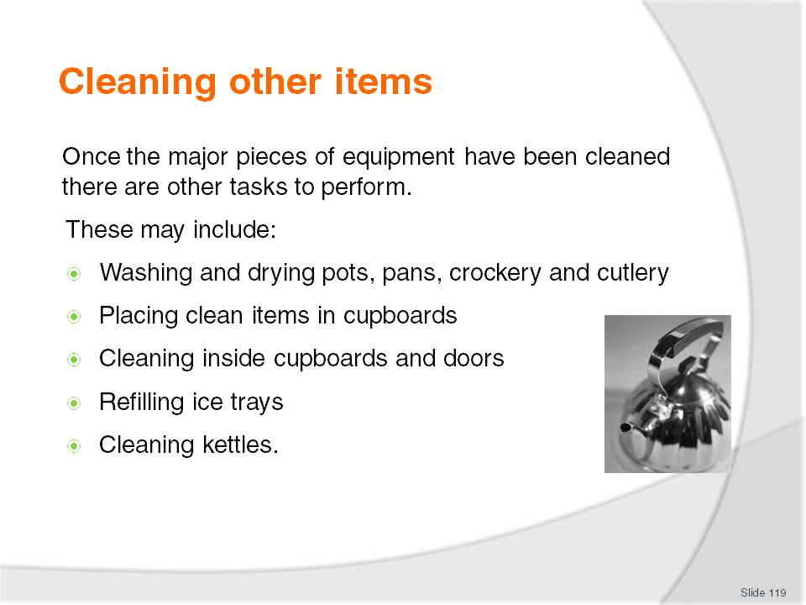
Slide No | Trainer Notes
Class Activity – General Discussion and Demonstration
Trainer to demonstrate and explain why steps are done as identified in the slide.
Trainees to practice cleaning other items.

Slide
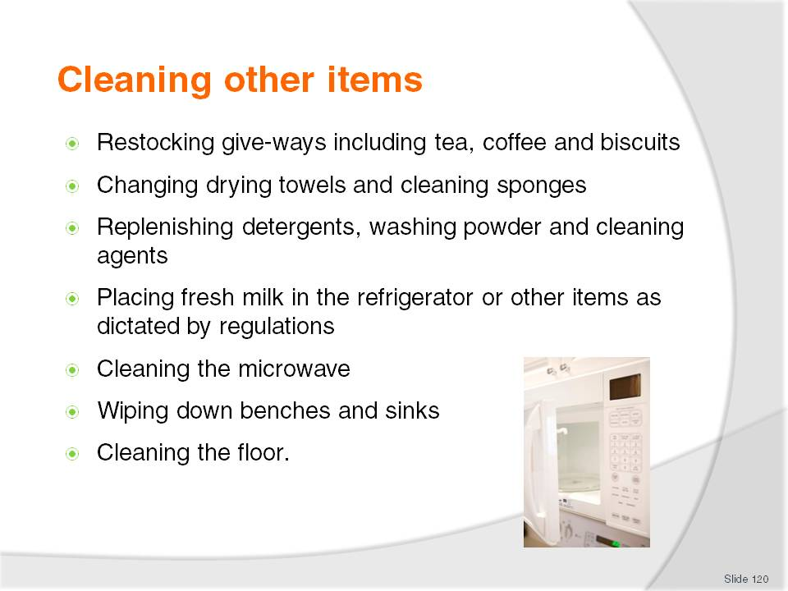
Slide No | Trainer Notes
Class Activity – General Discussion and Demonstration
Trainer to demonstrate and explain why steps are done as identified in the slide.
Trainees to practice cleaning other items.

Slide
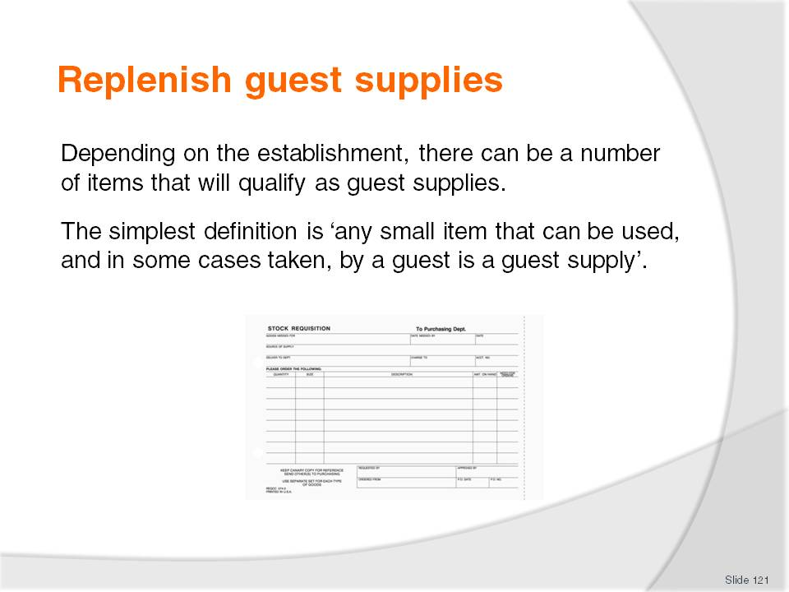
Slide No | Trainer Notes
Class Activity – General Discussion
What guest supplies are there?
Which ones do we allow guests to take?
Which ones do we charge for?

Slide
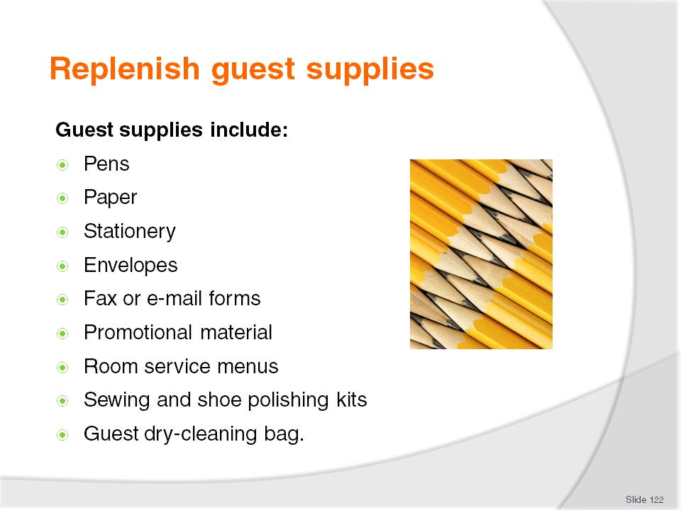
Slide No | Trainer Notes
Class Activity – General Discussion
Discuss the guest supplies in the slide:
Where are they located?
What is their quantity?
How should they be presented?
Do they expire? If so, how can you check they are still within the expiry date?

Slide
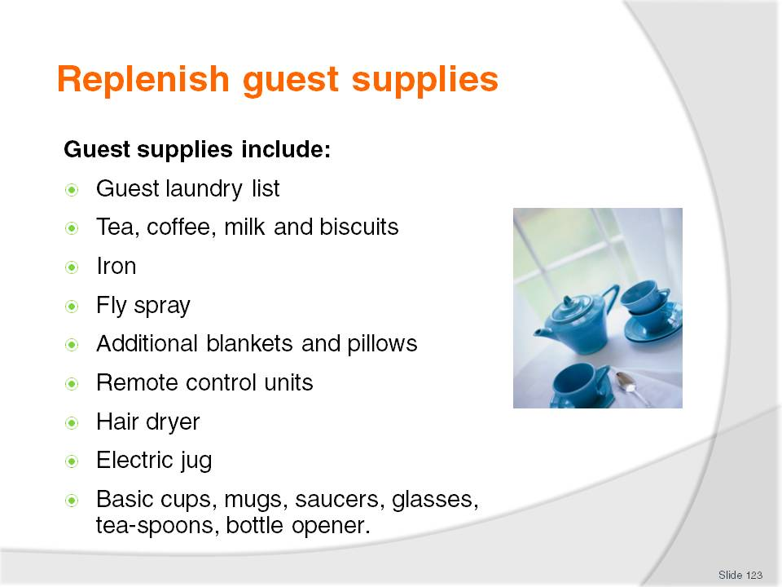
Slide No | Trainer Notes
Class Activity – General Discussion
Discuss the guest supplies in the slide:
Where are they located?
What is their quantity?
How should they be presented?
Do they expire? If so, how can you check they are still within the expiry date?

Slide
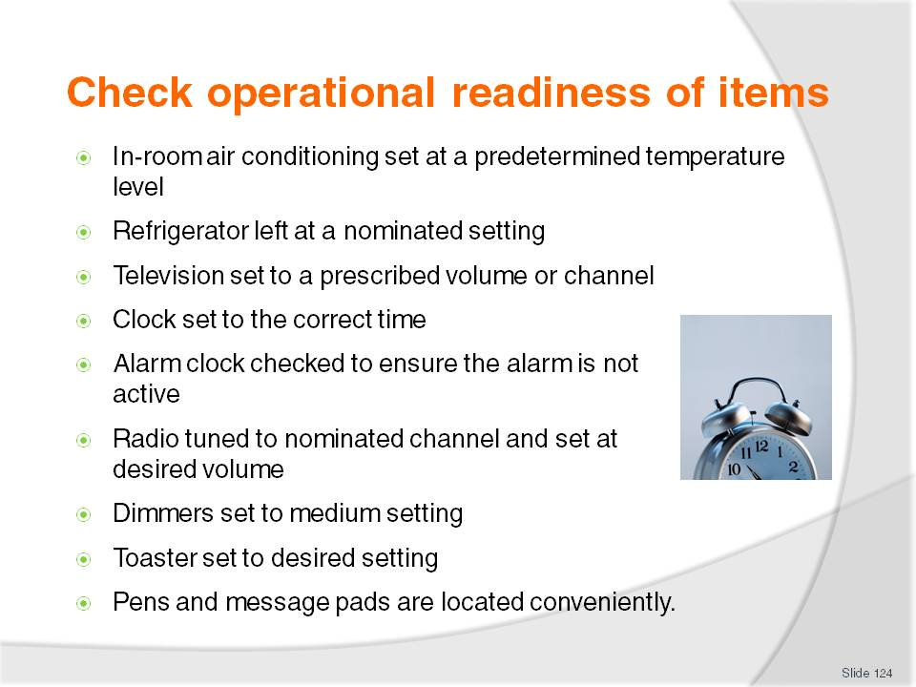
Slide No | Trainer Notes
Class Activity – General Discussion and Demonstration
Trainer to demonstrate and explain why steps are done as identified in the slide.
Trainees to practice checking the operational readiness of items.

Slide
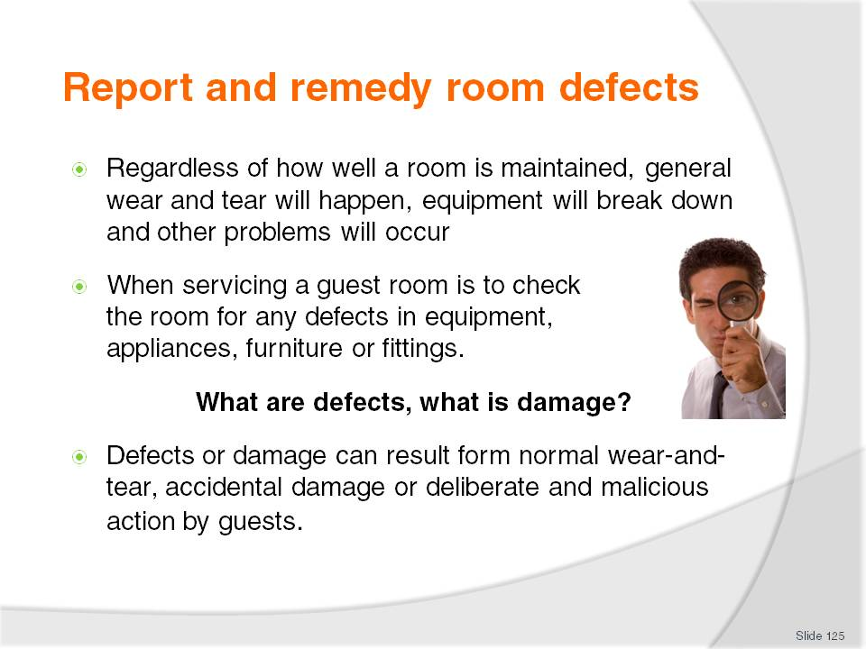
Slide No | Trainer Notes
Class Activity – General Discussion
What is the difference between a defect and damage?
What items normally have defects?
What items normally have damage?

Slide
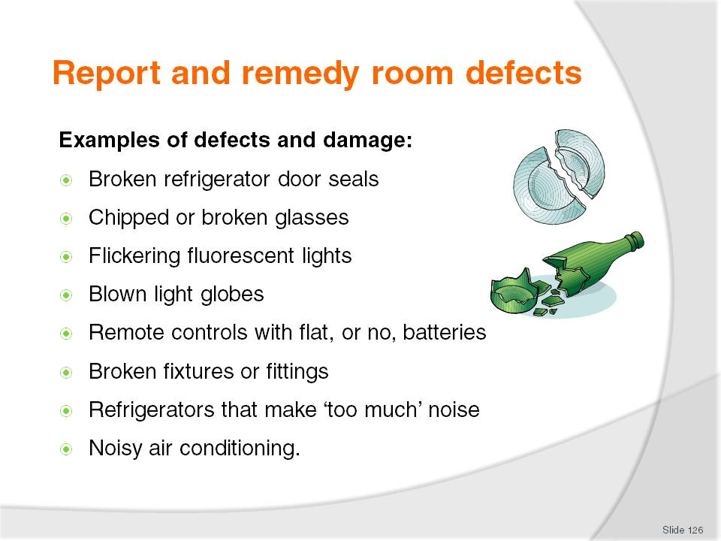
Slide No | Trainer Notes
Class Activity – General Discussion
What causes it?
What can you do about it?

Slide
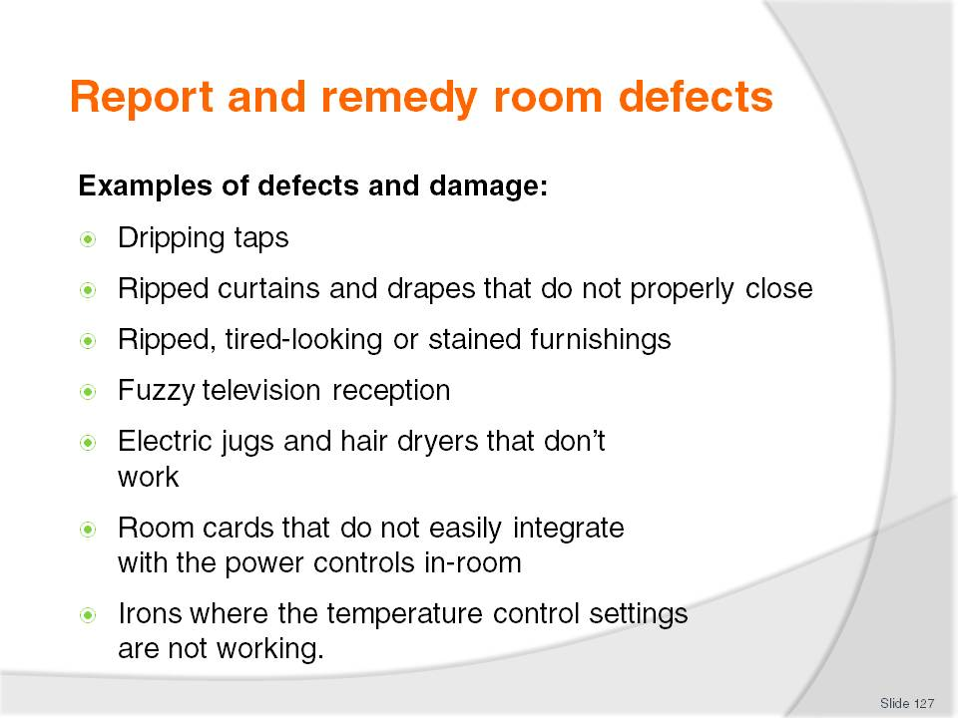
Slide No | Trainer Notes
Class Activity – General Discussion
What causes it?
What can you do about it?

Slide
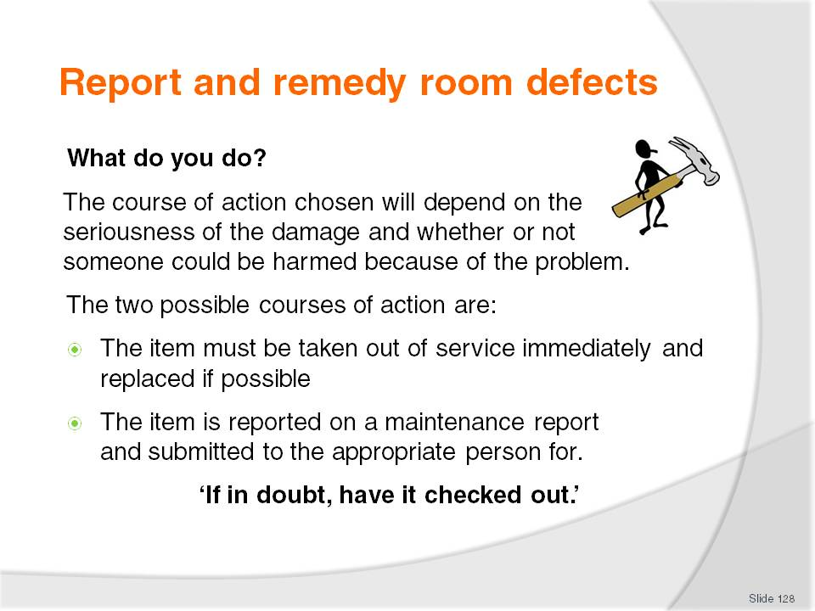
Slide No | Trainer Notes
Class Activity – General Discussion
Go back the list on the last 2 pages and identify which items can be:
- Replaced
- Will need to be repaired in the room.

Slide
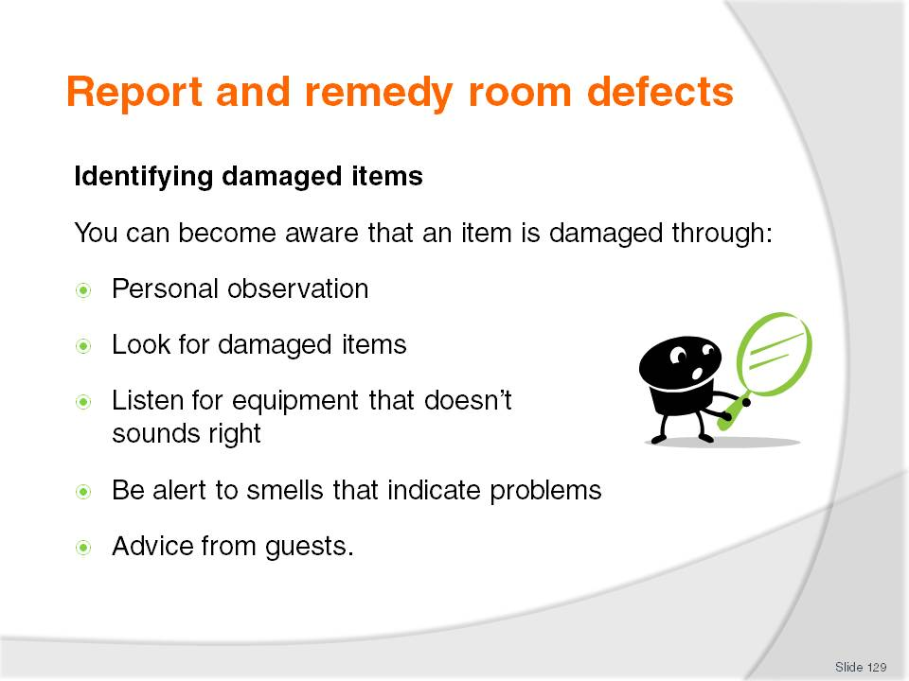
Slide No | Trainer Notes
Class Activity – General Discussion
Personal observation and guest comments are the two common ways.
When can you observe?
How do guests normally advise staff of problems?

Slide
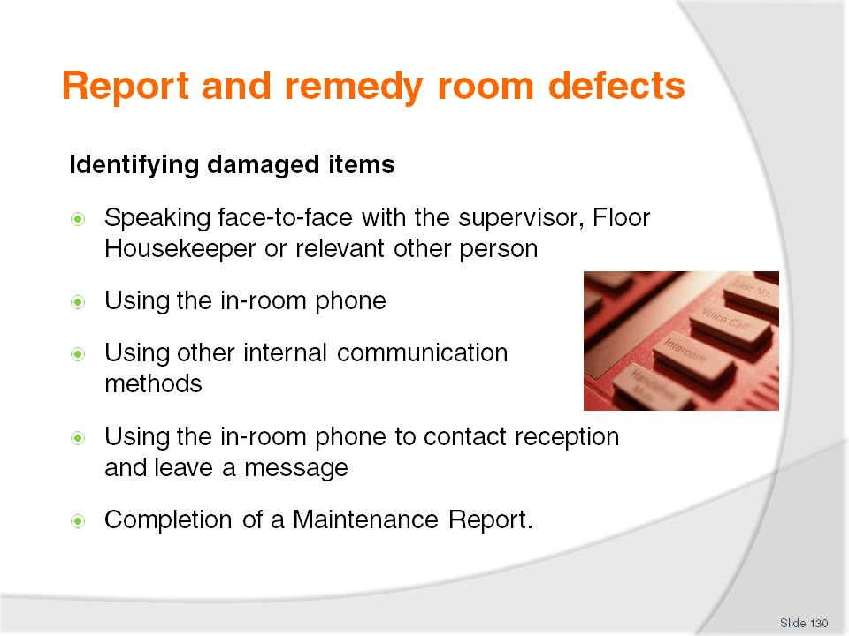
Slide No | Trainer Notes
Class Activity – General Discussion
Which is the best way and why?

Slide
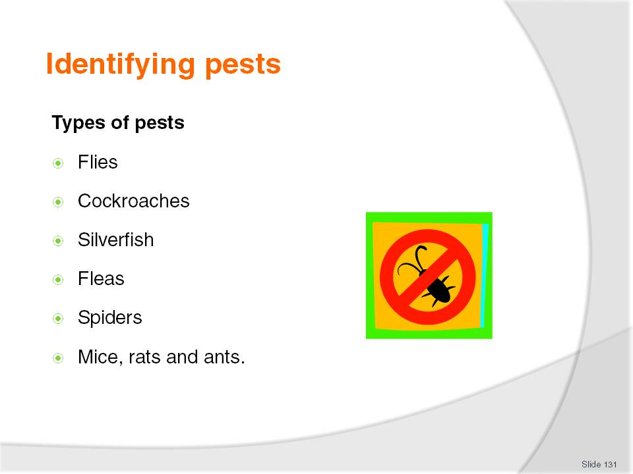
Slide No | Trainer Notes
Class Activity – General Discussion
What are common pests and how do you eliminate their presence?

Slide
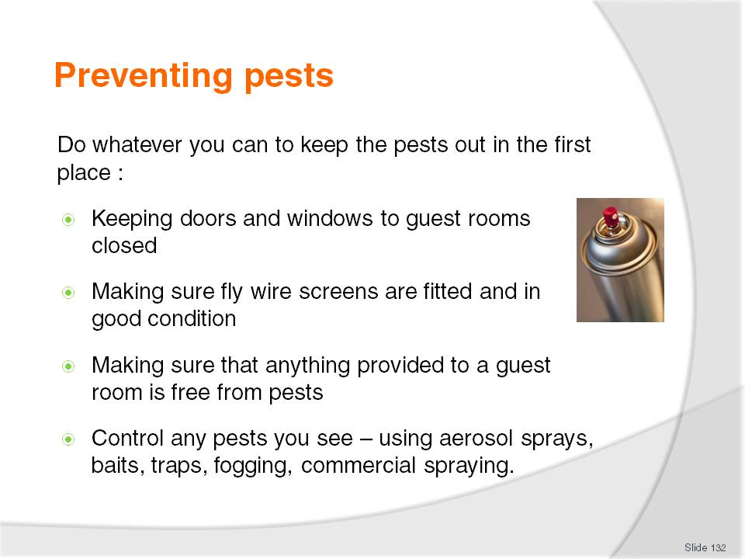
Slide No | Trainer Notes
Class Activity – General Discussion
What is the best way to prevent them?

Slide
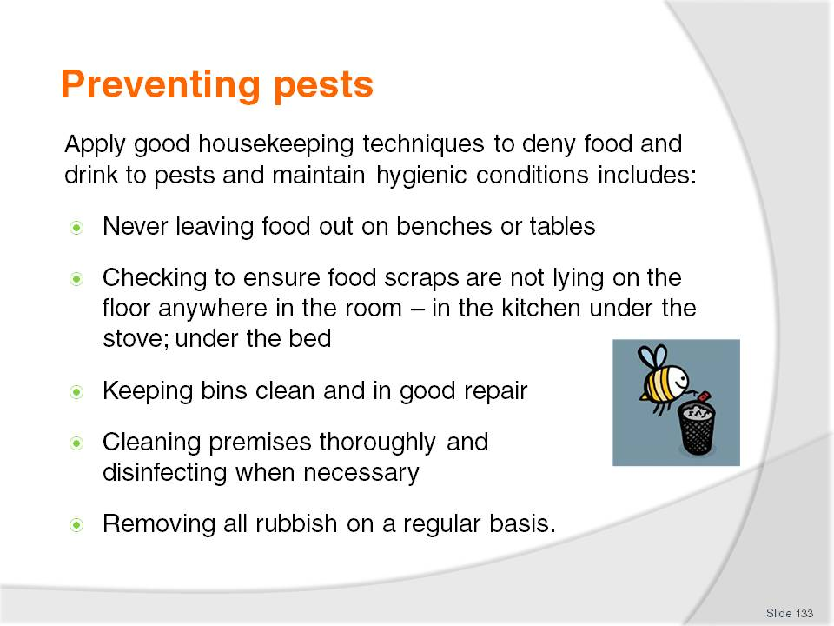
Slide No | Trainer Notes
Class Activity – General Discussion
What are other ways to keep food and beverage away?

Slide
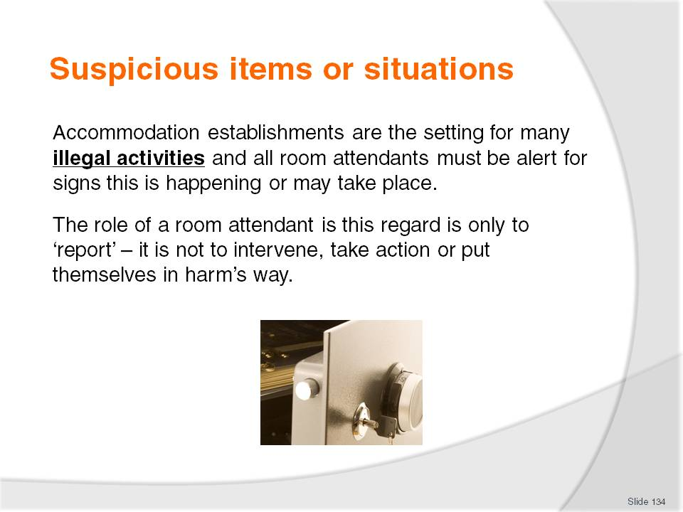
Slide No | Trainer Notes
Class Activity – General Discussion
What are illegal activities that commonly take place in hotel rooms?
How do you know they are happening?
What can you do about it?

Slide
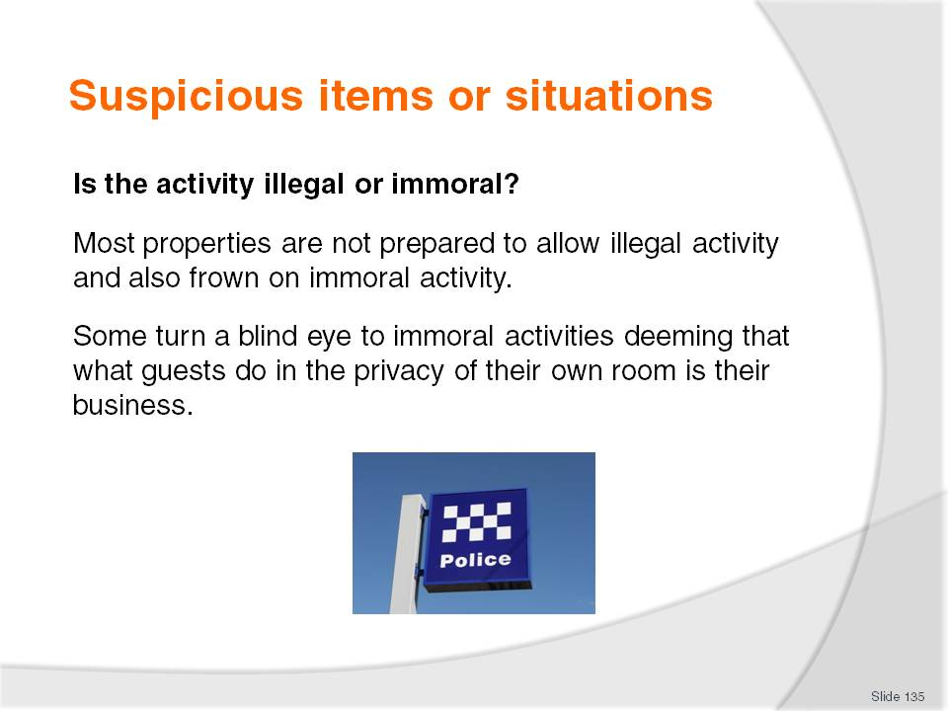
Slide No | Trainer Notes
Class Activity – General Discussion
What are the common immoral activities that take place in guest rooms?
What can you do about it?

Slide
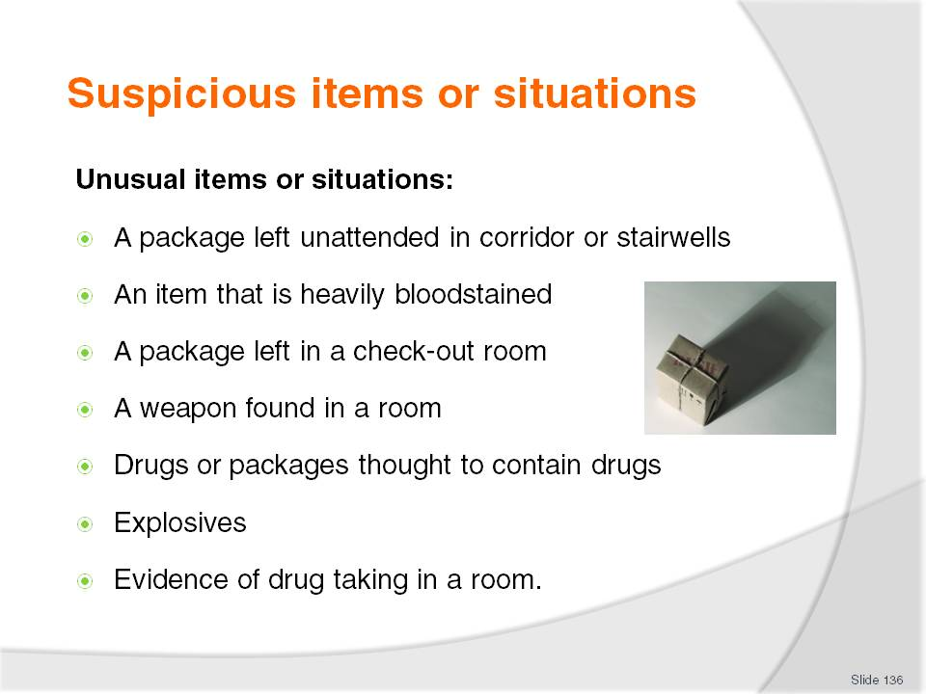
Slide No | Trainer Notes
Class Activity – General Discussion
What are common items found?

Slide
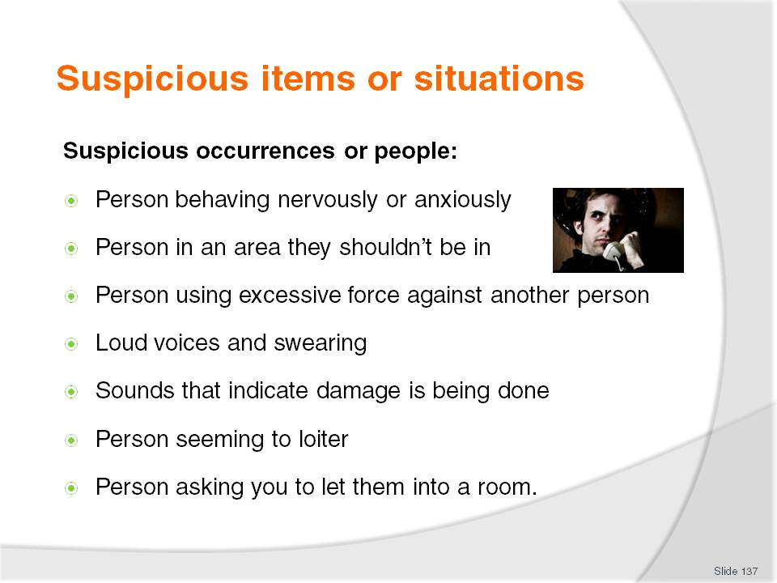
Slide No | Trainer Notes
Class Activity – General Discussion
What are common suspicious occurrences or people?

Slide
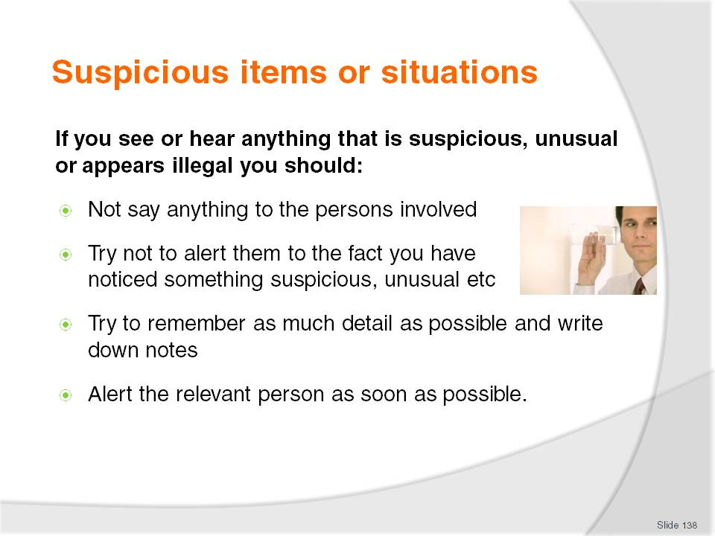
Slide No | Trainer Notes
Class Activity – General Discussion
What do you normally do?

Slide
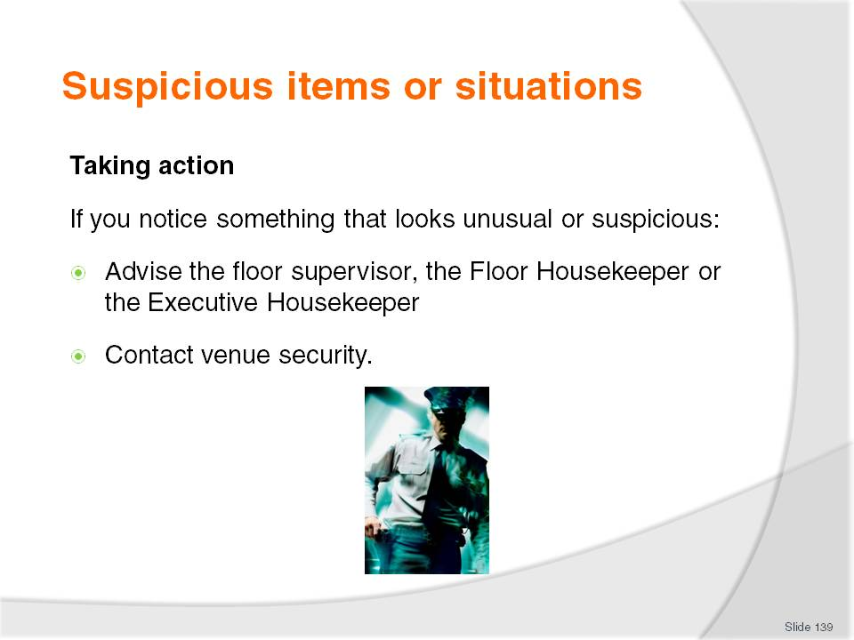
Slide No | Trainer Notes
Class Activity – General Discussion
In what cases would you contact security directly?

Slide
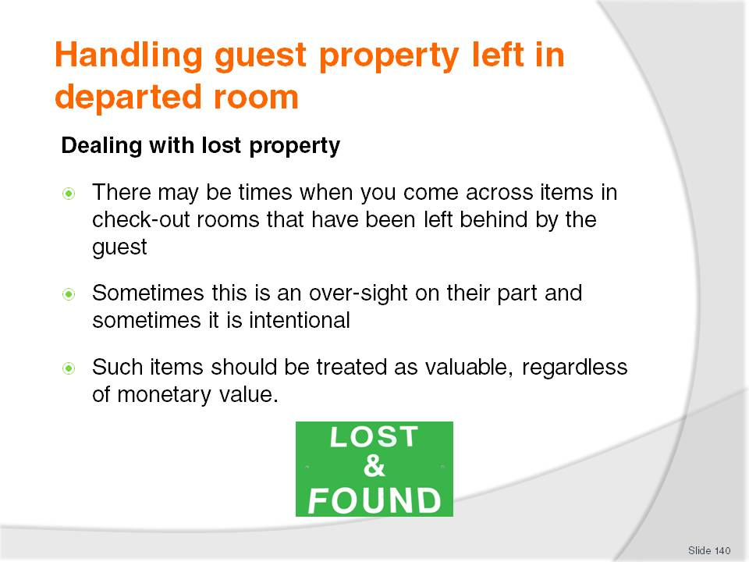
Slide No | Trainer Notes
Class Activity – General Discussion
What items are usually left in rooms?
Where are they normally located?
Are they left there intentionally?

Slide
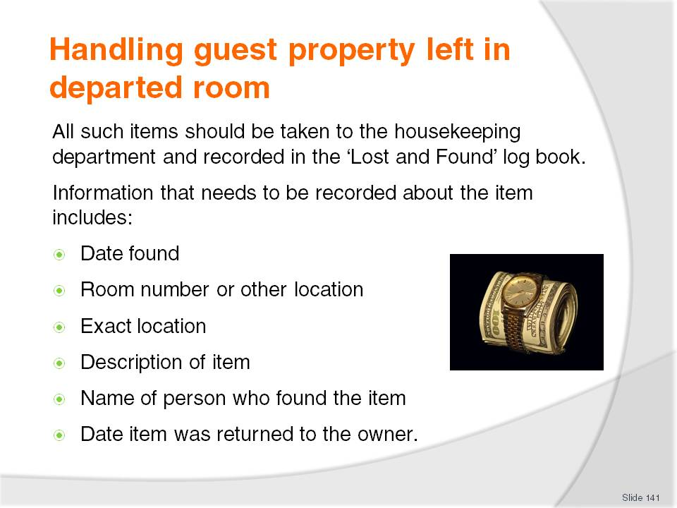
Slide No | Trainer Notes
Class Activity – General Discussion
What it the procedure in most hotels?

Slide
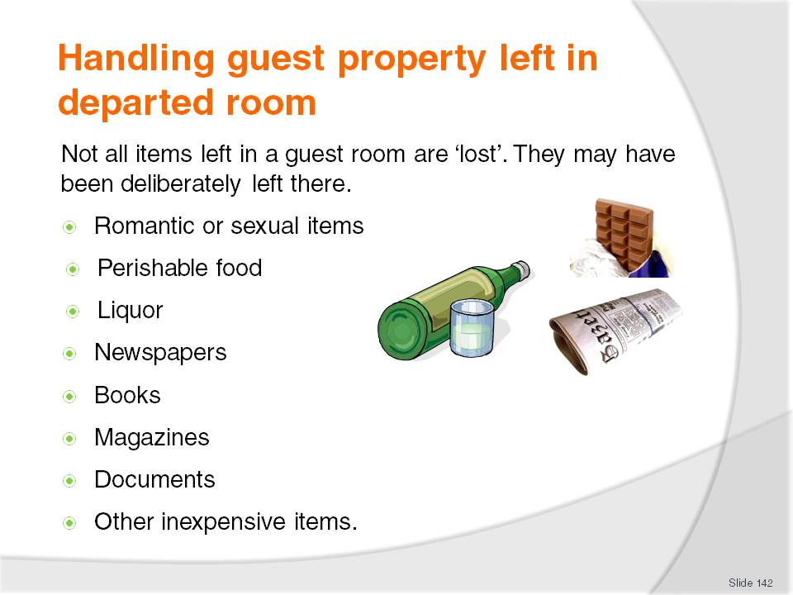
Slide No | Trainer Notes
Class Activity – General Discussion
What is the procedure in most hotels for handling items that are considered to be left on purpose?

Slide
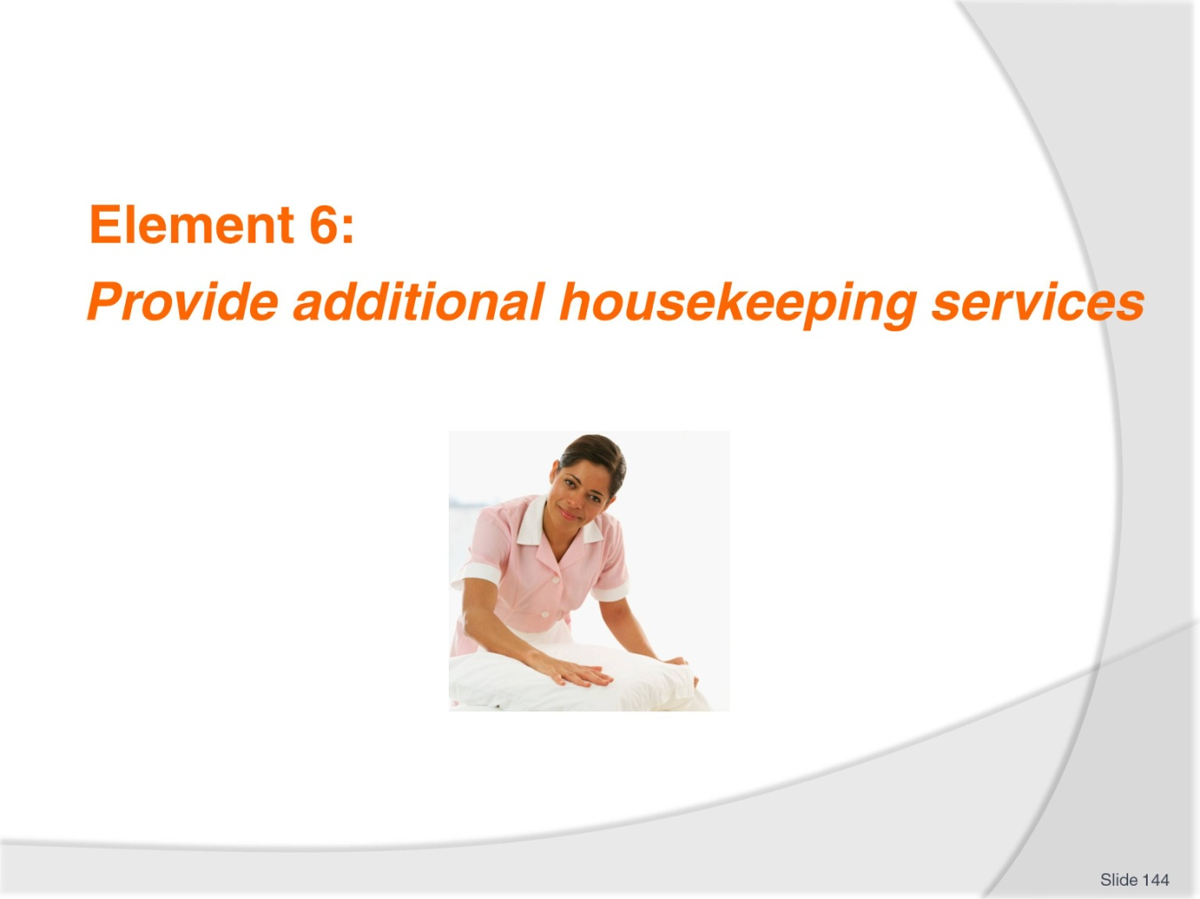
Slide No | Trainer Notes
Introduce topic.
Class Activity – General Discussion
Ask general questions:
What are additional housekeeping services?
When would these be done?

Slide
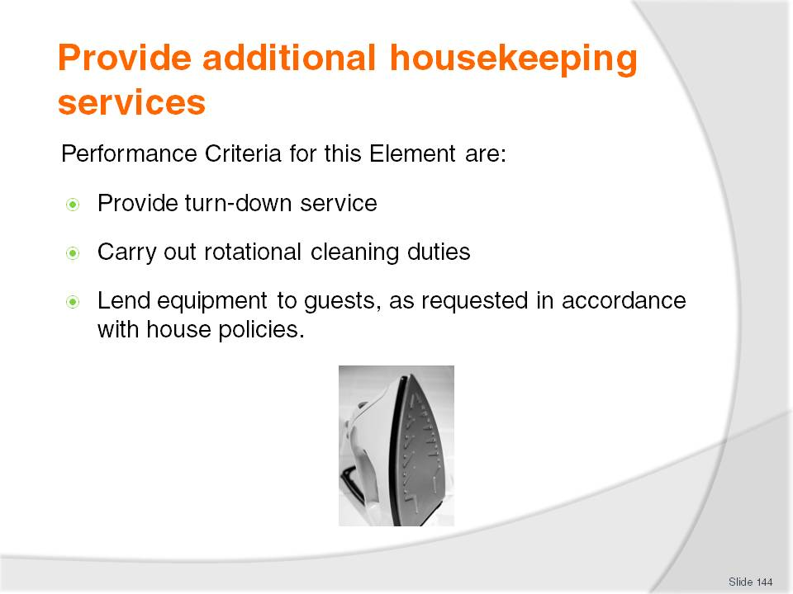
Slide No | Trainer Notes
 | Trainer identifies the Performance Criteria for this Element, as listed on the slide.

Slide
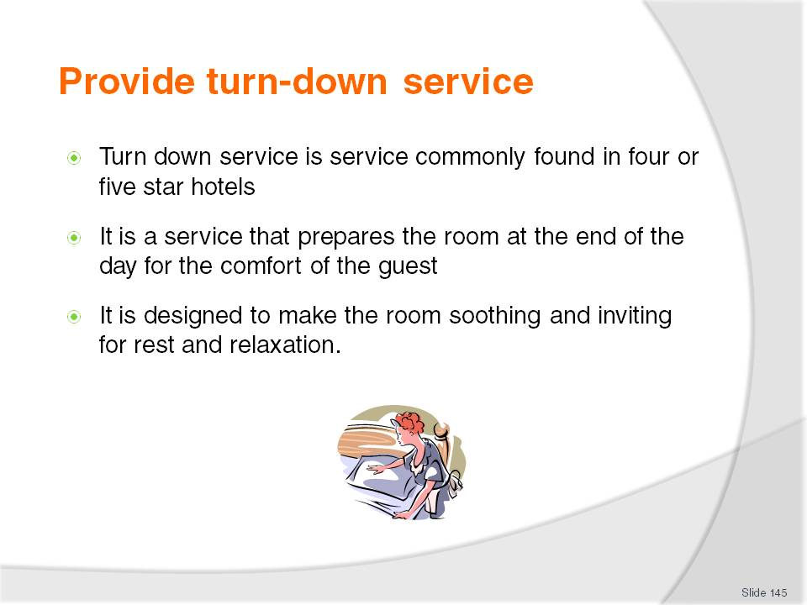
Slide No | Trainer Notes
Class Activity – General Discussion
What activities are involved in turn-down service?
When should it take place?
How long should it take?

Slide
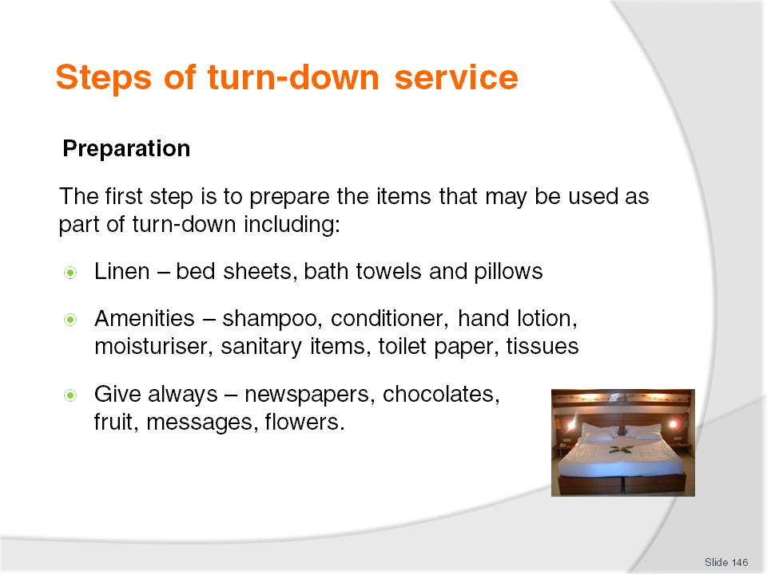
Slide No | Trainer Notes
Class Activity – General Discussion and Demonstration
Trainer to demonstrate and explain why steps are done as identified in the slide.
Trainees to practice turning down a room.

Slide
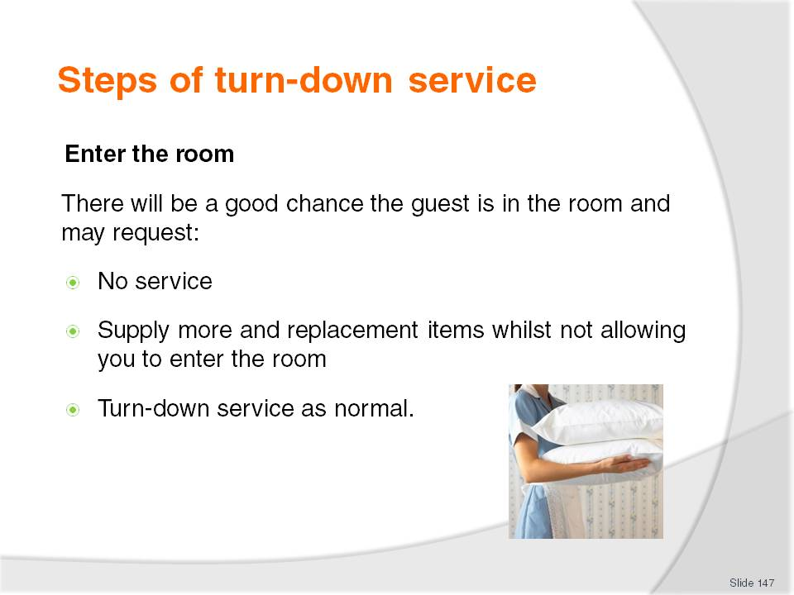
Slide No | Trainer Notes
Class Activity – General Discussion and Demonstration
Trainer to demonstrate and explain why steps are done as identified in the slide.
Trainees to practice turning down a room.
What are common supplies a guest would normally ask for?

Slide
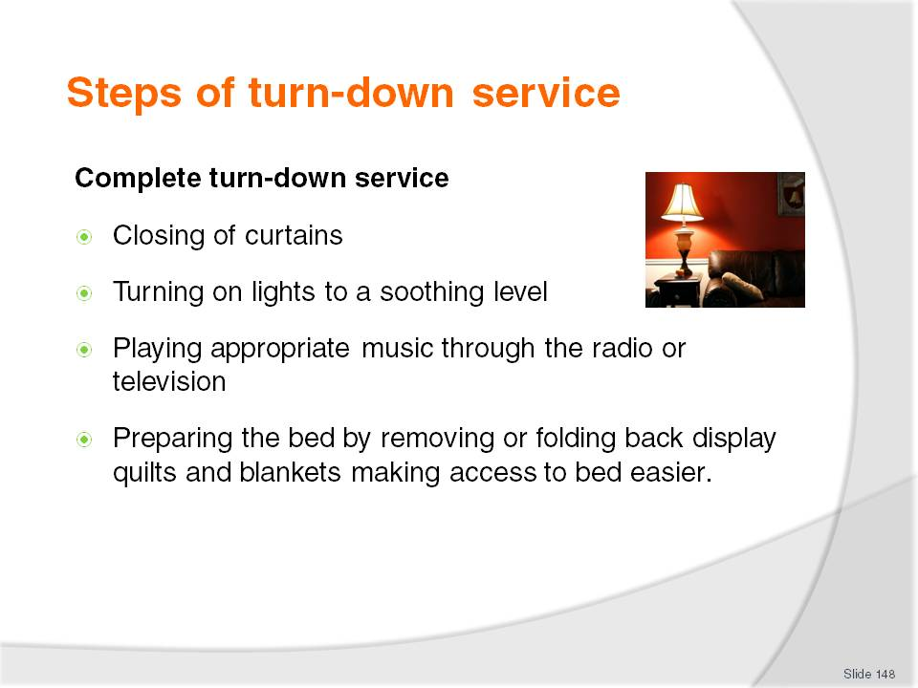
Slide No | Trainer Notes
Class Activity – General Discussion and Demonstration
Trainer to demonstrate and explain why steps are done as identified in the slide.
Trainees to practice turning down a room.

Slide
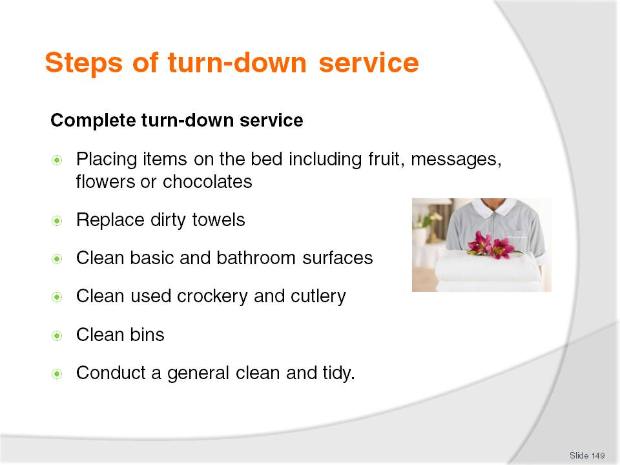
Slide No | Trainer Notes
Class Activity – General Discussion and Demonstration
Trainer to demonstrate and explain why steps are done as identified in the slide.
Trainees to practice turning down a room.

Slide
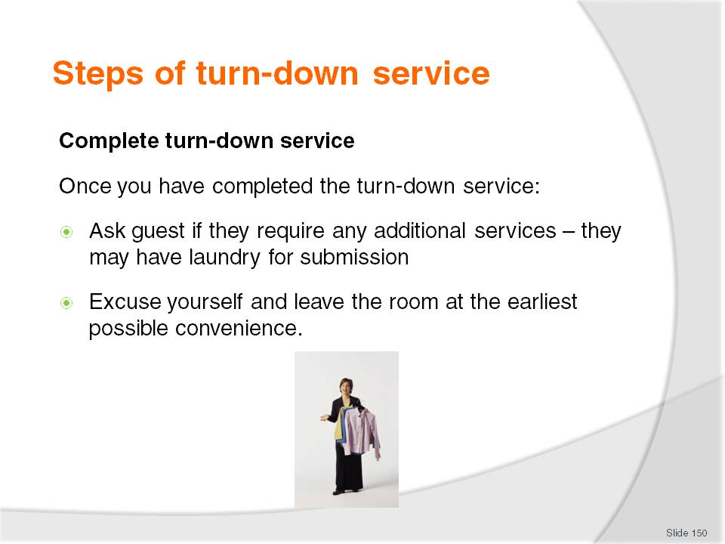
Slide No | Trainer Notes
Class Activity – General Discussion and Demonstration
Trainer to demonstrate and explain why steps are done as identified in the slide.
Trainees to practice turning down a room.

Slide
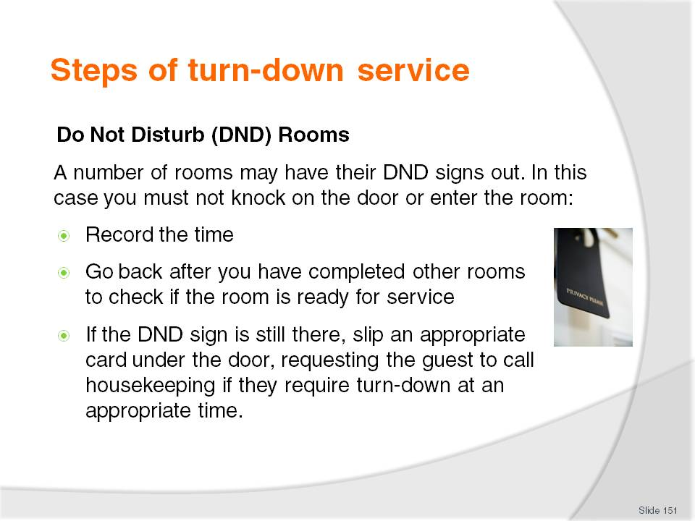
Slide No | Trainer Notes
Class Activity – General Discussion
What it the procedure in most hotels?

Slide
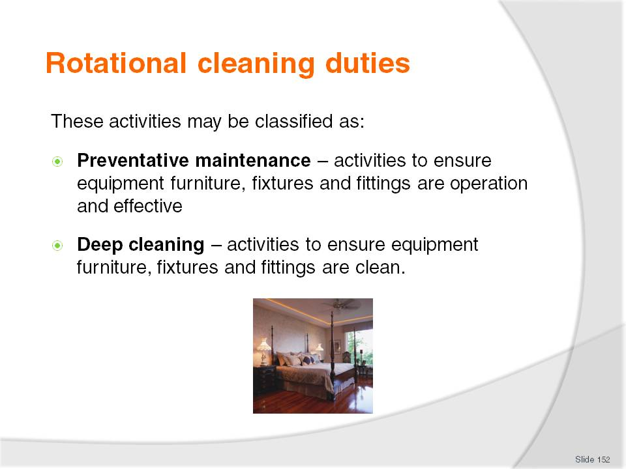
Slide No | Trainer Notes
Class Activity – General Discussion
What are examples of preventative maintenance?
What are examples of deep cleaning?

Slide
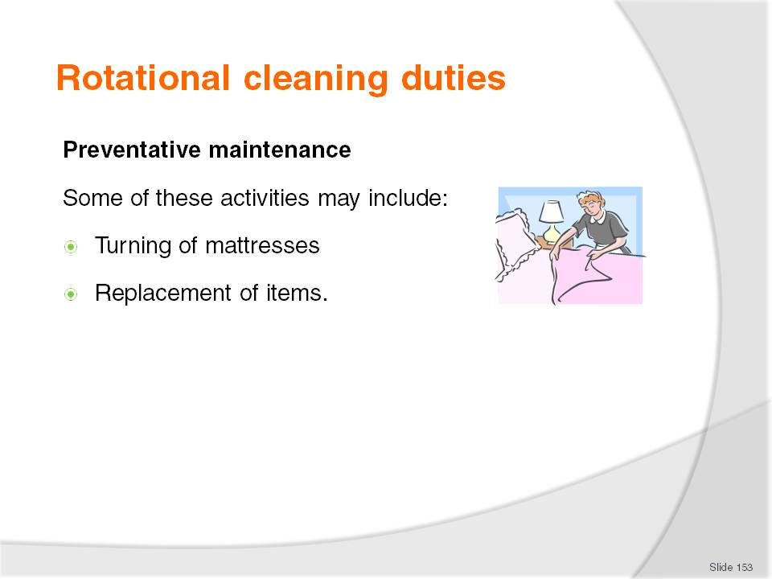
Slide No | Trainer Notes
Class Activity – General Discussion
Why do mattresses need to be turned?
What items need to be replaced on a regular basis? Why?

Slide
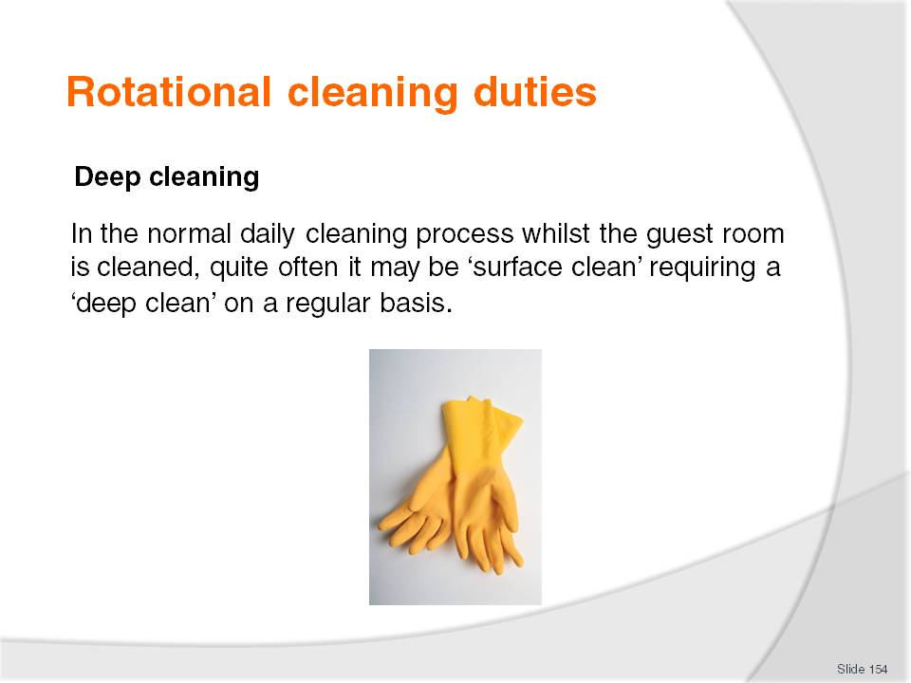
Slide No | Trainer Notes
Class Activity – General Discussion
What areas of a room need deep cleaning?
Why?
When should it be done?

Slide
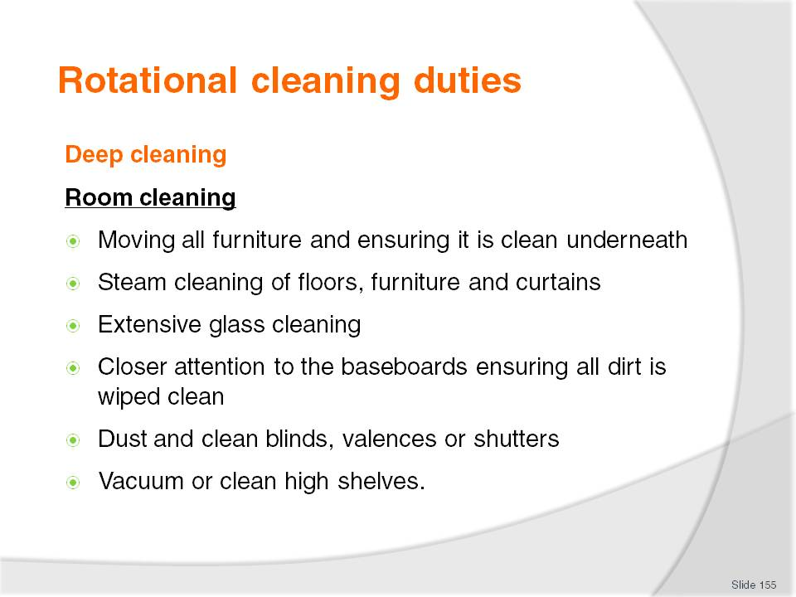
Slide No | Trainer Notes
Class Activity – General Discussion
For each of the items needing deep cleaning provide an explanation of the exact cleaning to take place.

Slide
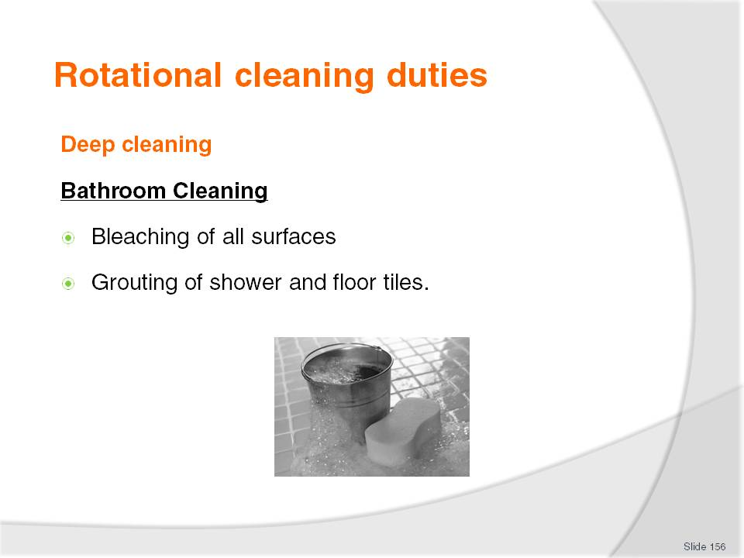
Slide No | Trainer Notes
Class Activity – General Discussion
For each of the items needing deep cleaning provide an explanation of the exact cleaning to take place.

Slide
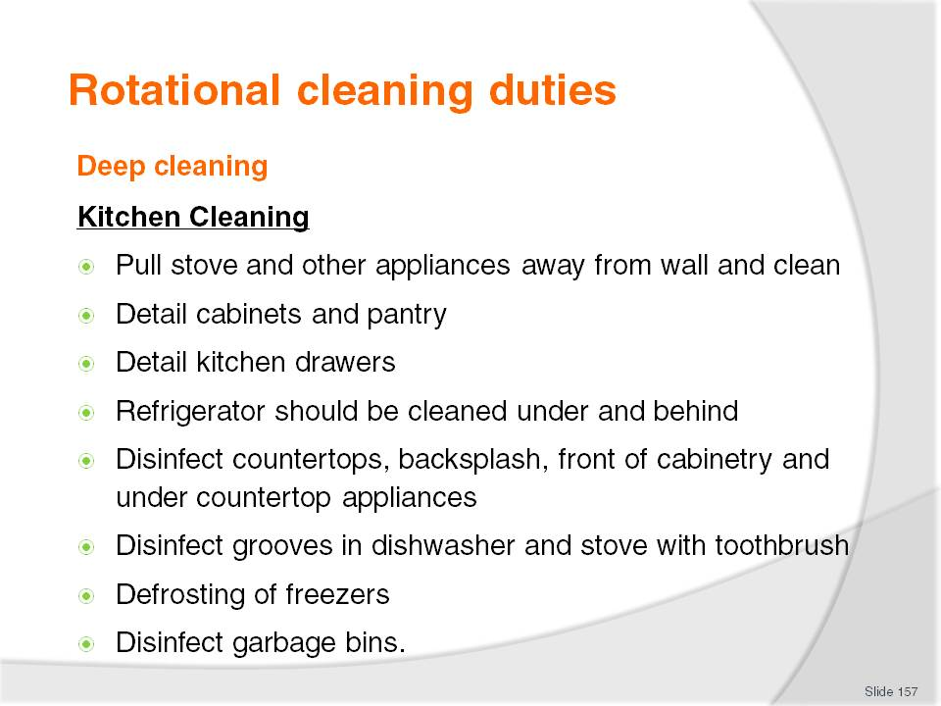
Slide No | Trainer Notes
Class Activity – General Discussion
For each of the items needing deep cleaning provide an explanation of the exact cleaning to take place.

Slide
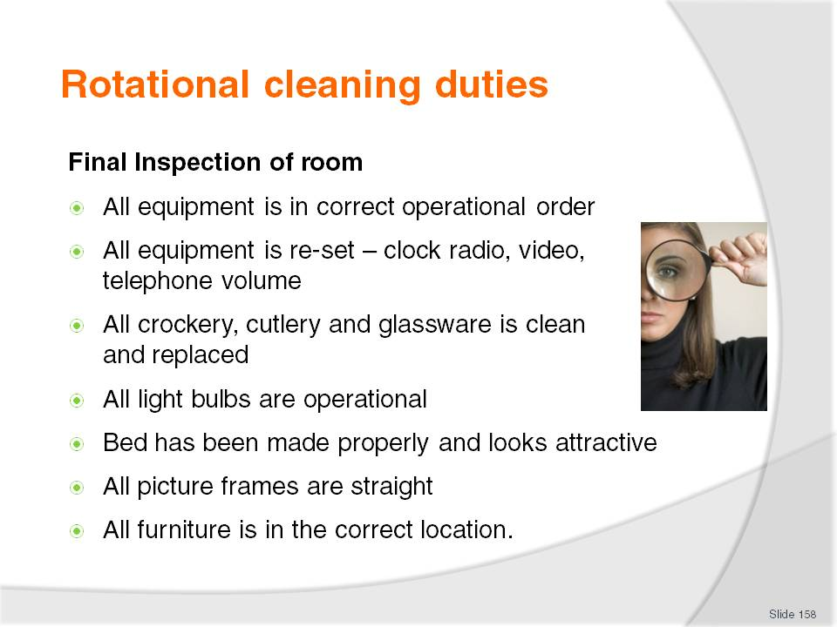
Slide No | Trainer Notes
Class Activity – General Discussion
For each of the items needing inspection provide an explanation of the exact cleaning to take place.

Slide
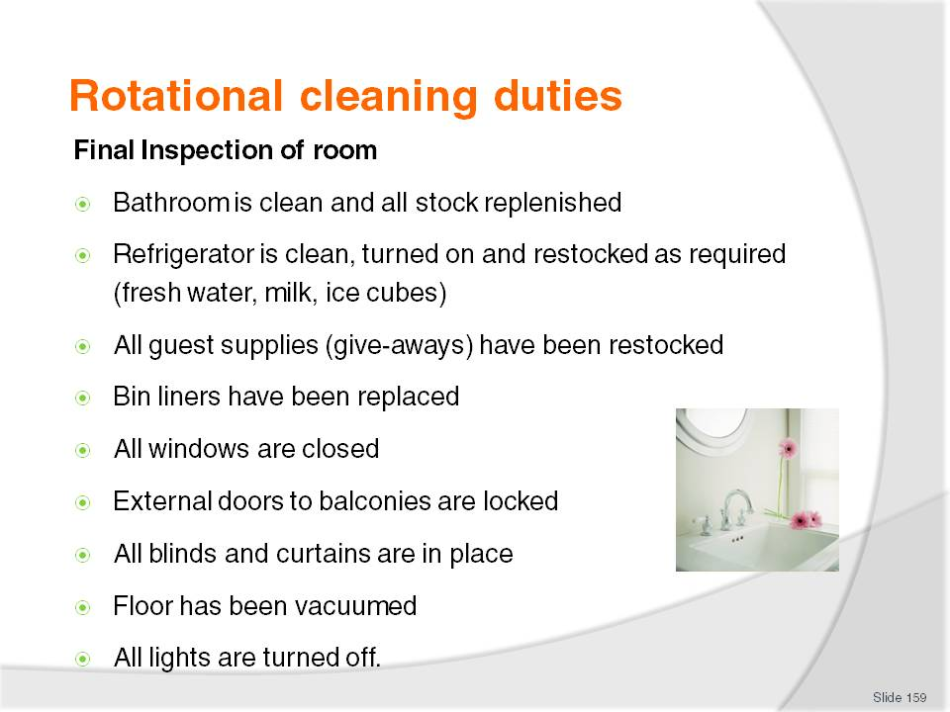
Slide No | Trainer Notes
Class Activity – General Discussion
For each of the items needing inspection provide an explanation of the exact cleaning to take place.

Slide
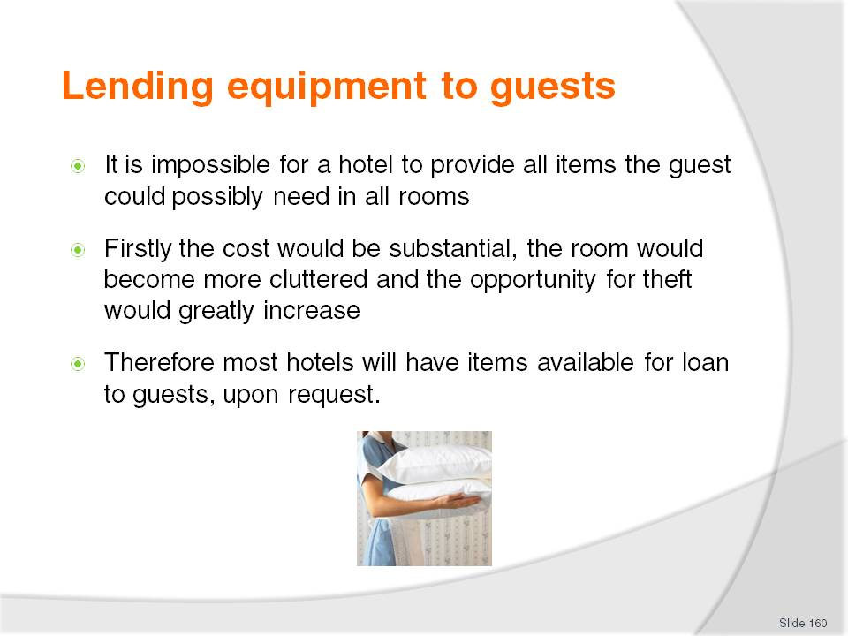
Slide No | Trainer Notes
Class Activity – General Discussion
What items are normally loaned to guests?
Is there a charge?
What procedures take place when loaning items?

Slide
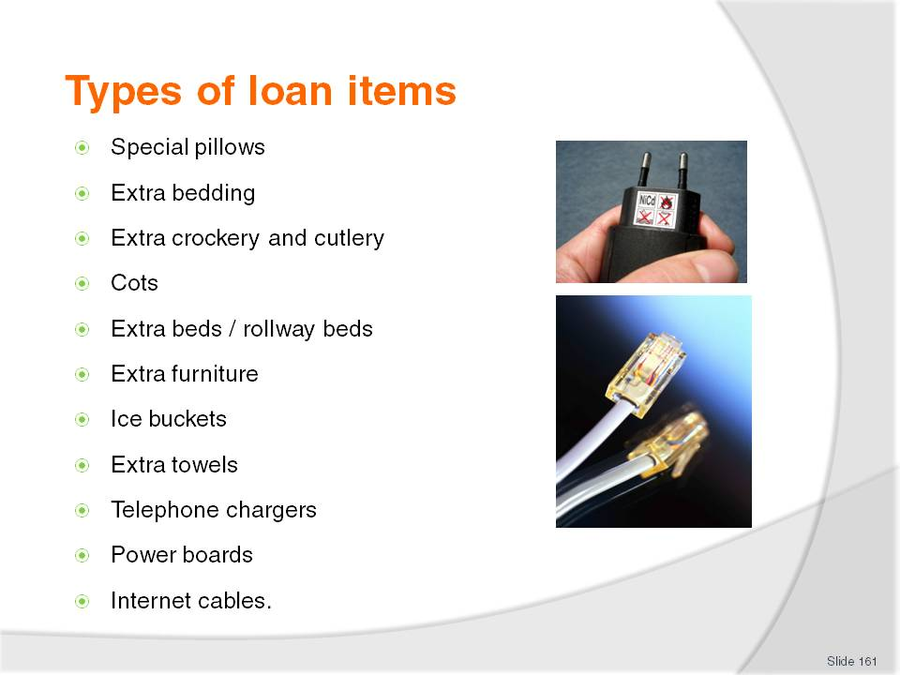
Slide No | Trainer Notes
Class Activity – General Discussion
For each of the loan items, identify:
Is there a charge?
What procedures take place when loaning items?

Slide
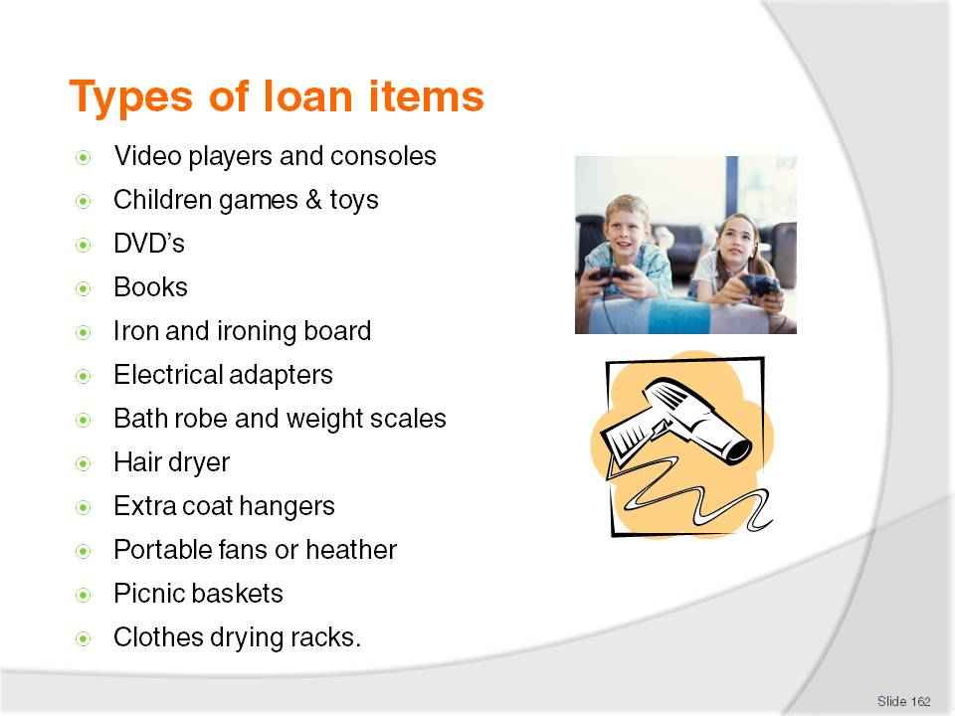
Slide No | Trainer Notes
Class Activity – General Discussion
For each of the loan items, identify:
Is there a charge?
What procedures take place when loaning items?

Slide
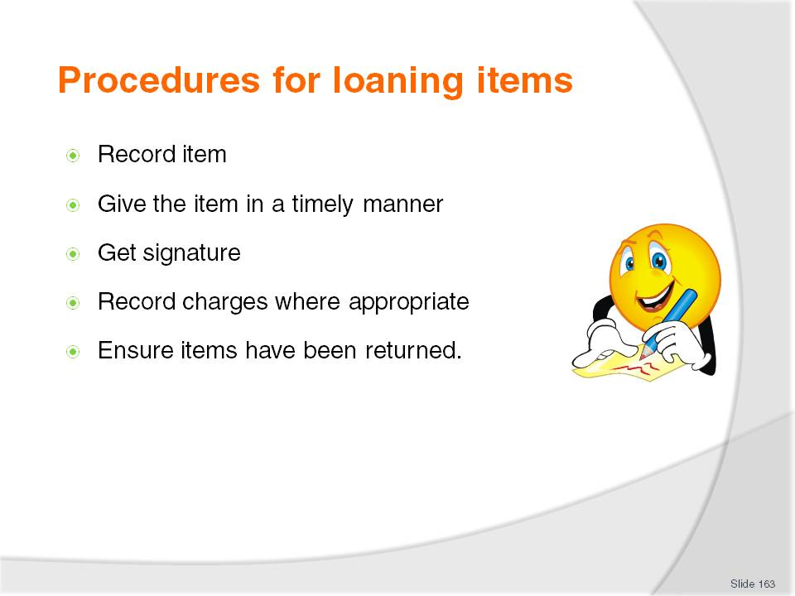
Slide No | Trainer Notes
Record item – this is to ensure that once the guest has departed the item is still in the room and accounted for and that the appropriate action is taken to return it to its appropriate storage location
Give the item in a timely manner – this is the most important aspect. It is important to get the item as soon as possible to the guest
Get signature – at times a guest signature may be required if an item is expensive or if there is a charge involved
Record charges where appropriate – this is often completed at Front Office
Ensure items have been returned.

Slide
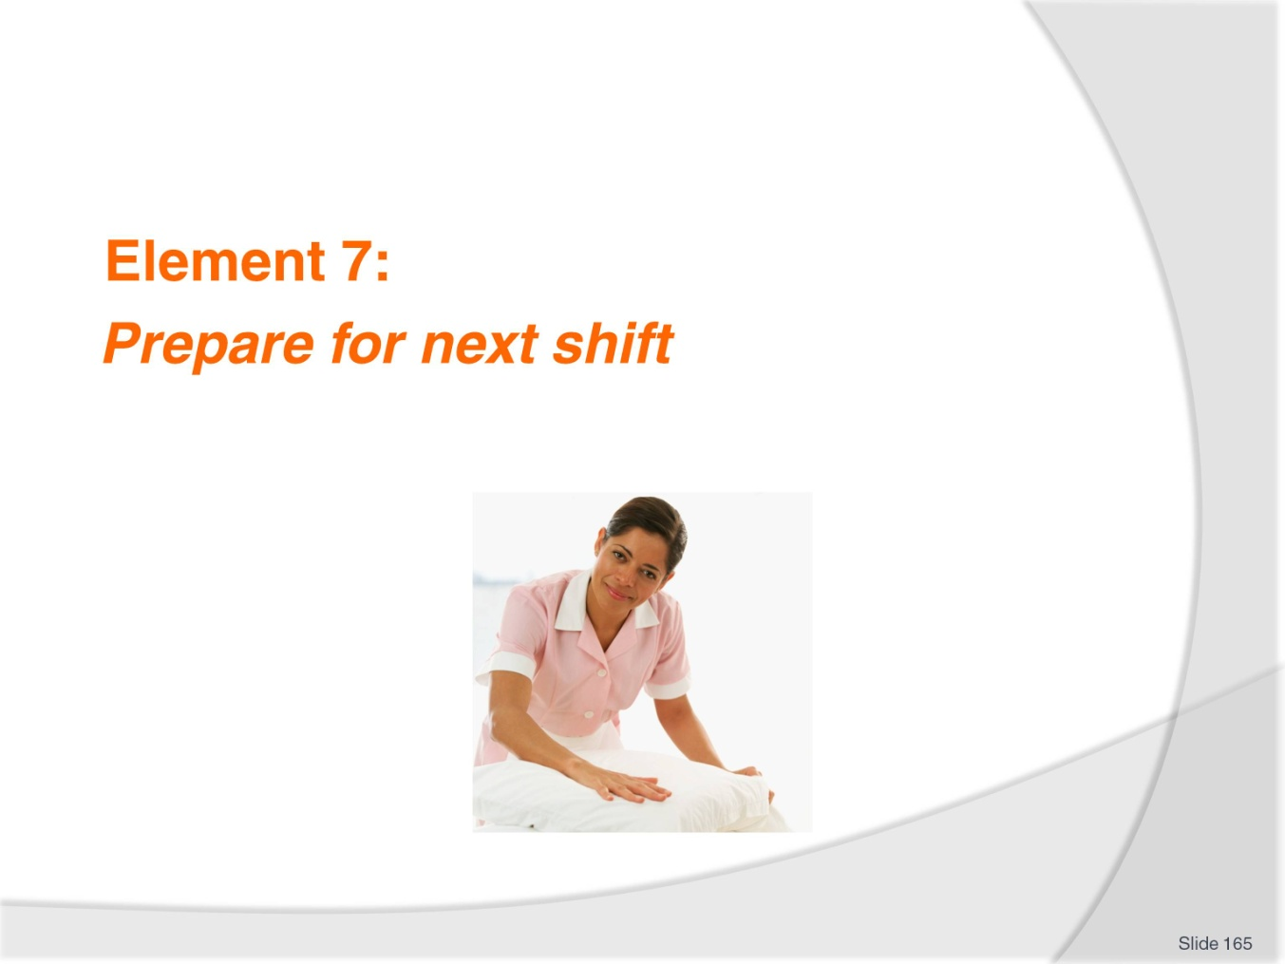
Slide No | Trainer Notes
Introduce topic.
Class Activity – General Discussion
Ask general questions:
What do you need to do to prepare for the next shift?
When would these be done?

Slide
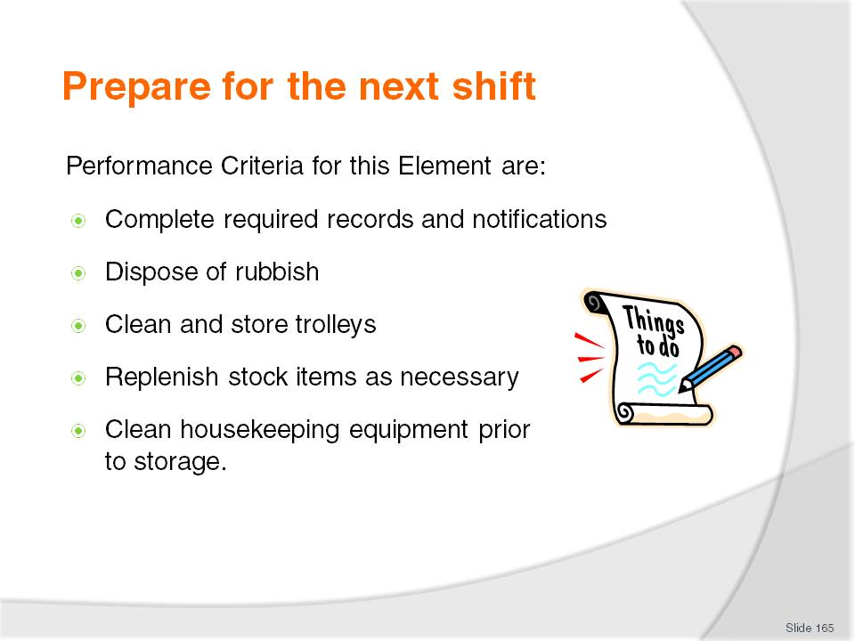
Slide No | Trainer Notes
 | Trainer identifies the Performance Criteria for this Element, as listed on the slide.

Slide
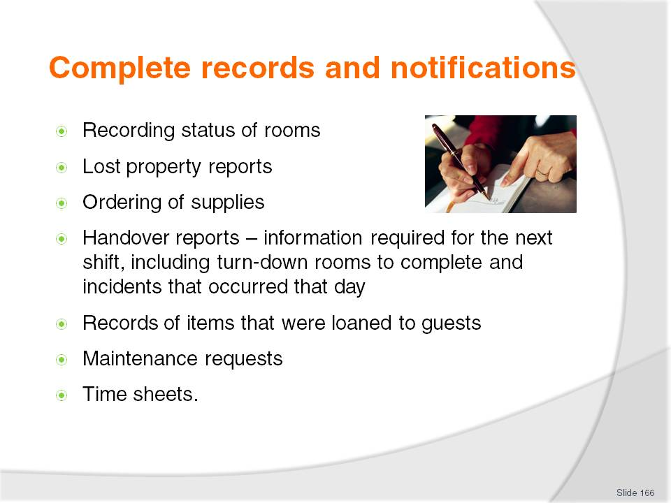
Slide No | Trainer Notes
Class Activity – General Discussion
What other documents may a room attendant be required to fill out?
For the examples in this slide, the Trainer should try to get examples of them and demonstrate how to fill them out.

Slide
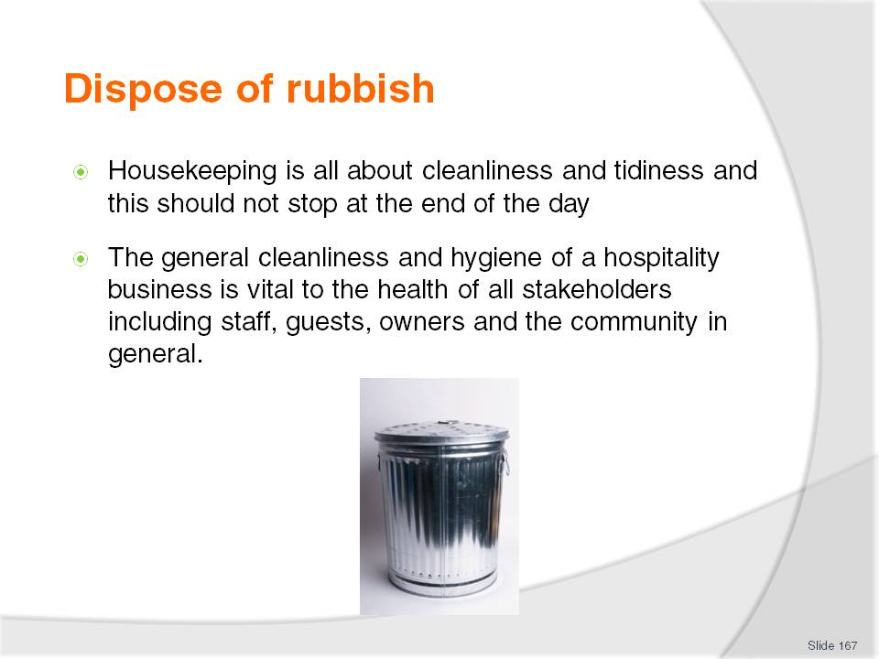
Slide No | Trainer Notes
Class Activity – General Discussion
What is considered to be rubbish?
Where is rubbish kept during a shift, considering a room attendant works on a guest floor?
What is the procedure for disposing of rubbish?

Slide
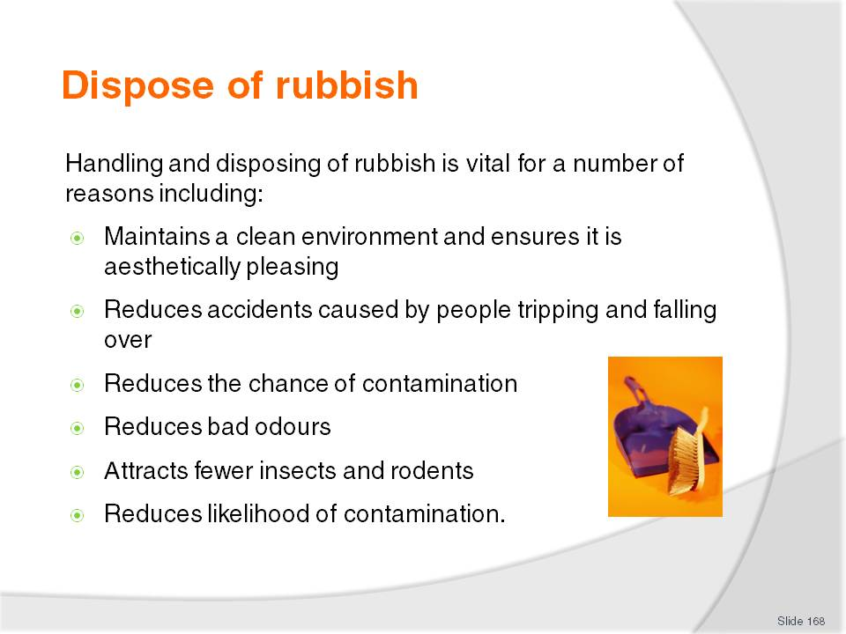
Slide No | Trainer Notes
Class Activity – General Discussion
Discuss the benefits of proper waste management.
Get the trainees to think about why it is important to clean at their own home. What happens if you don’t clean?

Slide
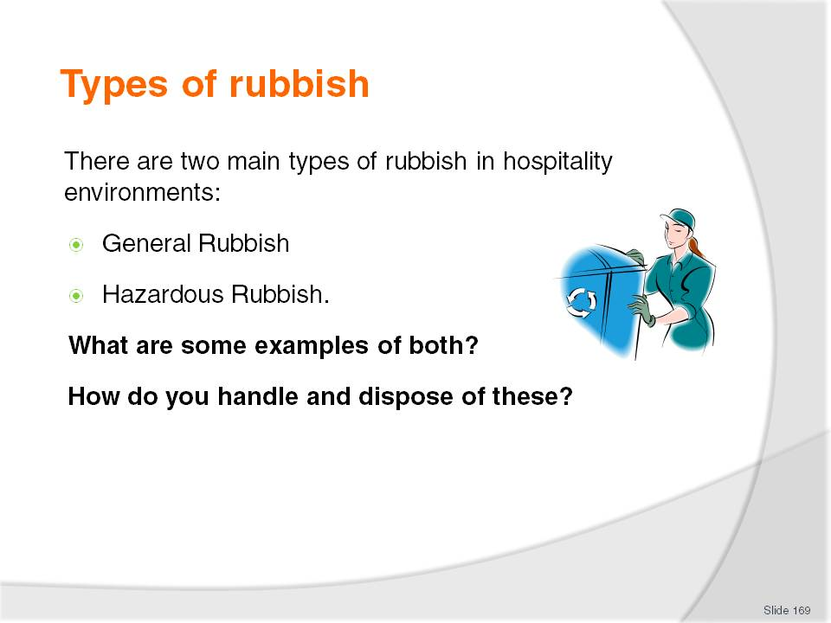
Slide No | Trainer Notes
Class Activity – General Discussion
Answer questions in the slide.

Slide
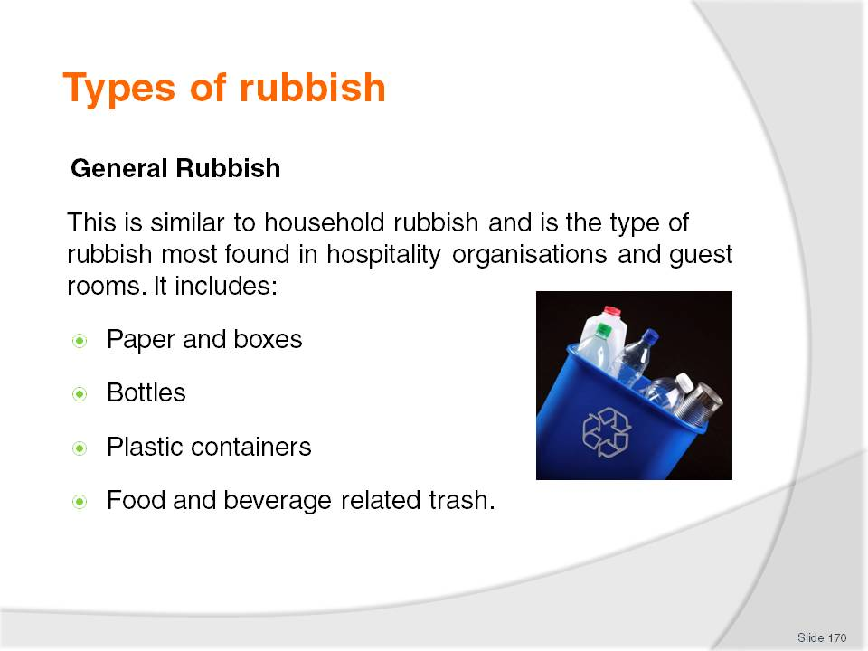
Slide No | Trainer Notes
Class Activity – General Discussion
How do you handle this rubbish?

Slide
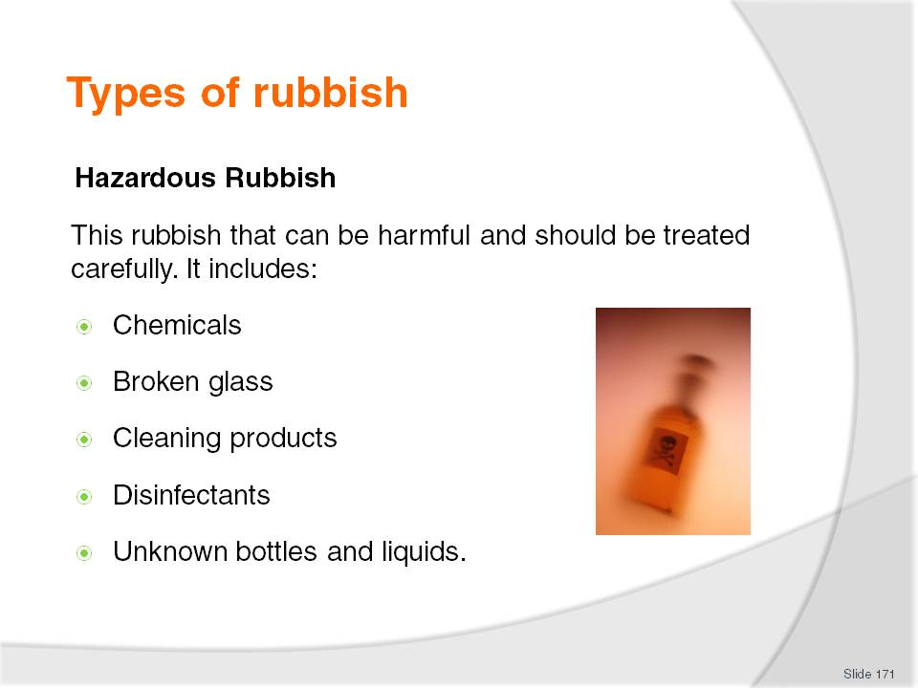
Slide No | Trainer Notes
Class Activity – General Discussion
How do you handle this rubbish?

Slide
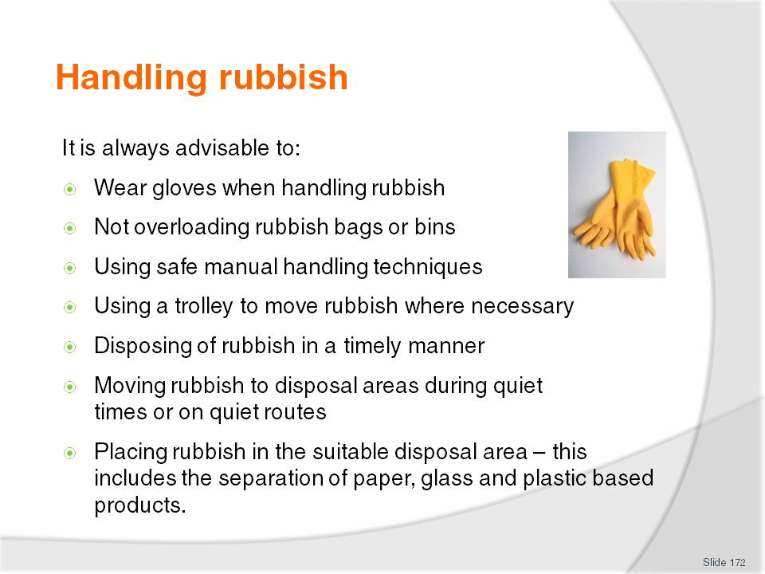
Slide No | Trainer Notes
Class Activity – General Discussion
Discuss each point and the importance of each step.

Slide
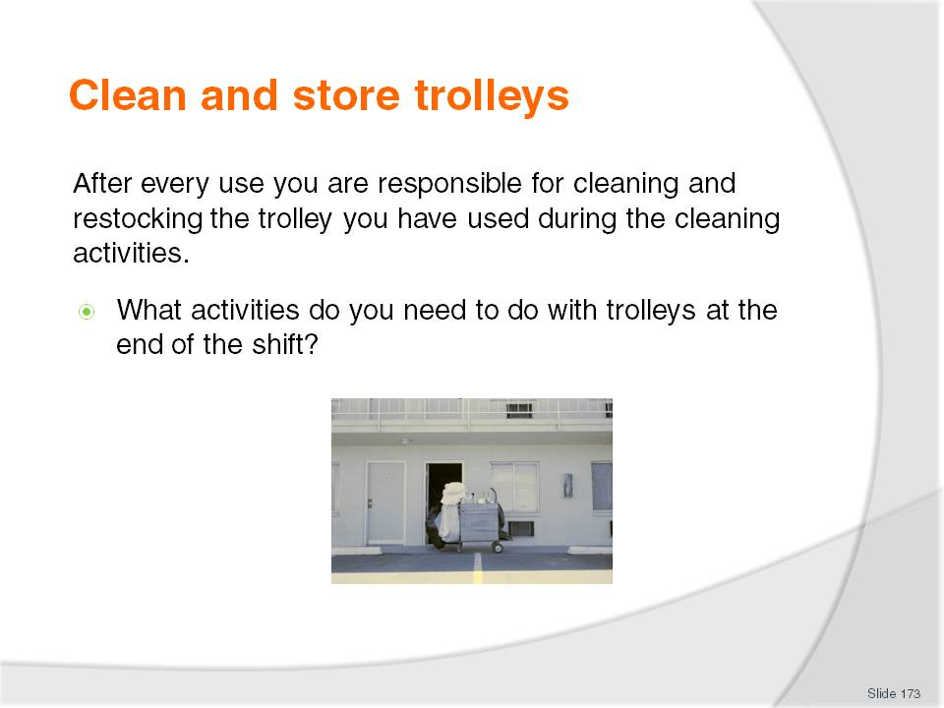
Slide No | Trainer Notes
Class Activity – General Discussion
Answer question in the slide.

Slide
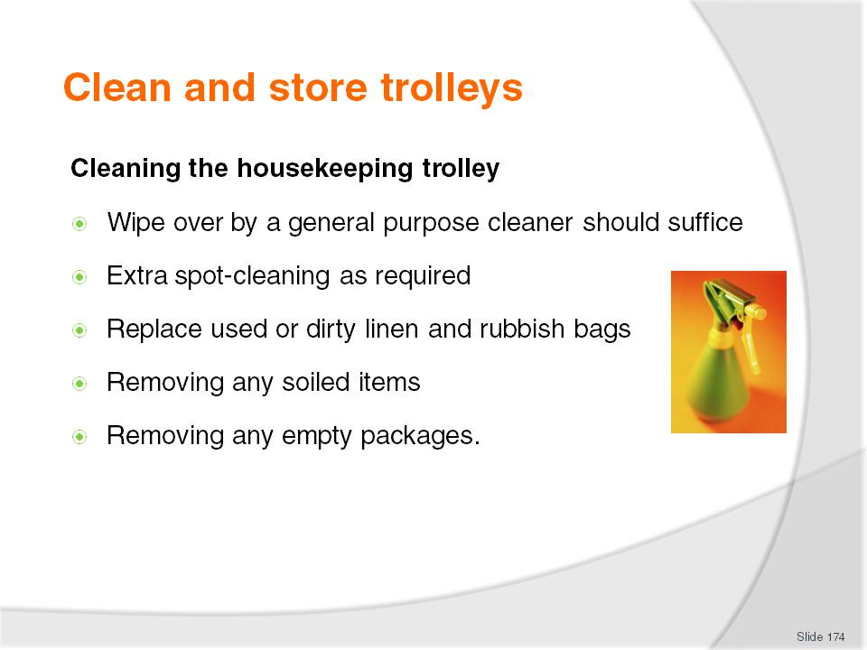
Slide No | Trainer Notes
Class Activity – General Discussion and Demonstration
Trainer to demonstrate and explain why steps are done as identified in the slide.
Trainees to practice cleaning and storing trolleys.

Slide
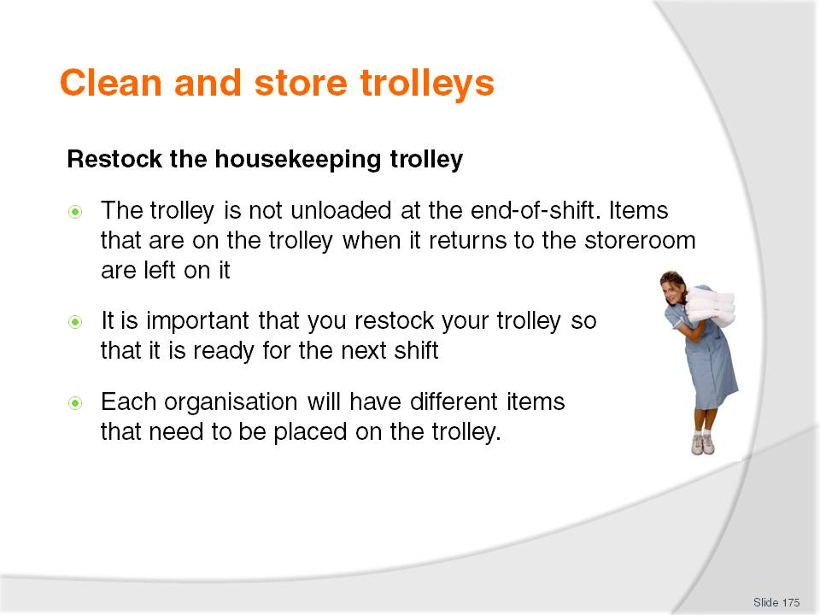
Slide No | Trainer Notes
Class Activity – General Discussion and Demonstration
Trainer to demonstrate and explain what needs to be re-stocked on a trolley.
Trainees to practice re-stocking trolleys.

Slide
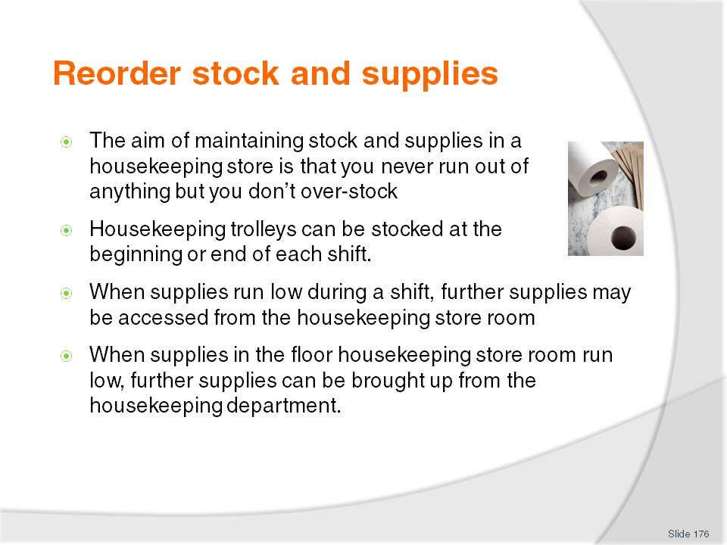
Slide No | Trainer Notes
Class Activity – General Discussion and Demonstration
What is the normal procedure for the movement of stock before, during and after a shift?
How normally does this?

Slide
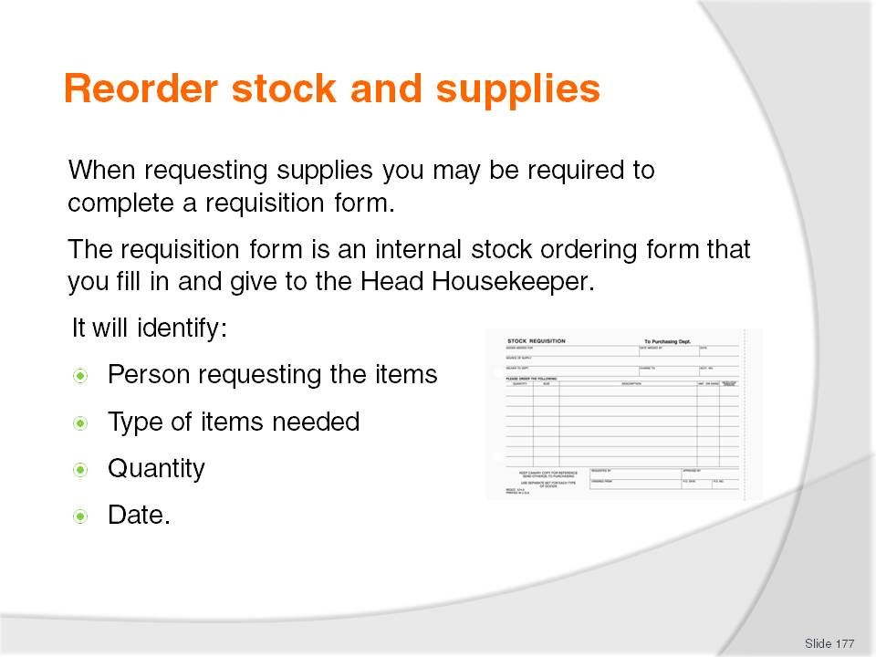
Slide No | Trainer Notes
Class Activity – General Discussion
How do you fill out a requisition form?
Trainer should try to get examples of them and demonstrate how to fill them out.

Slide
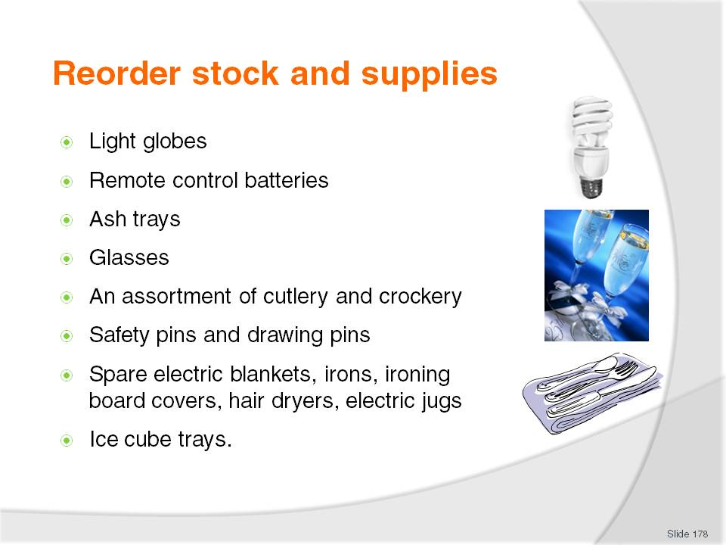
Slide No | Trainer Notes
Class Activity – General Discussion
Discuss points

Slide
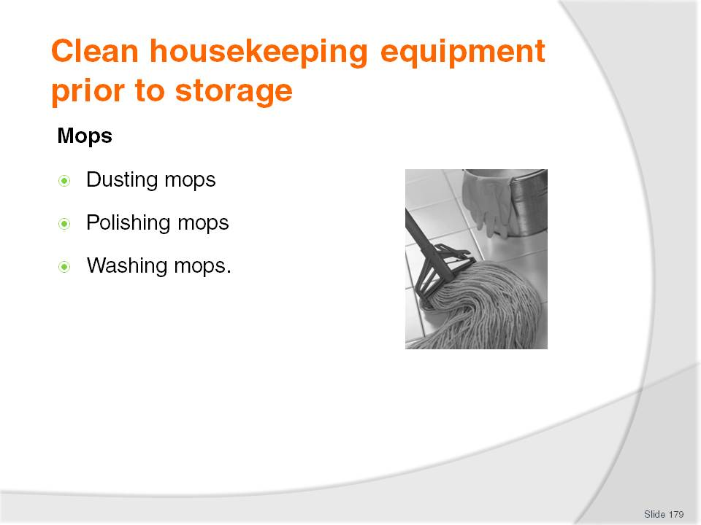
Slide No | Trainer Notes
Class Activity – General Discussion and Demonstration
Trainer to demonstrate and explain why steps are done as identified in the slide.
Trainees to practice cleaning equipment.
Dusting mops – after use, shake thoroughly in appropriate location (outside) then wash in hot soapy water, and hang out to air dry
Polishing mops – on a regular basis, remove fluff and rinse mop in turpentine, which will remove the polish – after the mop has been squeeze-dried, re-coat with polish
Washing mops – on a regular basis mops should be washed in hot soapy water, rinsed thoroughly, squeeze-dried, and then hung up to air dry.

Slide
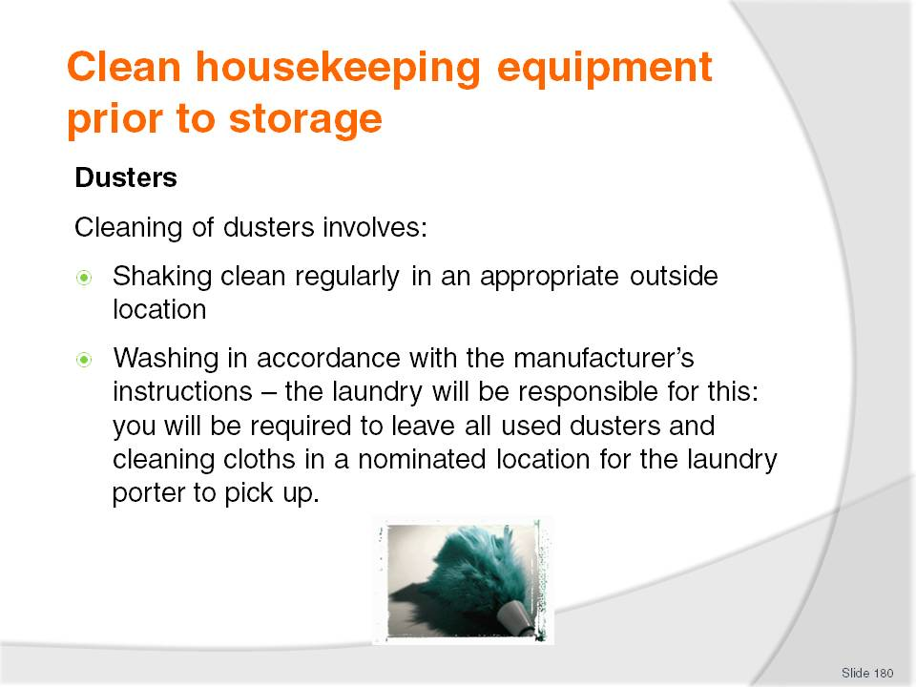
Slide No | Trainer Notes
Class Activity – General Discussion and Demonstration
Trainer to demonstrate and explain why steps are done as identified in the slide.
Trainees to practice cleaning equipment.

Slide
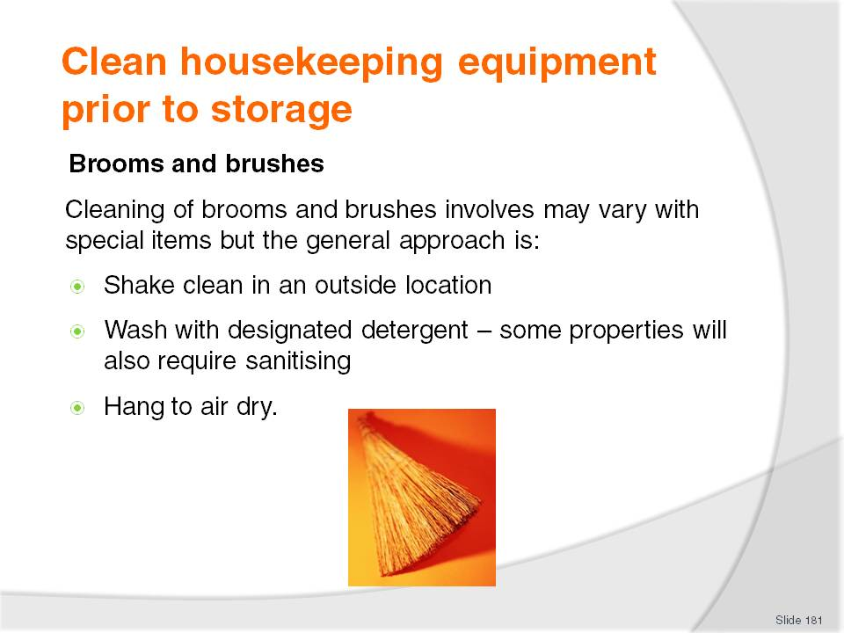
Slide No | Trainer Notes
Class Activity – General Discussion and Demonstration
Trainer to demonstrate and explain why steps are done as identified in the slide.
Trainees to practice cleaning equipment.

Slide
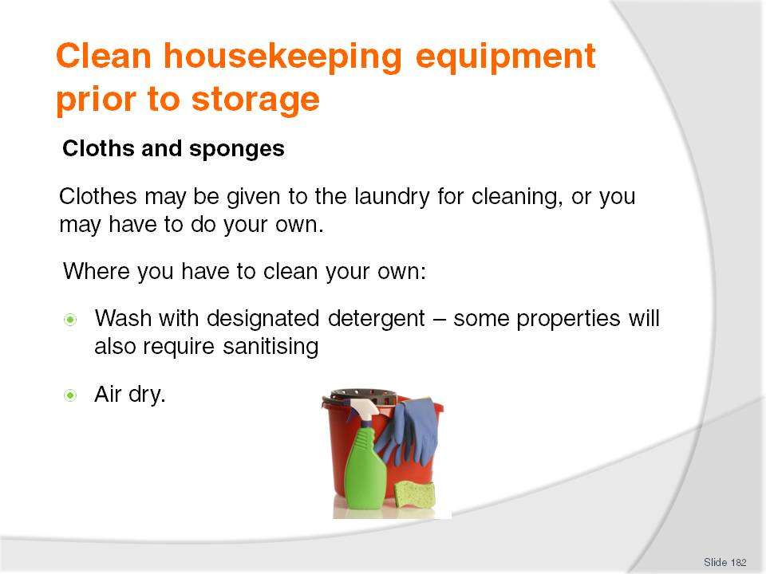
Slide No | Trainer Notes
Class Activity – General Discussion and Demonstration
Trainer to demonstrate and explain why steps are done as identified in the slide.
Trainees to practice cleaning equipment.

Slide
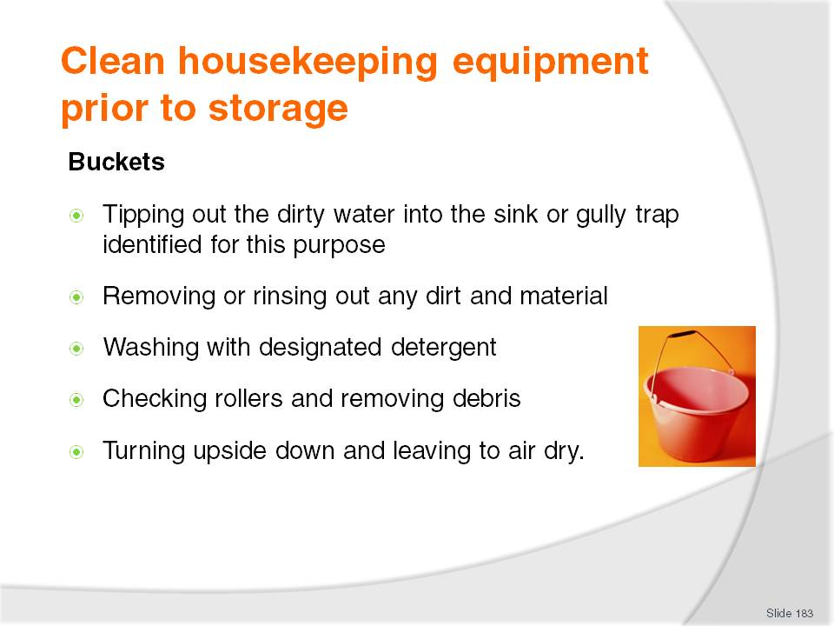
Slide No | Trainer Notes
Class Activity – General Discussion and Demonstration
Trainer to demonstrate and explain why steps are done as identified in the slide.
Trainees to practice cleaning equipment.

Slide
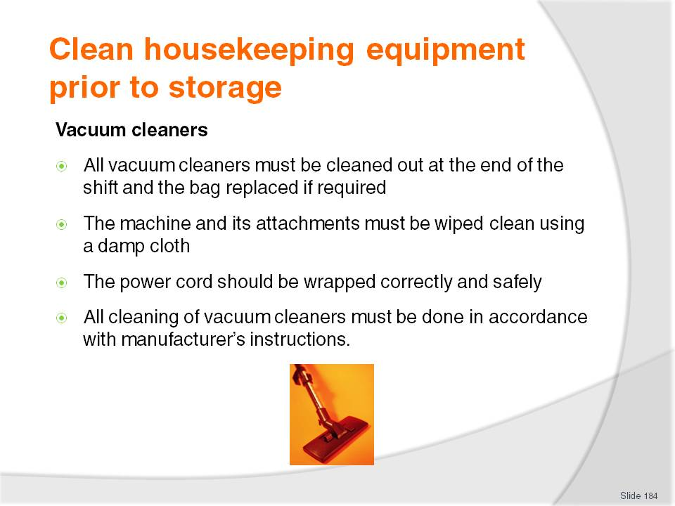
Slide No | Trainer Notes
Class Activity – General Discussion and Demonstration
Trainer to demonstrate and explain why steps are done as identified in the slide.
Trainees to practice cleaning equipment.

Slide
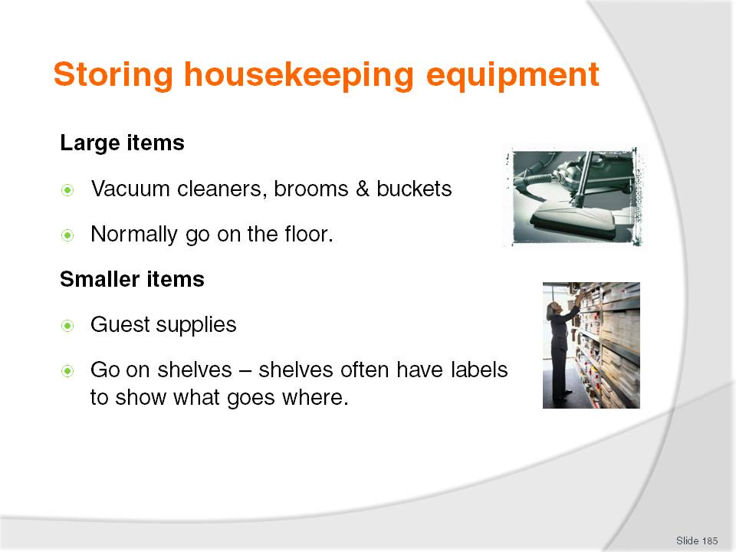
Slide No | Trainer Notes
Class Activity – General Discussion and Demonstration
Trainer to show where items are stored in a storage area.

Slide
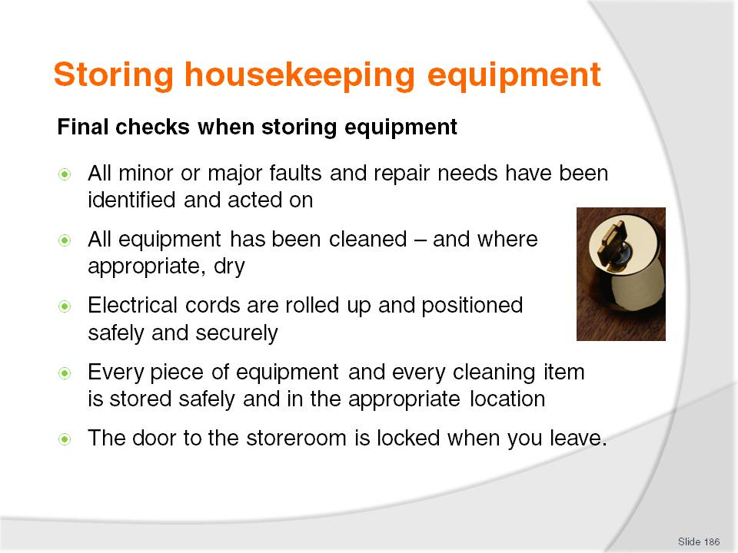
Slide No | Trainer Notes
Class Activity – General Discussion and Demonstration
Discuss points.
What happens now that all equipment has been cleaned and stored away?

Slide
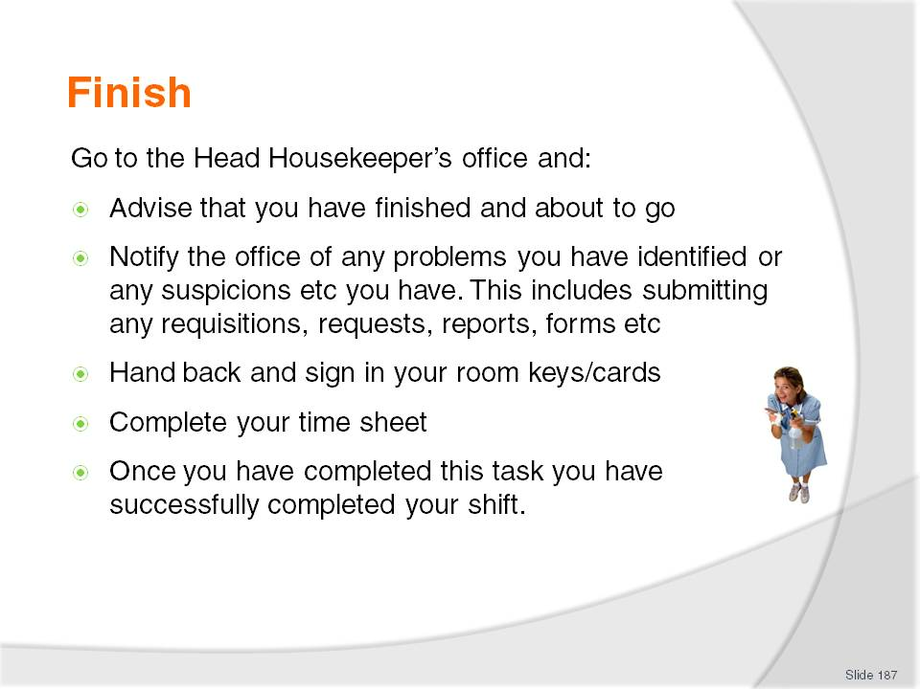
Slide No | Trainer Notes
Class Activity – General Discussion and Demonstration
Discuss points.

Recommended training equipment
Bed linen – including pillows, pillow cases, sheets, blankets and duvet
Chemicals – various for cleaning
Communication documents used in workplace
Computer with internet and email access
Emergency procedures
Equipment – various including vacuum cleaner, brooms, mops, brushes, sponges
Equipment manuals
Guest room access – a simulated environment
Guest room supplies – various including shampoo, conditioner, moisturisers, hand lotions, tissues, sewing kit, shoe mitt, laundry bags
Housekeeping trolley
In-room compendium
Job descriptions
Kitchenette including fridge, microwave, oven, stove, pots, pans, utensils, crockery and cutlery
Note pads and pens
Organisational Chart
Policies and procedures for organisation, housekeeping and room attendant position
Posters
Safety Signs
Standard Operating Procedures (SOPs)
Telephone system
Towels – various including bath mats, hand towels, face washers and bath towels.

Instructions for Trainers for using
PowerPoint – Presenter View
Connect your laptop or computer to your projector equipment as per manufacturers’ instructions.
In PowerPoint, on the Slide Show menu, click Set up Show.
Under Multiple monitors, select the Show Presenter View check box.
In the Display slide show on list, click the monitor you want the slide show presentation to appear on.
Source: http://office.microsoft.com
Note:
In Presenter View:
You see your notes and have full control of the presentation
Your trainees only see the slide projected on to the screen.
More Information
You can obtain more information on how to use PowerPoint from the Microsoft Online Help Centre, available at: http://office.microsoft.com/training/training.aspx?AssetID=RC011298761033.
Note Regarding Currency of URLs
Please note that where references have been made to URLs in these training resources trainers will need to verify that the resource or document referred to is still current on the internet. Trainers should endeavour, where possible, to source similar alternative examples of material where it is found that either the website or the document in question is no longer available online.

Appendix – ASEAN acronyms
AADCP | ASEAN – Australia Development Cooperation Program.
ACCSTP | ASEAN Common Competency Standards for Tourism Professionals.
AEC | ASEAN Economic Community.
AMS | ASEAN Member States.
ASEAN | Association of Southeast Asian Nations.
ASEC | ASEAN Secretariat.
ATM | ASEAN Tourism Ministers.
ATPMC | ASEAN Tourism Professionals Monitoring Committee.
ATPRS | ASEAN Tourism Professional Registration System.
ATFTMD | ASEAN Task Force on Tourism Manpower Development.
CATC | Common ASEAN Tourism Curriculum.
MRA | Mutual Recognition Arrangement.
MTCO | Mekong Tourism Coordinating office.
NTO | National Tourism Organisation.
NTPB | National Tourism Professional Board.
RQFSRS | Regional Qualifications Framework and Skills Recognition System.
TPCB | Tourism Professional Certification Board.







